Algebra 1 Name ___________________________________________________________
Regents Review #4 Period ______
1. Solve for x  $$\frac{3}{2}\left(x-\frac{1}{3}\right)+x=3$$ | 2. Express each in simplest exponent form.  a. $(-4x^{5})(-x^{3})$  b. $(2x^{5})({3x}^{2})(-2x)$  c. ${{(3x}^{3})}^{2}({2x}^{4})$
3. The function $y=f(x)$ is defined by the graph shown below.
y
x

a. Find all values of $x$such that $f\left(x\right)=0$

b. Find $f(2)$ and $f(6)$

c. Find all values of $x$ such that $f\left(x\right)=-3$

d. This function achieves a minimum value of __________ when $x=________$

4. Solve the inequality for all values of x.  $$-2\left(3x-4\right)-2x≥-16$$  Graph the solution set below  Write the solution set using interval notation | 5. Find three consecutive odd integers such that six times the second decreased by twice the first is equal to twenty more than the sum of the second and third.
6. Solve for $x$ in terms of $b,c,d,and e$.  $$4c-bx=dx-3e$$ | 7. Simplify  a. $\left(5x-4\right)\left(3x+7\right)$  b. $\left(\left(7x-10\right)-\left(x-3\right)\right)(6x+7)$

8. The length of a soccer field is 99 feet shorter than twice the width. The perimeter of the field is 1,134 feet.

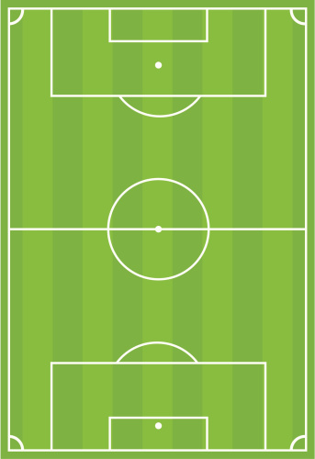
Write and solve an equation to find the dimensions of the field (length and width.)

Length = _____________ Width= _______________

Express the dimensions in yards: Length = ___________ yards Width = ____________ yards

9. Solve the inequality shown below. Express your solution as a single compound inequality.  $$-10<-3x+5≤14$$  Graph the solution set on the number line.  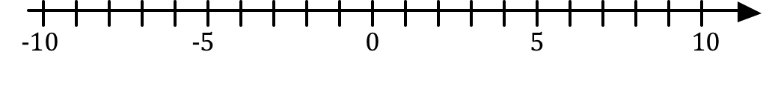  Express the solution set using interval notation. | 10. The West Seneca sports boosters need to purchase a new scoreboard for the gymnasium. They currently have a balance of $3,500 in their account. To raise the money needed to purchase the scoreboard, the boosters are selling jackets and hoodies. For each jacket, j, sold they earn a profit of $27, and for each hoodie sold, h, they earn $22. To purchase the scoreboard, the sports boosters need to have an account balance of at least $9,400.  Write an algebraic inequality to model the problem above.  If the sports boosters sell 136 jackets solve your inequality to find the minimum number of hoodies they would need to sell to purchase the scoreboard.

11. Consider the function rule defined below.

Three decreased by twice the input results in the output.

a. Write an algebraic equation using $x and y$ to represent the function rule.

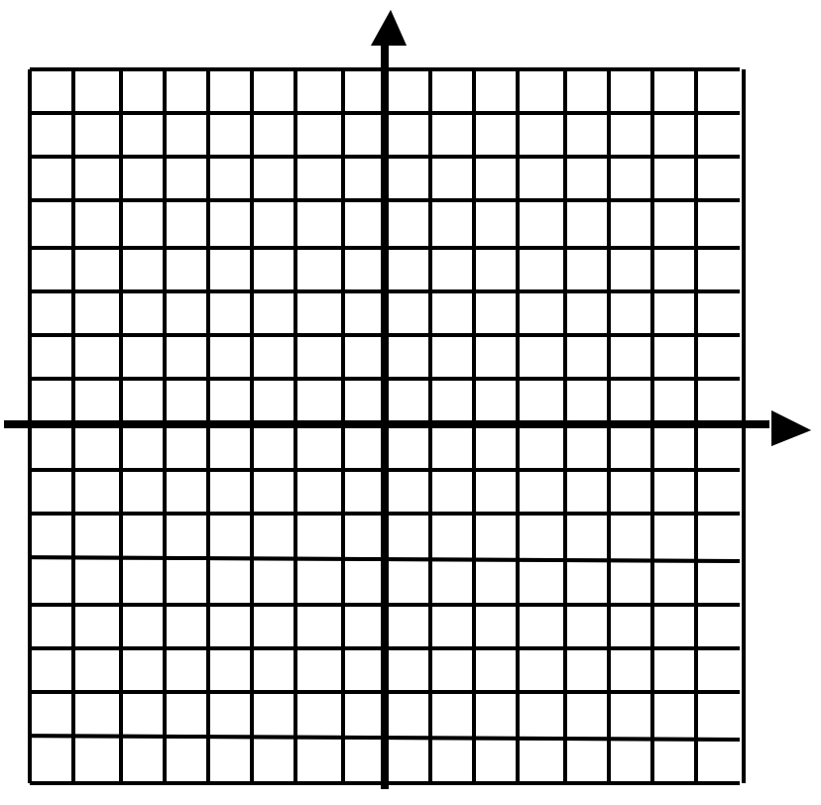
b. Complete the table using your function rule. c. Graph the function on the grid below.

x | Computation (Work Space) | y
-2
-1
0
1
2
3

d. Find the value of $f(x)$ when $x=-5$ e. Find the value of $x$ when $f\left(x\right)=-9$

