Name ________________________________ Period _______ Week of January 5-9
Every day you enter class and complete this assignment. It will count for 15% of your grade. You must hand in every Friday. It will not be accepted late, unless you are absent. If absent, please hand in on Monday. You cannot make up this assignment. Come to extra help, if you have questions.
Monday, January 5, 2015 (show your work)
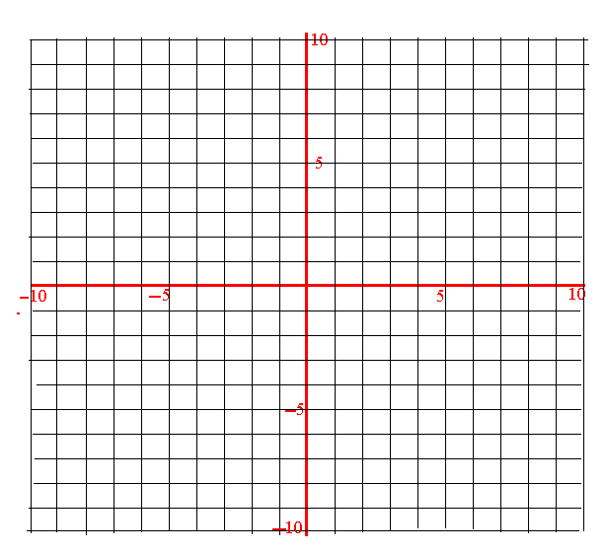
Graph f(x) = │x│on the interval -5≤ x ≤ 5 . Use the graph to answer parts (a) – (g).
Tuesday, January 6, 2015 (show your work)
(a) Is this a function? Explain why.

b) State the domain ________________
c) State the range ________________
Wednesday, January 7, 2015
d) Over the interval [-5,0] is the function increasing or decreasing? _____________

Thursday , January 8, 2015
e) Evaluate each of the following: f (0) = __________ f (4) = __________

f) State the y- intercept(s) __________________ state the x-intercept(s) ____________________
State the minimum or maximum ____________________________

Friday, January 9, 2015
(g) Find the average rate of change from $x=1$ to $x=4$.

