Algebra 1 Name _______________________________________
Regents Review #7 Period _____
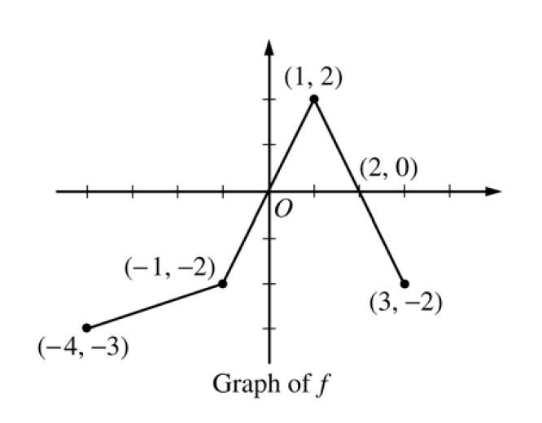
1. The graph of $y=f(x)$ is shown below.

A. What is the domain of the function? _____________________ What is the range? _______________________

B. Over what interval(s) is the function increasing? C. Over what interval(s) is the function decreasing?

D. Find the average rate of change for the function over the following intervals.

$-4≤x≤-1$ ________

$-1≤x≤1$ ________

$1≤x≤3$ ________

E. What are the Zeros of the function? F. State the interval where the function is positive. _______________________

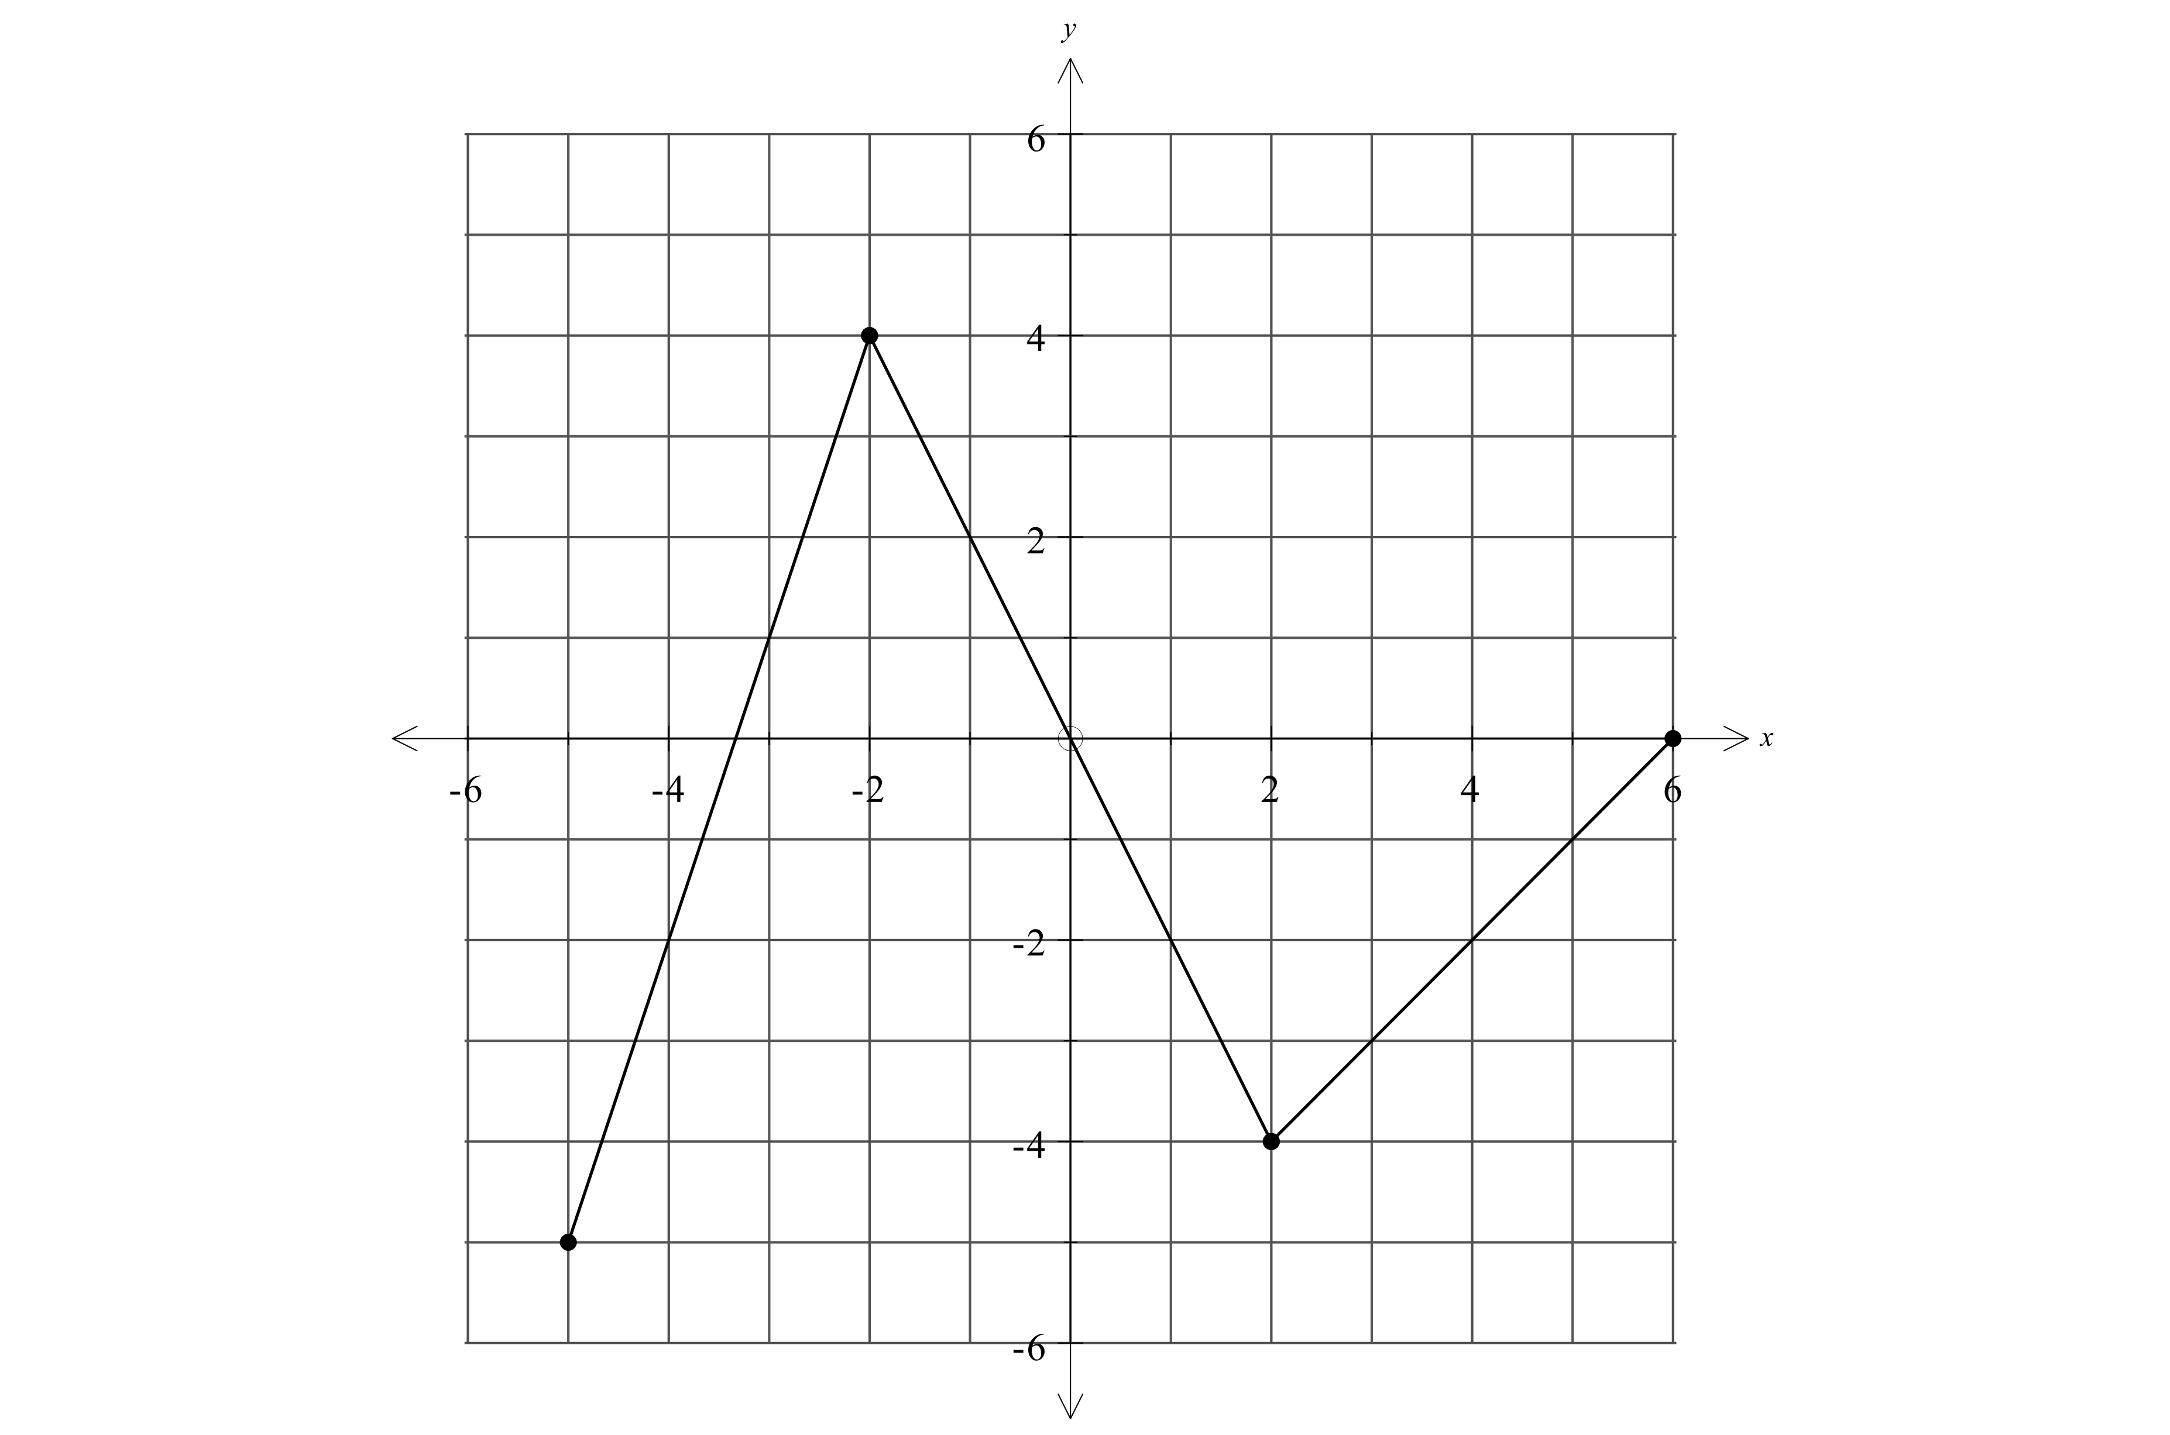  2. Find the equation of the line in slope-intercept form that passes through the points $(-4,9)$ and $(4,3)$. | 3. The function $y=f(x)$ is defined by the graph below.  A. Use the graph to find $f\left(-3\right)$, $f(3)$, and $f(6)$.  B. Use the graph to solve $f\left(x\right)=-2$ for all values of $x.$
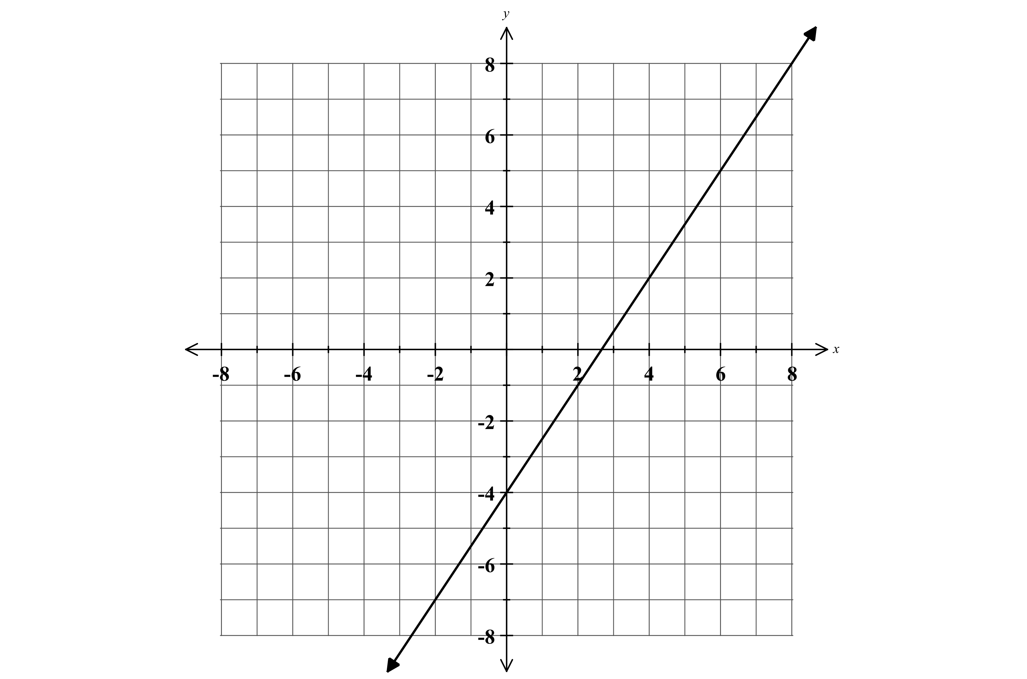
4. The graph of $y=f(x)$ is shown on the coordinate plane below.

A. Write the equation of the line in slope-intercept form.

B. Rewrite the equation below in slope-intercept form.

$$3x+6y=24$$

C. Graph and label the equation from part B.

D. Circle the points below that are solutions to the function
$y=f\left(x\right).$ Explain your reasoning.

$(-2,-7)$ $(4,0)$ $(7,7)$ $(2,-1)$ $(5,6)$

E. What point is a solution to both linear equations? ____________. Verify your answer algebraically (check point in both equations!)

5. For each of the following relationships choose the most appropriate domain. Use the choices below.

1. $\{…-2,-1 ,0 , 1 , 2…\}$ 2. $\{0, 1 , 2 , 3…\}$ 3. $\{Rational Numbers≥0 \}$ 4. $\{1 , 2 , 3…\}$

A. $P(h)$ where $P$ represents the total pay and $h$ represents the number of hours worked at a clothing store. _________

B. $C(f)$ where $C$ represents the cost to heat a home and $f$ represents external temperature in full degrees Fahrenheit. _________

C. $D(t)$ where $D$ represents the total distance traveled and $t$ represents the time traveled in hours. _________

D. $S(n)$ where $S$ represents the sum of the first $n$ numbers of at least two whole numbers. ________

6. Consider the two relations shown below.
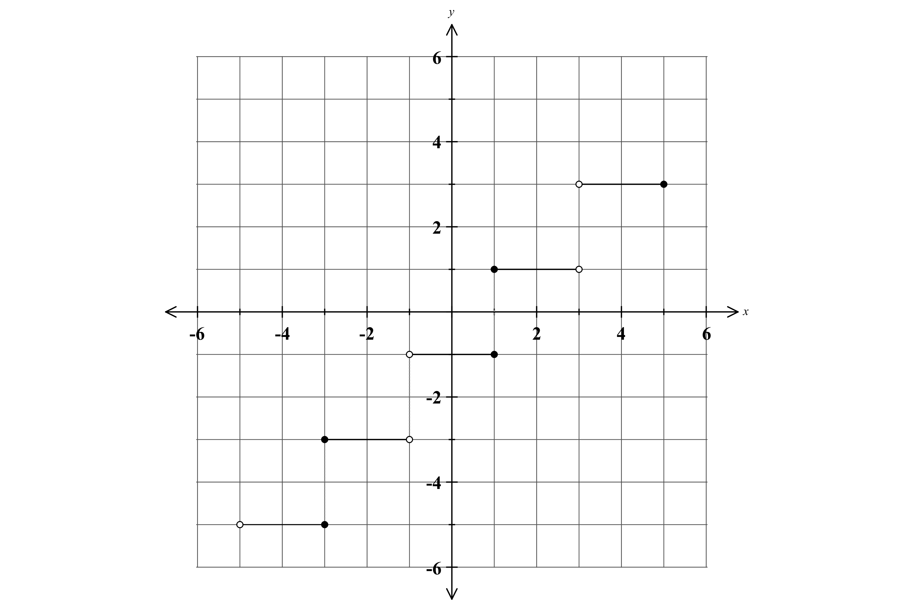
Relation A: $\{\left(1,5\right), \left(3, 4\right), \left(4, 5\right), \left(9,2\right)\}$ Relation B

State the domain in roster form.

State the range in roster form.

Create a mapping of the relation.

Domain Range

Does the relation represent a function? Explain. Does the relation represent a function? Explain.

7. The linear equation $0.10\left(x+5\right)+0.05\left(x\right)=\$8.75$shows the equation that could be used to solve the problem below.

Brad has five more dimes than nickels, for a total of $8.75. Write an equation that could be used to find the number of nickels Brad has.

A. Lisa has twelve fewer dimes than quarters, for a total of $11.05.

Write a linear equation that could be used to find the number of quarters Lisa has. ___________________________________________

B. Solve the equation to find the number of quarters Lisa has.

8. Stephanie’s checking account can be modeled with a linear function. After three weeks, $w,$ her checking account balance, c , was $325. After 10 weeks, $w$, her balance was $150.

A. Use the information above to create two coordinate pairs,$\left(w,c\right),$showing the number of weeks and the remaining balance.

B. Use your points from part A to find both the rate of change and the initial value (y-intercept.) Show your work.

C. Write the linear equation, using c and $w$, to represent the relationship between Stephanie’s balance and the number of weeks.

D. Explain what the rate of change and the y-intercept in your equation represent in the context of the problem.

E. Use your equation to find when Stephanie’s checking account balance will reach zero.

F. Use your equation to find Stephanie’s checking account balance after 7 weeks.

