Algebra 1 Name ______________________________________________
Regents Review #8 Period _____
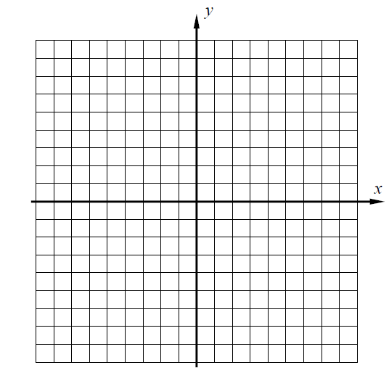
1. The graph of $y=f(x)$ is shown below.

A. Write the equation for the line in slope-intercept form.

___________________________

B. Convert the linear equation below into slope - intercept form.
Graph and label the resulting equation.
$6x+4y=32$

C. Which coordinate pair is a solution to both equations? ___________

2. Graph and label the 3 equations on the grid provided.

$$y=-7$$

$$x=-3$$

$$y=-x$$

Find the area of the triangle enclosed by the three lines.

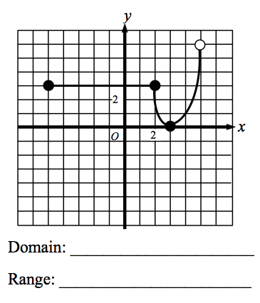
3. Consider the functions $y=f(x)$ and $y=g(x)$ shown below. Determine the domain and range for each using interval notation.
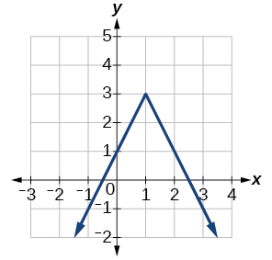

Domain ______________

Range ________________

4. Determine the equation of the line in slope-intercept form that passes through the points $(-3,7)$ and $(3,5)$.  Graph the equation you found from part A to verify your answer. | 5. The length of a volleyball court is thirty feet less than three times the width. The perimeter of the court is 180 feet. Write and solve an algebraic equation to determine the dimensions (length and width) of the court.  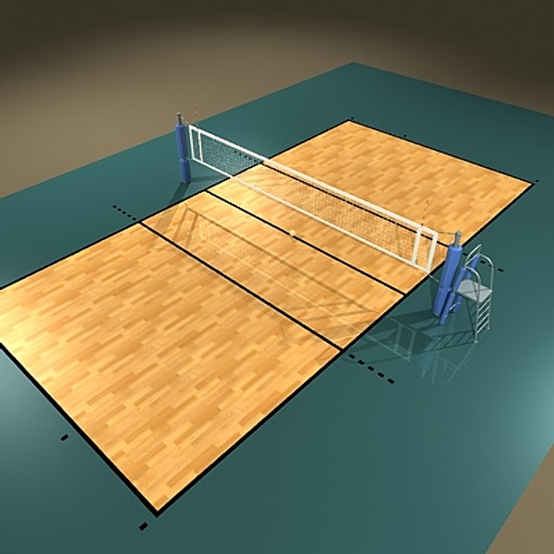  Let w = the width.  B. What is the area of a volleyball court?
6. Consider the function $f\left(x\right)=\left|x+4\right|-5$

A. Graph the function over the domain $-8≤x≤3$ by creating a table of values.

$$x$$
$$f(x)$$

B. Over what interval is the function decreasing?

C. Over what interval is the function increasing?

D. State the range of the function using interval notation.

7. Two competing truck rental companies charge customers based on the information below.

Ted’s Truck World: $30 deposit plus $0.30 per mile.
Randy’s Rentals: $0.10 per mile plus a $90 deposit.

A. Write a cost function for each company. Use $T(m)$ for Ted’s and $R(m)$ for Randy’s.
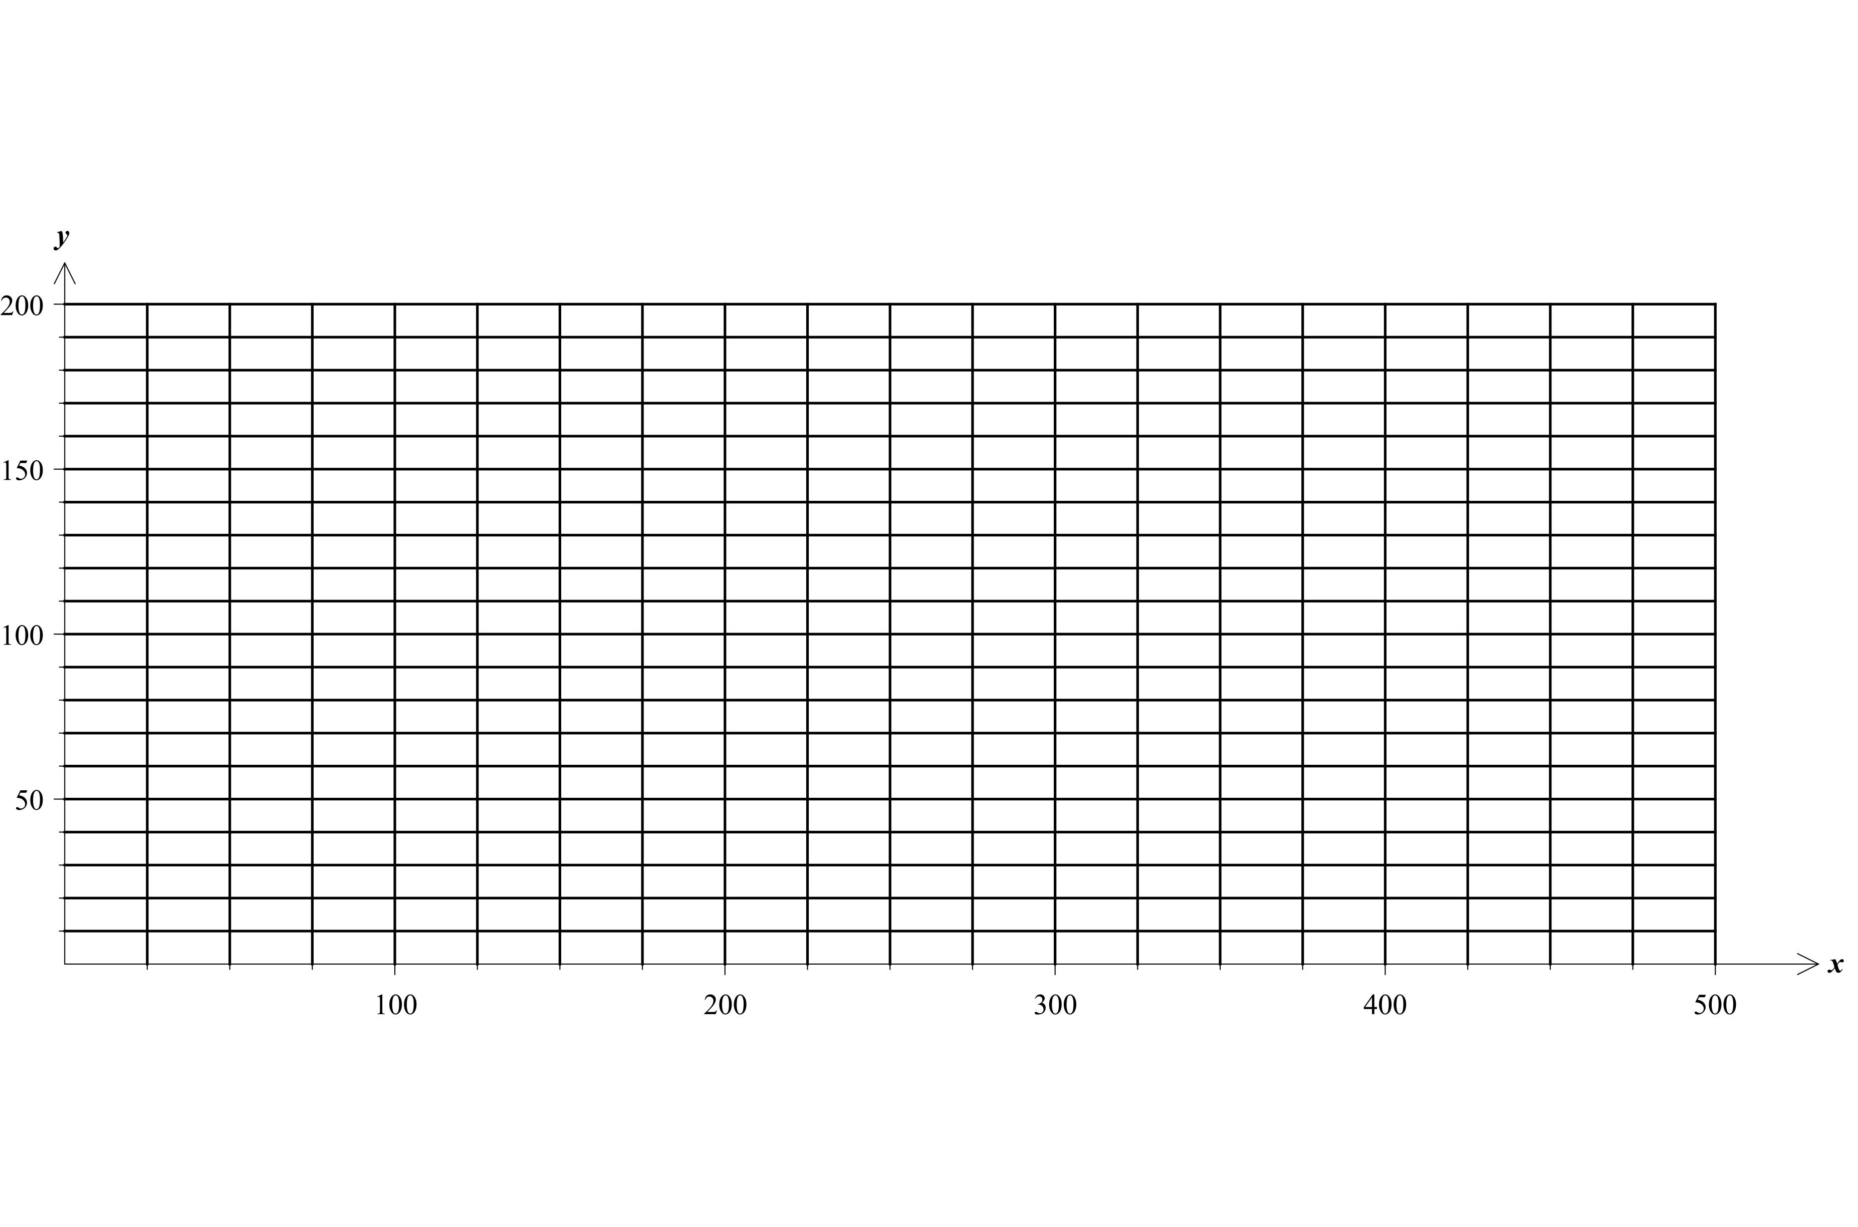

B. Use the table feature on your graphing calculator to graph both functions. (Go to tbl set and change $∆Tbl$ to 100 and tblStart to $0.)$

Cost in Dollars
Number of miles, m

C. Use the graph to determine the number of miles at which the cost to rent is equivalent________________

D. Use your equations from part A to algebraically verify the number of miles at which the cost to rent is equivalent.

8. Simplify the following.

A. $(4x-3)(3x-2)$ B. ${(2x+5)}^{2}$ C. $(5x+4)(5x-4)$

9. A local silk screening company charges $20 per shirt for any order up to and including 5 shirts as shown in the graph.

The table below shows the pricing policy for various orders exceeding 5 shirts.

Number of t-shirts | Cost per shirt
$$1≤t≤5$$ | $20
$$5<t≤20$$ | $15
$$20<t≤40$$ | $12
$$t>40$$ | $8

Complete the graph for the cost of ordering t-shirts as a function of the number of t-shirts ordered. The first interval is shown.

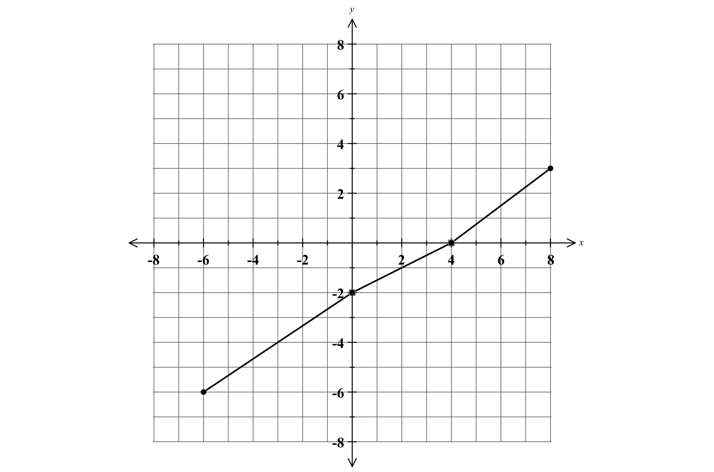
10. Determine the average rate of change for each interval.

$-6≤x≤0$ ________

$0≤x≤4$ ________

$4≤x≤8$ ________

B. Which interval represents the lowest average rate of change? _______________________

