**You must show work/explain EVERY question, even the multiple choice questions.**

**Multiple Choice: (2) points each.**

1. Consider the following equations labeled I – IV:

I. $2x-7=9$  
 II. $6x-21=27$  
 III. $\frac{2}{3}x-7=3$  
 IV. $\frac{2}{3}x-\frac{7}{3}=3$

Which of the following equations will have the **same** solution?

|  |  |  |  |
| --- | --- | --- | --- |
| 1) | I and II | 3) | I,II,and IV |
| 2) | I,II,and III | 4) | All I-IV |

1.)_________

2.) What is the order of from least to greatest?

|  |  |  |  |
| --- | --- | --- | --- |
| 1) |  | 3) |  |
| 2) |  | 4) |  |

2.)_________

3.) Students in a ninth grade class measured their heights, h, in centimeters. The height of the shortest student was 155 cm, and the height of the tallest student was 190 cm. Which inequality represents the range of heights?

|  |  |  |  |
| --- | --- | --- | --- |
| 1) |  | 3) |  |
| 2) | or | 4) | or |

3.)_________

4.) What is  expressed in simplest radical form?

|  |  |  |  |
| --- | --- | --- | --- |
| 1) |  | 3) |  |
| 2) |  | 4) |  |

4.)_________

5.) Solve for *x*: 

|  |  |  |  |
| --- | --- | --- | --- |
| 1) | 1 | 3) | 3 |
| 2) |  | 4) | 5.)_________ |

**Short Answer (2) points each.**

6.)A method for solving  is shown below. Identify the property used to obtain each of the two indicated steps.

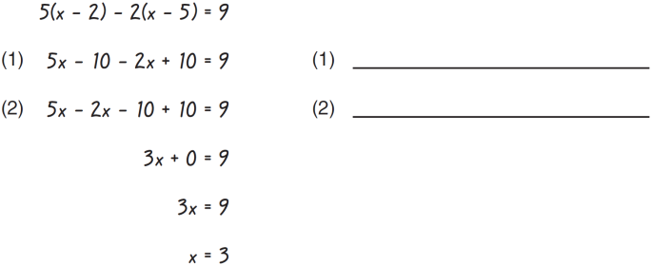 6.) put answers on lines in problem

**Short Answer (3) points each.**

7.) Subtract: 

7.)________________________

**Short Answer (5) points each.**

8.) Solve **and check** algebraically for *x*: 

8.)_______________________