**You must show work/explain EVERY question, even the multiple choice questions.**

1.) Which point is not on the graph represented by  1.)_________

|  |  |  |  |
| --- | --- | --- | --- |
| 1) |  | 3) |  |
| 2) |  | 4) |  |

2.) The freshman class held a canned food drive for 12 weeks. The results are summarized in the table below.

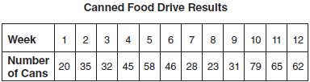

Which number represents the second quartile of the number of cans of food collected? 2.)_________

|  |  |  |  |
| --- | --- | --- | --- |
| 1) | 29.5 | 3) | 40 |
| 2) | 30.5 | 4) | 60 |

3.) What is  expressed in simplest radical form? 3.)_________

|  |  |  |  |
| --- | --- | --- | --- |
| 1) |  | 3) |  |
| 2) |  | 4) |  |

4.) A school newspaper will survey students about the quality of the school’s lunch program. Which method will create the *least* biased results? 4.)_________

|  |  |  |  |
| --- | --- | --- | --- |
| 1) | Twenty-five vegetarians are randomly surveyed. | 3) | Students who dislike the school’s lunch program are chosen to complete the survey. |
| 2) | Twenty-five students are randomly chosen from each grade level. | 4) | A booth is set up in the cafeteria for the students to voluntarily complete the survey. |

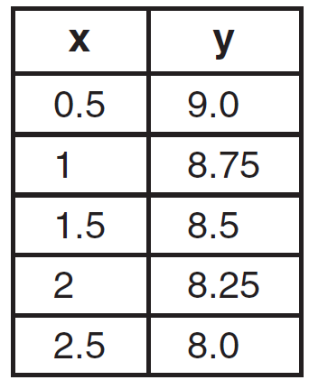 5.) What is the rate of change displayed in the table? 5.)__________

|  |  |  |  |
| --- | --- | --- | --- |
| 1) | Positive | 3) | Negative |
| 2) | Undefined | 4) | Zero |

**Short Answer (5) points each.**

6.) The number of people on the school board is represented by *x*. Two subcommittees with an equal number of members are formed, one with  members and the other  with members. How many people are on the school board? Please show all work AND a check for full credit.

7.) The table below shows the number of prom tickets sold over a ten-day period.

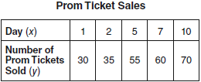

a) Plot these data points on the coordinate grid below. Use a consistent and appropriate scale. b) Draw a reasonable line of best fit and write its equation. c) How many tickets were sold on day 3?

