**You must show work/explain EVERY question, even the multiple choice questions.**

**Multiple Choice: [2] points each.**

1. Kevin has six more nickels than dimes in his pocket, for a total of $2.10. Which equation could be used to determine the number of dimes, *x*, in his pocket?

|  |  |  |  |
| --- | --- | --- | --- |
| 1) |  | 3) |  |
| 2) |  | 4) |  |

1.)________

2.) Given:    

Which expression results in an irrational number?

|  |  |  |  |
| --- | --- | --- | --- |
| 1) |  | 3) |  |
| 2) |  | 4) |  |

2.)_________

3.) Which of the following expressions is equivalent to?

|  |  |  |  |
| --- | --- | --- | --- |
| 1) |  | 3) |  |
| 2) |  | 4) |  |

3.) _________

4.) Which of the following values of *x* will make the equation 2(*x* – 3)2 + 4 = 22 true?

|  |  |  |  |
| --- | --- | --- | --- |
| 1) | 6 | 3) | 8 |
| 2) | 7 | 4) | 9 |

4.) _________

5.) The length of the shortest side of a right triangle is 8 inches. The lengths of the other two sides are represented by consecutive odd integers. Which equation could be used to find the lengths of the other sides of the triangle?

|  |  |  |  |
| --- | --- | --- | --- |
| 1) |  | 3) |  |
| 2) |  | 4) |  |

5.) _________

**Short Answer: [5] points each.**

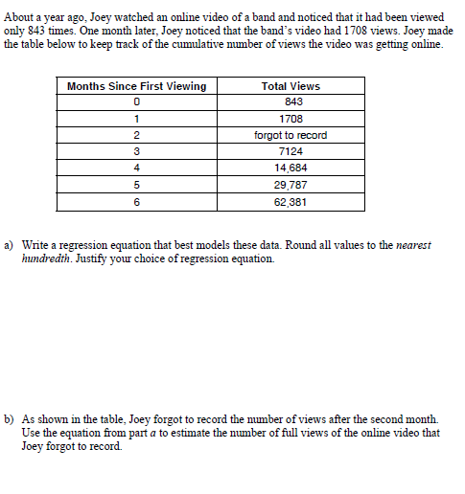6.) About a year ago, Joey watched an online video of a band and noticed that it had been viewed only 843 times. One month later, Joey noticed that the band’s video had 1708 views. Joey made the table below to keep track of the cumulative number of views the video was getting online.

1. Write a regression that ***best*** models this data. Round all values to the nearest hundredth. **Justify your choice of regression equation.**
2. As shown in the table, Joey forgot to record the number of views after the second month. Use the equation from part a) to estimate the number of full views of the online video that Joey forgot to record.

***y***

***x***

7.) The function  is shown graphed on the grid to the right. Answer the following questions based on the graph.

(a) Evaluate  and . Label each on the graph.

= =

(b) What is the domain of the function? Express your answer using any acceptable notation.

(c) Which has a greater average rate of change, the linear function  or the function above over the interval? Show how you arrived at your answer.