**You must show work/explain EVERY question, even the multiple choice questions.**

**Multiple Choice: [2] points each.**

1. 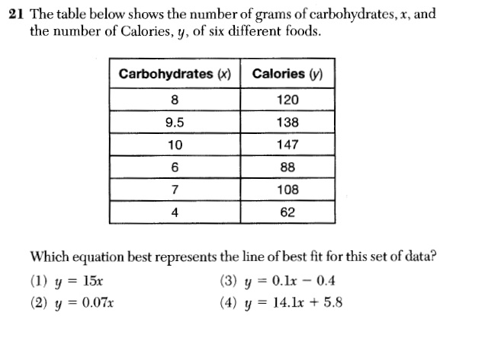The table below shows the number of grams of carbohydrates, x, and the number of Calories, y, of six different foods. Which equation best represents the line of best fit for this set of data?

|  |  |  |  |
| --- | --- | --- | --- |
| 1) | $$y=15x$$ | 3) | $$y=0.1x-0.4$$ |
| 2) | $$y=0.07x$$ | 4) | $$y=14.1x+5.8$$ |

1.)________

2.) Rashawn recently spent $100 to open a store selling t-shirts. At his business, he purchases plain t-shirts for $11 each, prints graphics on them, and then sells them for $26 each. What is the *minimum* number of t-shirts that Rashawn would need to sell in order to make a profit (total income minus total expenses) of *at least* $400.

|  |  |  |  |
| --- | --- | --- | --- |
| 1) | 26 | 3) | 33 |
| 2) | 27 | 4) | 34 |

2.)_________

3.) If $f(x)=2x+4$ and $g(x)=x^{2}-4$, the value of $f(5) +g(-3)$ is

|  |  |  |  |
| --- | --- | --- | --- |
| 1) | 19 | 3) | 34 |
| 2) | 23 | 4) | 41 |

3.) _________

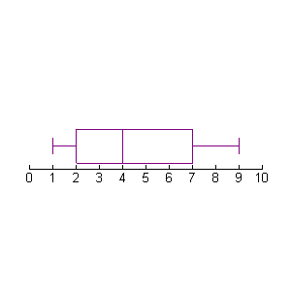4.) Which set of data could be used to represent the box and whisker to the right?

|  |  |  |  |
| --- | --- | --- | --- |
| 1) | 1, 1, 2, 3, 4, 4, 4, 5, 7, 8, 9 | 3) | 1, 2, 3, 4, 5, 6, 7, 8, 9, 10, 11 |
| 2) | 1, 2, 3, 3, 4, 4, 5, 5, 8, 9, 9 | 4) | 1, 1, 1, 4, 5, 5, 5, 7, 8, 9, 9 |

4.) _________

5.) What is the solution set of the inequality ?

|  |  |  |  |
| --- | --- | --- | --- |
| 1) |  | 3) |  |
| 2) |  | 4) |  |

5.) _________

**Short Answer: [5] points each.**

6.) Find three consecutive odd integers such that six times the second decreased by twice the first is equal to twenty more than the sum of the second and third. You must show all your work for full credit (VEWAC).

7.) Consider the function rule: Three decreased by twice the input results in the output.

a. Write an algebraic equation using $x and y$ to represent the function rule.

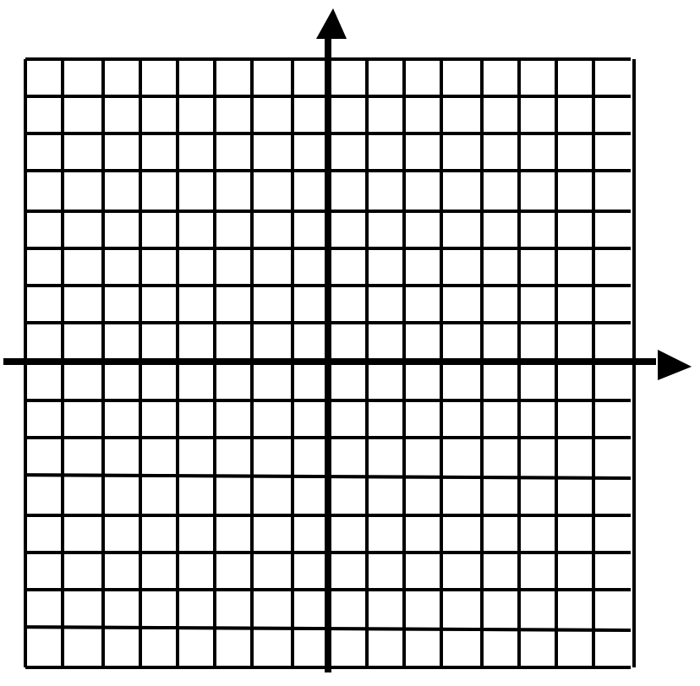b. Complete the table using your function rule. c. Graph the function on the grid below.

|  |  |  |
| --- | --- | --- |
| x | Computation (Work Space) | y |
| -2 |  |  |
| -1 |  |  |
| 0 |  |  |
| 1 |  |  |
| 2 |  |  |
| 3 |  |  |

d. Find the value of $f(x)$ when $x=-5$ e. Find the value of $x$ when $f\left(x\right)=-9$