1. **points each. You must show work/explain EVERY question, even the multiple choice questions.**

1.) Alina is comparing average rates of change of the four functions below. Which function has the *smallest*

average rate of change over the interval ? 1.)_________

   

|  |  |  |  |
| --- | --- | --- | --- |
| 1) | f(x) | 3) | h(x) |
| 2) | g(x) | 4) | j(x) |

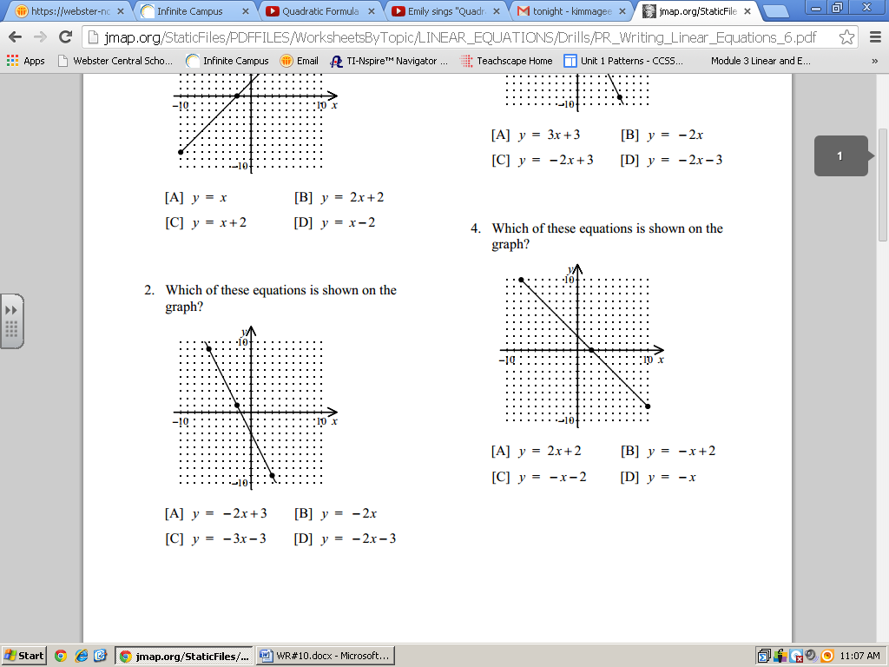 2.) What is the average rate of change shown on the graph to the right? 2.)_________

|  |  |  |  |
| --- | --- | --- | --- |
| 1) | $$2$$ | 3) |  |
| 2) | $$-1$$ | 4) | $$-2$$ |

3.) The volume of a cone can be calculated using the formula . Which expression can be used to represent the height, *h*?

|  |  |  |  |
| --- | --- | --- | --- |
| 1) |  | 3) |  |
| 2) |  | 4) |  |

3.)_________

4.) Nick and Gabby are comparing their scores on ten Algebra quizzes and determine that they both have the same mean score. They also discover that the standard deviation for Nick’s scores is 17.1, while the standard deviation for Gabby’s scores is 4.6. Which statement about the two sets of quiz scores *must* be true?

|  |  |  |  |
| --- | --- | --- | --- |
| 1) | The median of Gabby’s scores is lover than median of Nick’s scores. | 3) | Nick’s scores are more spread out than Gabby’s scores. |
| 2) | Nick’s scores are, on average, 12.5 points higher than Gabby’s scores. | 4) | Nick’s hishest score is greater than Gabby’s highest score. |

4.)__________

5.) What is the common difference of the arithmetic sequence ?

|  |  |  |  |
| --- | --- | --- | --- |
| 1) |  | 3) | 3 |
| 2) | -3 | 4) | 9 |

5.)_________

**Short Answer: [2] points each.**

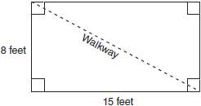 6.) Nancy’s rectangular garden is represented in the diagram below. 6.)_________

Find the length of the walkway.

**Short Answer: [3] points each.**

7.) What is the solution to $-29+8x=-5(1-4x)$? 7.)_________

Be sure to include an appropriate check.

**Short Answer: [5] points each.**

8.) Write the inequality that is represented by the graph below. Select 8.)_________

a point within the solution set to check using your inequality and prove

that it is a true solution.

