**Multiple Choice: [2] points each. You must show work/explain EVERY question for full credit.**

1.) What is the value of the expression  when  and ?

|  |  |  |  |
| --- | --- | --- | --- |
| 1) | 64 | 3) | -49 |
| 2) | 49 | 4) | -64 |

1.)_________

2.) What is the value of , if  and ?

|  |  |  |  |
| --- | --- | --- | --- |
| 1) |  | 3) | 2 |
| 2) | 10 | 4) | 14 |

2.)_________

3.) Which is the correct graph of the inequality $5x-1<3\left(x-2\right)$?

|  |  |  |  |
| --- | --- | --- | --- |
| 1) |  | 3) |  |
| 2) |  | 4) |  |

3.)_________

4.) Marcy determined that her father's age is four less than three times her age.

If *x* represents Marcy's age, which expression represents her father's age?

|  |  |  |  |
| --- | --- | --- | --- |
| 1) |  | 3) |  |
| 2) |  | 4) |  |

4.)_________

5.) If , then *x* equals

|  |  |  |  |
| --- | --- | --- | --- |
| 1) |  | 3) |  |
| 2) |  | 4) |  |

5.) _________

**Short Answer (2) points.**

6.) The formula for the volume of a cone is *.* The radius, *r*, of the cone may be expressed as

**Short Answer (3) points.**

7.) Given , determine the largest integer value of *a* when .

**Short Answer (5) points.**

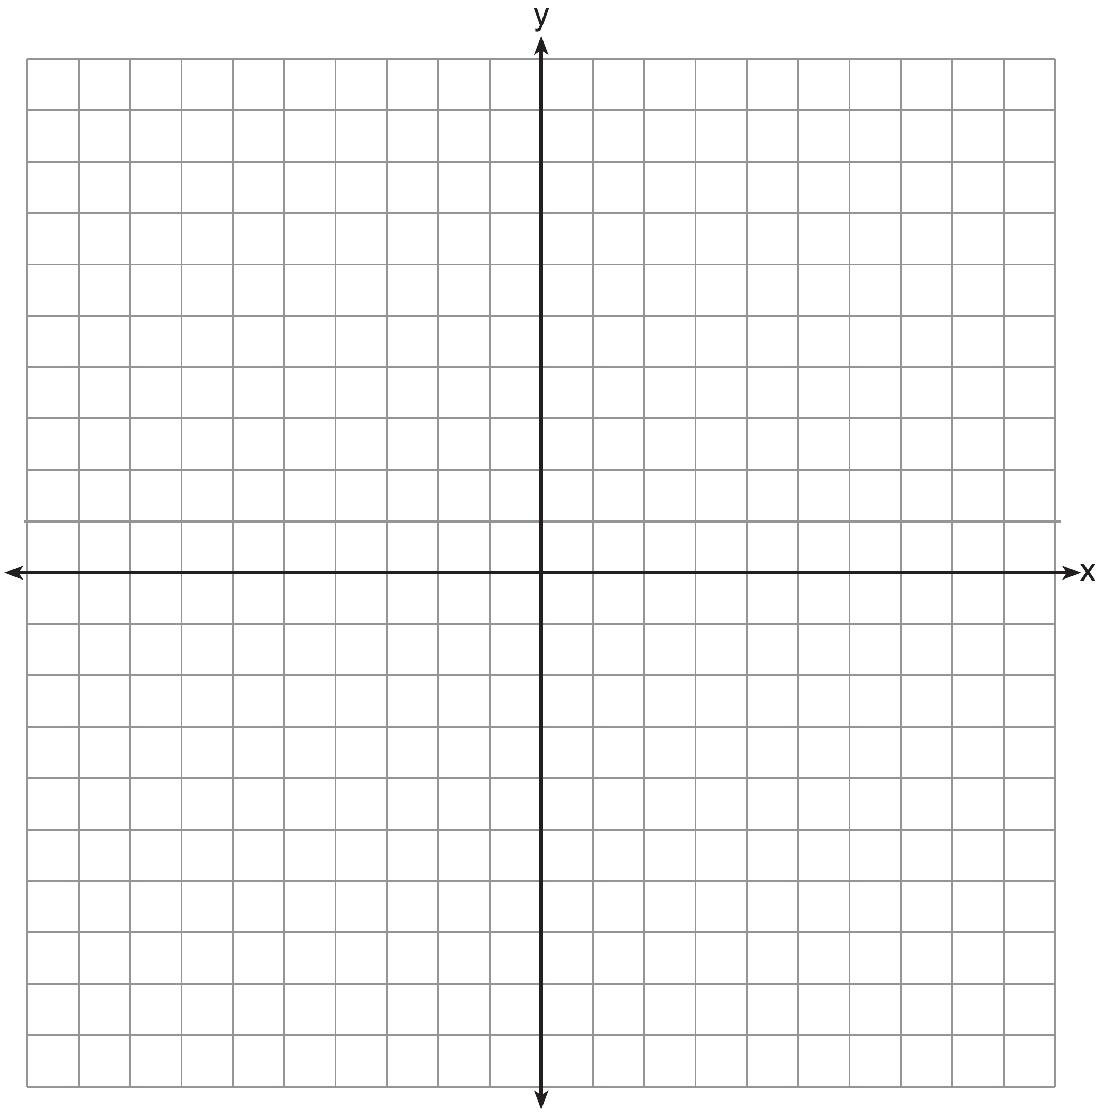8.) On the set of axes below, draw the graph of the equation .

|  |  |
| --- | --- |
| X | Y |
|  |  |
|  |  |
|  |  |
|  |  |
|  |  |

Is the point  a solution to the equation? Explain your answer based on the graph drawn.