Multiple Choice: [2] points each. You must show work/explain EVERY question for full credit.

1.) If x represents a given number, the expression "5 less than twice the given number" is written as

1) |  | 3)
2) |  | 4)
1.)_________
2.) If and , the value of y is
1) | 1 | 3) | -10
2) | 0 | 4) | 10
2.)_________
3.) What is the slope of the linear equation ?
1) | 10 | 3) | 2
2) | -10 | 4) | -15
3.)_________
4.) Which value of x is in the solution set of ?

1) | -3 | 3) | 0
2) | -1 | 4) | 3
4.)_________

5.) The accompanying graph shows the heart rate, in beats per minute,
of a jogger during a 4-minute interval. What is the range of the jogger's
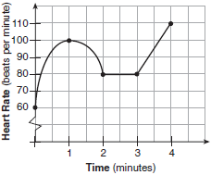
heart rate during this interval?

1) | [0,4] | 3) | [0,110]
2) | [1,4] | 4) | [60,110]
5.) _________

Short Answer (2) points.
6.) Solve the inequality for x: $-31≤5+9x<77$

Short Answer (3) points.
7.) a) Solve the inequality algebraically for x.

b) Write your answer in interval notation: __________

Short Answer (5) points.
8.) Lea just emptied her piggy bank and found that she had $2.85 in nickels and dimes. If the number of nickels is 1 more than twice the number of dimes, how many nickels did she have in her piggy bank? You must show all your work!! (VEWAC)

