Multiple Choice: [2] points each. You must show work/explain EVERY question for full credit.

1.) Which relation is a function? (Don’t forget to explain why!)
1) |  | 3)
2) |  | 4)
1.)_________
2.) Which statement is not always true? (Don’t forget to explain why!)
1) | The product of two rational numbers is rational | 3) | The product of two irrational numbers is irrational
2) | The sum of two rational numbers is rational | 4) | The sum of a rational number and an irrational number is irrational
2.)_________
3.) Which equation represents a linear function? (Don’t forget to explain why!)

1) |  | 3)
2) |  | 4)
3.)_________
4.) What is an equation of the line that passes through the point and has a slope of ?

1) |  | 3)
2) |  | 4)
4.)_________
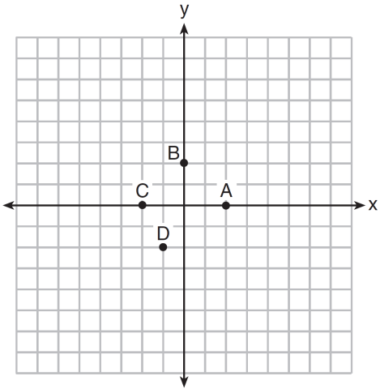
5.) The graph of is shown below. Evaluate f(-1).

1) | A | 3) | B
2) | C | 4) | D
5.) _________

Short Answer (2) points.
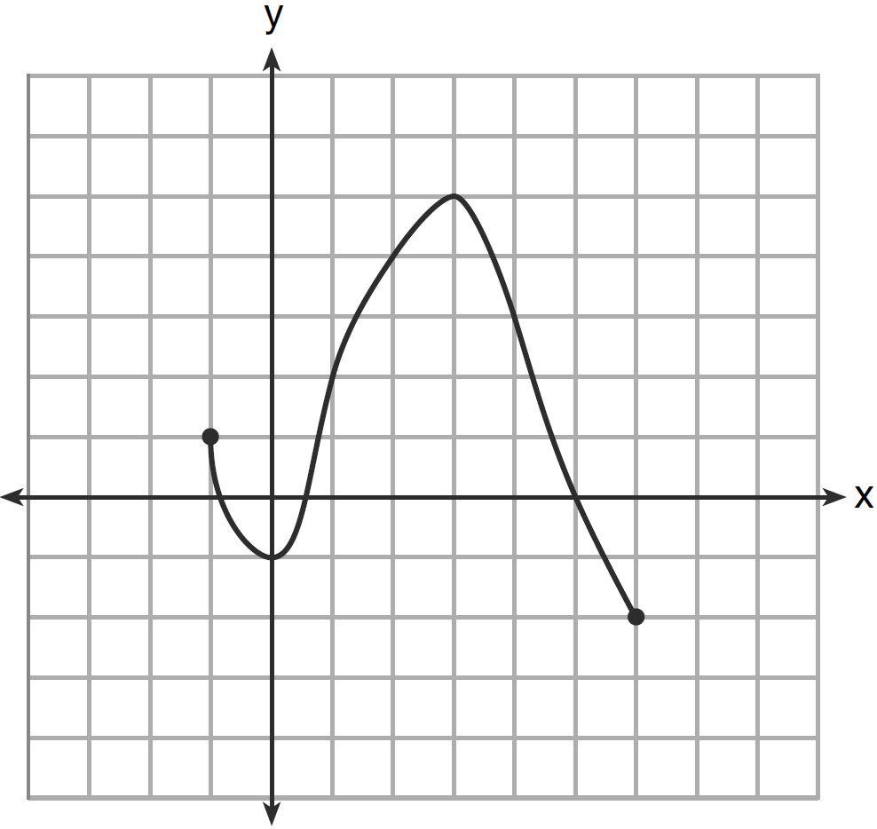
6.) Using the function below, determine the domain and range in interval notation.

Domain: _____________ Range: _________________

Short Answer (3) points.
7.) Solve algebraically for x and CHECK: $\frac{2}{3}=\frac{5}{m-3}$

Short Answer (5) points.
8.) Graph the solution set for the inequality on the set of axes below.
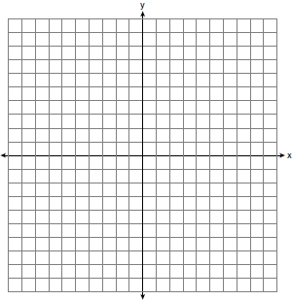

b) Determine if the point is in the solution set. Justify your answer.

