Multiple Choice: [2] points each. You must show work/explain EVERY question for full credit.

1.) Robin spent $17 at an amusement park for admission and rides. If she paid $5 for admission, and rides cost $3 each, what is the total number of rides that she went on?
1) | 12 | 3) | 9
2) | 2 | 4) | 4
1.)_________
2.) Given the piecewise equation $\left(x\right)=\left\{\begin{aligned}x-3, &x≤1 \\ 2x, &x>1\end{aligned}\right.$ , determine f(-2).
1) | 6 | 3) | -4
2) | -5 | 4) | -1
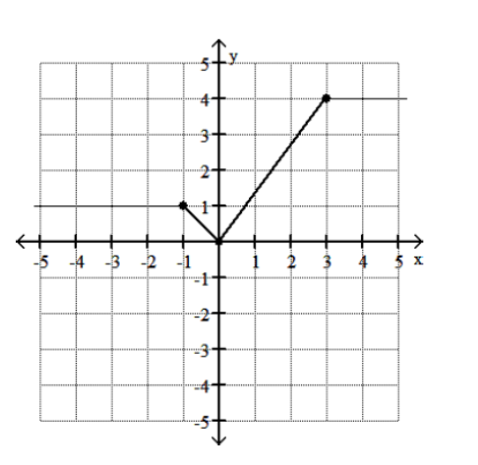2.)_________
3.) Determine the domain of the function.

1) | $$(-∞, ∞)$$ | 3) | $$[0, 4]$$
2) | $$[-∞, ∞]$$ | 4) | $$[-1, 3]$$
3.)_________
4.) Cindy has four more than twice as many CDs as Nina. If they have a total of 31 CDs, how many CDs does Nina have?

1) | 9 | 3) | 14
2) | 13 | 4) | 22
4.)_________
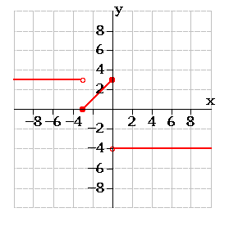
5.) Name the piecewise function to the right:

1) | $$f\left(x\right)\left\{\begin{aligned}\begin{aligned}-3, &x≤-3 \\ -x+3, &-3<x≤0\end{aligned} \\ 4, x>0 \end{aligned}\right.$$ | 3) | $$f\left(x\right)\left\{\begin{aligned}\begin{aligned} -3, &x<-3 \\ x+3, &-3≤x≤0\end{aligned} \\ -4, x>3 \end{aligned}\right.$$
2) | $$f\left(x\right)\left\{\begin{aligned}\begin{aligned} 3, &x<0 \\ x+3, &-3≤x≤0\end{aligned} \\ -4, x>3 \end{aligned}\right.$$ | 4) | $$f\left(x\right)\left\{\begin{aligned}\begin{aligned} 3, &x≤-3 \\ -x-3, &-3<x<0\end{aligned} \\ -4, x≥0 \end{aligned}\right.$$
5.) _________
Short Answer (2) points.
6.) If , then solve for w, in terms of x and y.
.

Short Answer (3) points.
7.) Solve for k AND check :

Short Answer (5) points.
8.) Graph the function.
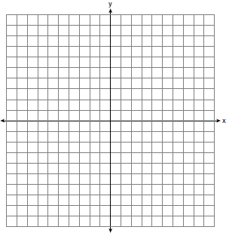
$f\left(x\right)=\left\{\begin{aligned}-2x-5, -5≤ &x≤-1 \\ -5, -1<x≤2 \\ -\frac{1}{2}x+1 x>2\end{aligned}\right.$

b) State the domain of the function, in interval notation.

c) State the range of the function, in interval notation.

