You must show work/explain EVERY question, even the multiple choice questions.
Multiple Choice: [2] points each.

1. The accompanying histogram shows the heights of the students in Kyra’s health class.
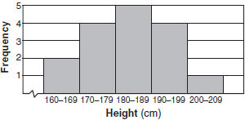
What is the total number of students in the class?

1) | 5 | 3) | 16
2) | 15 | 4) | 209
1.)_________

2.) Which statement is true about the data set 3, 4, 5, 6, 7, 7, 10?
1) | mean = mode | 3) | mean = median
2) | mean > mode | 4) | mean < median
2.)_________
3.) What is the value of the y-coordinate of the solution to the system of equations and ?
1) | 6 | 3) | 3
2) | 2 | 4) | 5
3.)_________

4.) In a linear equation, the independent variable increases at a constant rate while
the dependent variable decreases at a constant rate. The slope of this line is

1) | zero | 3) | positive
2) | negative | 4) | undefined
4.)_________
5.) If , then equals
1) | -36 | 3) | -6
2) | 6 | 4) | 18  5.)_________

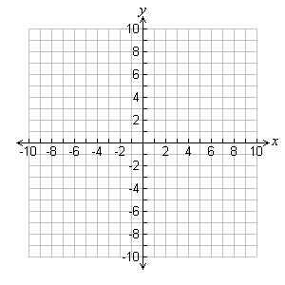
Short Answer: [5] points each.
1.) Find the solution(s) to the equation $x+3=x^{2}-x$

f(x)= g(x)=

x | y

x | y

State the solution(s) to the equation: ___________________

2.) Twenty-five people were attending an event. The ages of the people are indicated below:
3, 3, 4, 4, 4, 4, 5, 6, 6, 6, 6, 6, 6, 6, 7, 7, 7, 7, 7, 7, 16, 17, 22, 22, 25
  - Create a histogram of the ages using the provided axes.

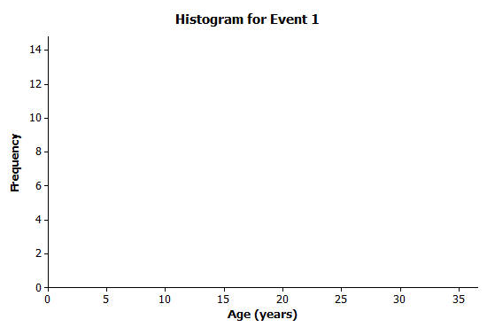
0 -

30 - 34
25 - 29
20 - 24
15 - 19
10 - 14
5 - 9
0 - 4
Age (years)
  - Would you describe your graph as symmetrical or skewed? Explain your choice.

c. Identify a typical age of the twenty-five people who were attending the event.

