**You must show work/explain EVERY question, even the multiple choice questions.**

**Multiple Choice: [2] points each.**

1. The end of a dog's leash is attached to the top of a 5-foot-tall fence post, as shown in the diagram below.

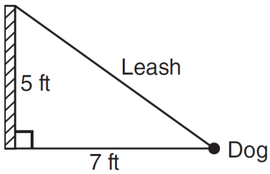 The dog is 7 feet away from the base of the fence post. How long is the leash?

|  |  |  |  |
| --- | --- | --- | --- |
| 1) | 4.9 | 3) | 9.0 |
| 2) | 8.6 | 4) | 12.0 |

1.)________

2.) What is the value of *x* in the equation $13x- 2(x+4) = 8x + 1$?

|  |  |  |  |
| --- | --- | --- | --- |
| 1) | 1 | 3) | 3 |
| 2) | 2 | 4) | 4 |

2.)_________

3.) Below are data sets measuring the temperature at 4 different cities on a random week in January. Which data set has the most diversity in temperature? Show any necessary calculations.

|  |  |  |  |
| --- | --- | --- | --- |
| 1) |  | 3) |  |
| 2) |  | 4) | 3.)_________ |

4.) Which situation is an example of **bivariate** data?

|  |  |  |  |
| --- | --- | --- | --- |
| 1) | The number of pizzas Tanya eats during her years in high school | 3) | The number of home runs Elias hits per game and the number of hours he practices baseball |
| 2) | The number of times Ezra puts air in his bicycle tires during the summer | 4) | The number of hours Nellie studies for her mathematics tests during the first half of the school year  4.)_________ |

5.) Which of the following points does not lie on the graph of ?

|  |  |  |  |
| --- | --- | --- | --- |
| 1) |  | 3) |  |
| 2) |  | 4) | 5.)_________ |

**Short Answer: [5] points each.**

6.) Guy and Jim work at a furniture store. Guy is paid $185 per week plus 3% of his total sales in dollars, *x*, which can be represented by Jim is paid $275 per week plus 2.5% of his total sales in dollars, *x*, which can be represented by  Determine the value of , in dollars, that well make their weekly pay the same.

6.) ___________________

7.) On the set of axes below, solve the following system of inequalities graphically.



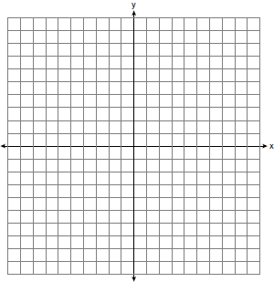

7.) State the coordinates of a point that is not in **either** solution set. ___________