Unit 2 – What’s My Function? - Algebra Review Sheet
Function Notation
- $f(x)$ replaces y
- $f(x)$ is the name of the function
- Use substitution to evaluate a function
- $x$ is the input; $f(x)$ is the output

Relations and Functions
Relation – a set of input and output values listed in ordered pairs
- Describes a relationship between two different sets of information

Function – a relation in which each element of the domain has one and only one element of the range associated with it
- For each $x$ there is one and only one $y$
- For each input there is one and only one output

Domain and Range
The domain is the set of the first elements in the ordered pairs
- Input
- $x$-value
- Independent variable
The range is the set of the second elements in the ordered pairs
- Output
- $y$-value
- Dependent variable
- $f(x)$
Vertical Line Test
If any vertical line can be drawn through the graph and pass through more than one point, then your graph is NOT a function.

If any vertical line can be drawn through the graph and pass through only one or no points, then your graph IS a function.

Ordered Pair (point)
two numbers written in a specific order that show the relationship between two different sets of information
- On a graph, an ordered pair shows the position on a graph
- First number $(x)$ is the horizontal coordinate $+ →, - ←$
- Second number $\left(y\right)$ is the vertical coordinate $+ ↑, - ↓$

During this unit, we looked at three different ways to model functions: tables, mapping diagrams, and graphs. All three are displayed below for the function $f\left(x\right)=2x+1$ with a domain of $\{1,2,3,4\}$
Table | Mapping Diagram | Graph
Tables are always set up with the same three columns. Domain goes on the left and range goes on the right.  $$x$$ The rule $$f(x)$$  $$x$$ $$f\left(x\right)=2x+1$$ $$f(x)$$  $$1$$ $$f\left(1\right)=2\left(1\right)+1$$ $$3$$  $$2$$ $$f\left(2\right)=2\left(2\right)+1$$ $$5$$  $$3$$ $$f\left(3\right)=2\left(3\right)+1$$ $$7$$  $$4$$ $$f\left(4\right)=2\left(4\right)+1$$ $$9$$ | Mapping diagrams are used to show the relationship between the domain and range. Domain is listed in one box and range is listed in the other. Arrows are drawn to connect each domain to its range.  Domain Range  $$1$$  $$2$$  $$3$$  $$4$$  $$3$$  $$5$$  $$7$$  $$9$$ | Ordered pairs are plotted on the coordinate plane. The first number gives us the horizontal coordinate and the second number gives the vertical coordinate.  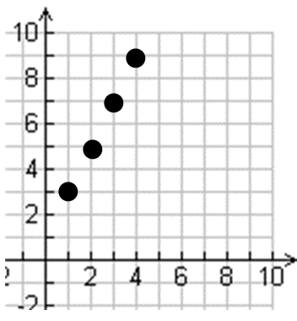
Translating Functions
g(x) = f(x) + h
- Adding a value OUTSIDE the function slides the function UP k units
g(x) = f(x) – h
- Subtracting a value OUTSIDE the function slides the function DOWN k units
g(x) = f(x + k)
- Adding a value INSIDE the function slides the function LEFT k units
g(x) = f(x – k)
- Subtracting a value INSIDE the function slides the function RIGHT k units
g(x) = af(x) when $a>1$
- When a is larger than 1, the graph becomes THINNER
g(x) = af(x) when $0<a<1$
- When a is between 0 and 1, the graph becomes WIDER
g(x) = -f(x)
- A negative in front of the function reflects the function over the X-AXIS
Parent Functions
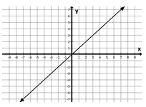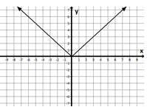
$$f\left(x\right)= x f\left(x\right)= \left|x\right|$$
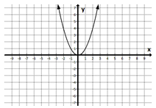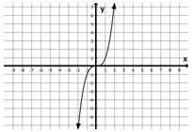
$$f\left(x\right)= x^{2} f\left(x\right)= x^{3}$$
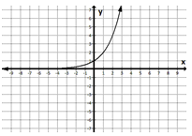
$$f\left(x\right)= 2^{x}$$
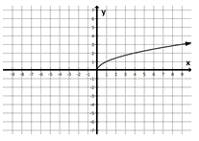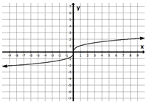
$$f\left(x\right)= \sqrt{x} f\left(x\right)= \sqrt[3]{x}$$

Great Things to Study
Graded warm-up, functions quiz, Part 1: pages 7, 9, 22, 31, 32
Part 2: pages 2, 3, 5, 10
Describing Graphs of Functions Vocabulary
maximum – the highest POINT on a graph
minimum – the lowest POINT on a graph
domain – the set of all of x-values (LEFT to RIGHT on a graph)
range – the set of all of y-values (DOWN to UP on a graph)
increasing – the INTERVAL where the x-values have a positive slope
decreasing – the INTERVAL where the x-values have a negative slope
turning point – where a graph changes slopes
$x$-intercept – the point where the graph crosses the $x$-axis
$y$-intercept – the point where the graph crosses the $y$-axis
zeros –the $x$-coordinate of the $x$-intercept
linear – a graph that makes a straight line
non-linear – a graph that does not make a straight line
axis of symmetry – The two sides of a graph on either side of the axis of symmetry look like mirror images of each other.
slope/rate of change – change in y-values divided by the change in x-values
end behavior – how a graph begins or ends (EX: as x increases, y decreases)
asymptote: a line that a graph approaches but will never touch

What are they asking for?!?
Remember: $f\left(x\right)$ is really $y$!!!!!!
EX:
Given the function $f\left(x\right)=2x+1$ find:
$f\left(3\right)$
What this means... FIND y
(or $f\left(x\right)$) when x = 3
So… $f\left(3\right)=2\left(3\right)+1=6+1=7$
This could also be written as: find the RANGE when the DOMIAN is 3

$x when f\left(x\right)=5$
What this means… FIND x when y = 5
So… $5=2x+1$ $4=2x$ $2=x$
This could also be written as: find the DOMAIN when the RANGE is 5

