Algebra 1 Name ___________________________________________________________________
Regents Review #14 Period _______
1. Determine the average rate of change for the three functions below over the interval $-2≤x≤2$.

$f\left(x\right)$ $g(x)$ $h(x)$
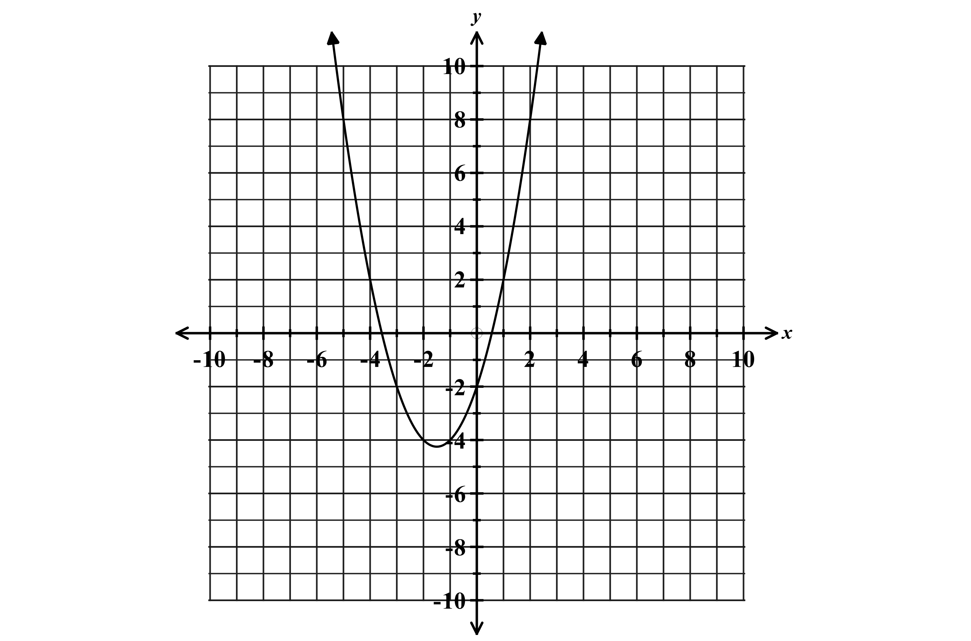
$h\left(x\right)=4{(2)}^{x}$

$f\left(x\right)$A.R.O.C = _____________ $g(x)$ A.R.O.C = _____________ $h\left(x\right)$A.R.O.C = _____________

$$x$$ | $$y$$
-2 | -7
-1 | -3
0 | 1
1 | 5
2 | 9

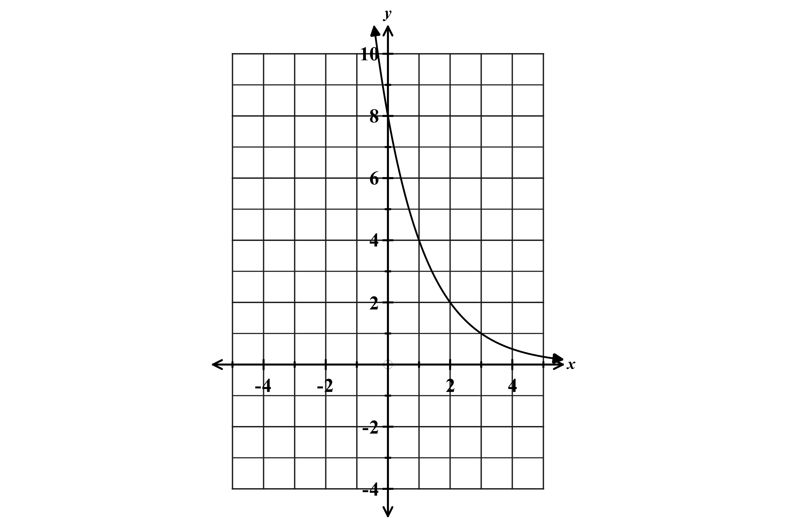  2. Write the exponential equation for the graph shown below.  Equation _________________________________________ | 3. Perform the indicated polynomial operation.  A. Let A = $-2x^{2}-3x+5$ and $B=2-4x+3x^{2}$  Express $A-B$ in standard form.  B. Let $f\left(x\right)=3x^{2}y$ and $g\left(x\right)=2x^{3}y-4x$  Find $f(x)∙g(x)$

4. Express each in standard form.  A. ${(4x-3)}^{2}$  B. $(4x-3)(2+5x)$ | 5. Perform the indicated polynomial operation.  A. Express the product of $2x^{2}-3x+5$ and $x-4$ in standard form.  B. Subtract $-3x^{2}-5x+4$ from $-x^{2}+2x-5$
6. Express each in standard form  A. $(x+3){(x-4)}^{2}$  B. $(x+2)(x-2)(x+1)(x-1)$ | 7. Write an equation that defines $f(x)$ as a trinomial where…  $$f\left(x\right)=\left(4x+3\right)\left(2-x\right)-(2x^{2}-3x+5)$$  Find $f(-2)$

8. Mark wants to purchase a combination of at least 16 turkey subs or roast beef subs for a party. Each turkey sub, $x$, is priced at $5 and each roast beef sub, $y$, is priced at $4. Mark has at most $80 to spend on the subs.

A. Write a system of inequalities that can be used to model this situation.

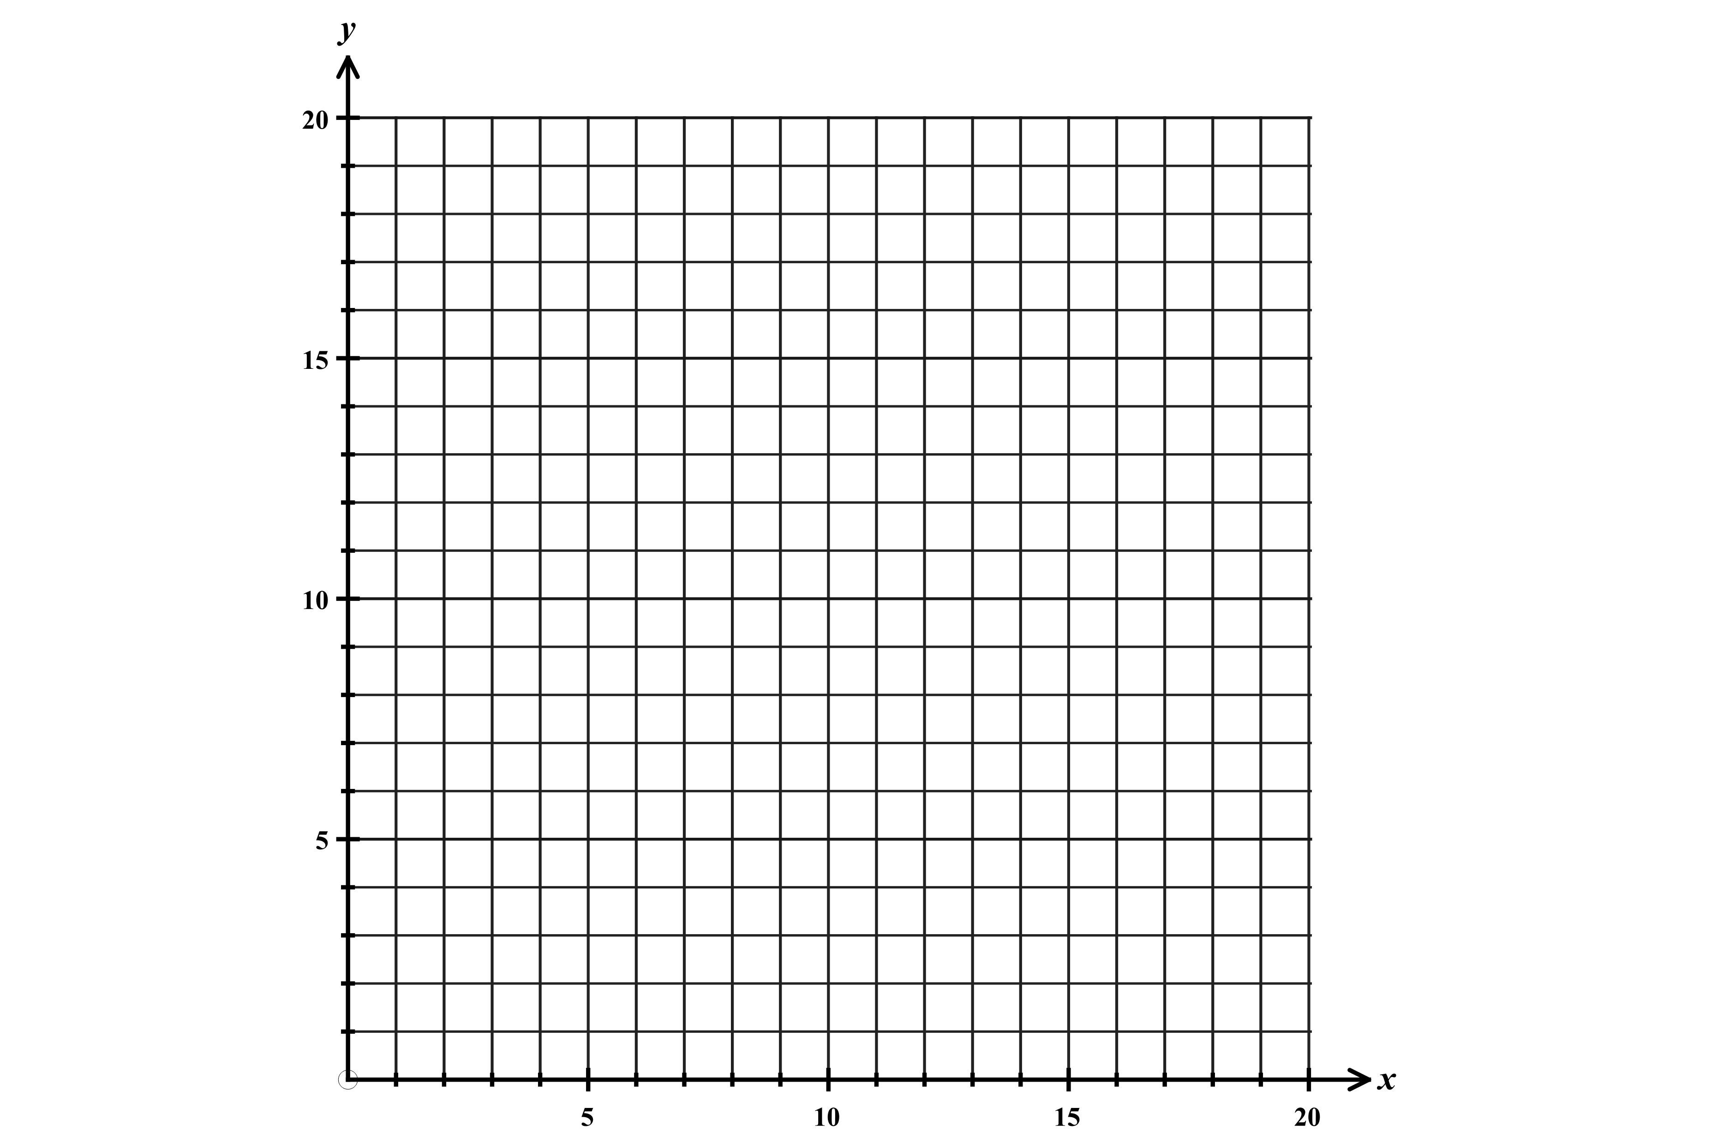
B. Graph the inequalities on the axes provided.

C. Name one combination of subs that will allow Mark to stay within his budget.

Turkey subs ___________ Roast beef subs__________

D. Using the combination of hours you chose for part C, how much would Mark spend?

9. When doctors prescribe medicine, they must consider how much the drug’s effectiveness will decrease as time passes. If each hour a drug is 20% less effective as the previous hour, at some point the patient will not be receiving enough medicine and must be given another dose.

A. Will this relationship show exponential growth or decay? Explain your reasoning.

B. A patient was given an initial dose of 200 mg of medication. Write an equation that shows the relationship between the amount of medication remaining in the patient’s bloodstream, $y,$ and the time in hours, $x$, since the medication was administered.

________________________________________________________

C. Draw a graph of the function over the first 12 hours after the initial dosage. Be sure to scale and label your axes appropriately and include a title.

D. When the level of medication falls below 50mg, the patient will need a new dose. After what number of hours does the level of medication fall below 50mg? Justify your answer.

