Name: ________________________________________

Equation: slope-intercept vs. standard form
$y=mx+b$ $Ax+By=C$

$(a) Determine the slope and y-intercept of the equation$
$4x-3y=6$.

Linear
Functions

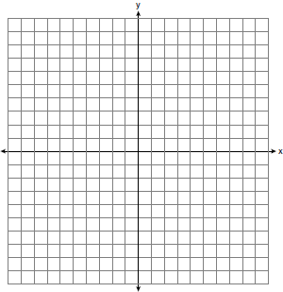
Graph:

Write the equations for each line shown in the graph above.
(a) (c)
(b) (d)
Period: _______
Table:
Write the equations of the linear functions represented in the tables below:
x | y
- (b)
x | y

Words:
- Joan has 5 more quarters than nickels. If she has a total of $3.35, how many total coins does Joan have?

(b) Ryan has 24 coins in his pocket which is made up of only nickels and dimes. If he has $1.50 in his pocket, how many nickels, n, does Ryan have?

Equation: standard form
$f(x)=ax^{b}$

Exponential
Functions

Graph:

Write the equation for the function shown in the graph above.

Table:
Write the equations of the exponential functions represented in the tables below:
x | y
- (b)
x | y

Words:
(a) The current population of a town is 10,000. If the population, P, increases by 20% each year, write an equation that could be used to find the population after t years?

(b) A car depreciates (loses value) at a rate of 4.5% annually. Greg purchased a car for $12,500. Write an equation that can be used to determine the value of the car, V, after 5 years?

(c) If the car depreciated at $300 per year, would it still be an exponential function? Write an equation that could be used to determine the value of the car, V, after y years.

