images-2Are you ready for some FOOTBALL?

Matt and Kyle are playing catch with a football, while a football scout/mathematician is watching them. Matt knows that by varying the angle of release, and the force behind his throw, he can chose to throw the ball a shorter or longer distance. After several throws back & forth, the scout/mathematician notes that Matt has thrown the football so that it follows the following equations:

$$y1= -x^{2}+4.5x$$

$$y2=-\frac{2}{3}x^{2}+2x$$

$$y3=-\frac{1}{12}x^{2}+\frac{1}{3}x$$

$y4=-0.38x^{2}+1.07x$

$$y5=-\frac{1}{3}x^{2}+\frac{4}{3}x$$

In this case, **x represents the air time**, or how long since the ball was thrown, and **y represents the vertical height of the ball**. For the sake of simplicity, we assume that the point at which Matt releases the ball is the origin ( at time = 0, the height = 0).

Use your graphing calculator to graph each throw below.

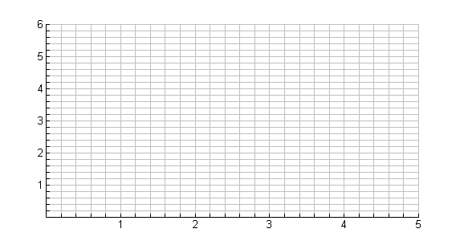

**Height**

In ft from

point of release

**Time**

In seconds





**Height**

In ft from

point of release

**Time**

In seconds





$$y3=-\frac{1}{12}x^{2}+\frac{1}{3}x$$

**Height**

In ft from

point of release

**Time**

In seconds





$y4=-.38x^{2}+1.07x$

**Height**

In ft from

point of release

**Time**

In seconds





$$y5=-\frac{1}{3}x^{2}+\frac{4}{3}x$$

**Height**

In ft from

point of release

**Time**

In seconds



(For each of the following, refer to the equations y1 – y5 that you graphed above.)

1. Which of Matt’s throws stayed in the air the longest?

Approximately how long did the ball fly through the air?

(Assume that Kyle catches the ball at the same height that Matt releases the ball.)

2. Which of Matt’s throws went the highest?

If Matt released the ball at a height of 6 feet, approximately how

high did it actually go?

The graph we’ve made is parabolic, so we can use a quadratic equation to model the height of the ball based on time. Standard form of a quadratic equation is **y = ax2 + bx +c.**

**Use your graphing calculator** to find the equation that models the time and height of each football below.



**Height**

In ft from

point of release

**Time**

In seconds



A

 (0.5, 1.3) (1.0, 2.2) (1.5, 2.7) (2, 2.8) (2.5, 2.5) (3, 1.8)



**Height**

In ft from

point of release

**Time**

In seconds



B

(1, 1.60) (1.2, 1.80) (1.4, 1.96) (2, 2.20) (2.4, 2.16) (2.6, 2.08)



**Height**

In ft from

point of release

**Time**

In seconds



C

(0.6, 0.81) (0.8, 0.96) (1.0, 1.05) (1.6, 0.96) (1.8, 0.81) (2.0, 0.60)

Looking at the graphs, you may notice that the graphs are symmetric.

**Parabolas are ALWAYS symmetric.**

By looking at the standard form of a quadratic equation, y = ax2 + bx + c, we can determine many things about the flight of the ball.

For starters, how long will the ball be in the air? Let’s look at a specific example

$$y=-x^{2}+2.4x$$

**Height**

In ft from

point of release

**Time**

In seconds



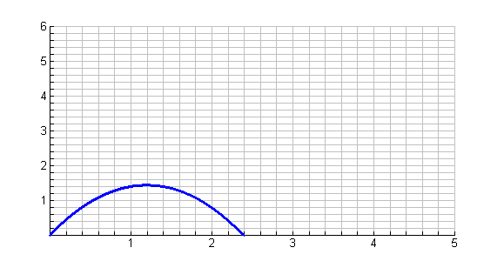

The x axis has been moved up so that we start with a height of zero, and are looking for when the height of the ball will again be zero (as it is coming down). Remember that we made the assumption that Kyle will catch the ball at the same height as it was released. Since x represents the time since the ball was thrown, we are looking for the x values that correspond to a height (y value) of zero.

... or starting with **y = ax2 + bx +c**

we are looking for x when **0 = ax2 + bx +c** 0

This quadratic equation can be solved with any of the techniques that you have previously learned. A quick and easy solution can be found using the quadratic formula:

This formula gives us **two values**

$$x=\frac{-b±\sqrt{b^{2}-4ac}}{2a}$$

for places where the parabola

**crosses the x axis**.

$$x=\frac{-b±\sqrt{b^{2}-4ac}}{2a}$$

When we use this formula, we are finding the X-INTERCEPTS of the graph. Another name for the X-INTERCEPTS is the ROOTS or ZEROS of the function.

Let’s verify that this is true for graphs y1 & y2 above.

$$y1= -x^{2}+4.5x$$

$$y2=-\frac{2}{3}x^{2}+2x$$

Show that it also works for the equations that you found for A, B & C.

A

B

C

You’ll notice that the highest point is where the ball has reached its MAXIMUM height. This is why it is called the MAXIMUM VALUE of the graph. This MAXIMUM VALUE is also called the TURNING POINT of the graph since it is the point where the changes from increasing height to decreasing height.

Sometimes, parabolas open up. In that case the

TURNING POINT would be called a MINIMUM VALUE.

To find the TURNING POINT of any parabola, we can look at the symmetry of the graph to see that it is always located in the middle between the two roots. Adding the two roots together and dividing by two, we see that we get x = -b/2a. This is a LINE that can be graphed to show that it is right down the middle of the parabola.

The equation $x= \frac{-b}{2a}$ is known as the AXIS OF SYMMETRY.

Verify that this is true for y1 and y2.

$$y1= -x^{2}+4.5x$$

$$y2=-\frac{2}{3}x^{2}+2x$$

So now, we know where the highest point will be on the graph. To find the actual height all we have to do is plug the value of x we found above (when the ball was at its highest point), into the original equation. Try this for y1 and y2 above.

$$y1= -x^{2}+4.5x$$

$$y2=-\frac{2}{3}x^{2}+2x$$

Using this idea, find the TURNING POINT for the equations you found for graphs

A, B & C. Do your calculations match your graphs?

A

B

C

Let’s try to put this all together...

Kyle throws the ball to Matt, as shown below. Use your graphing calculator to **find the equation** that models the height of the ball as it is thrown.

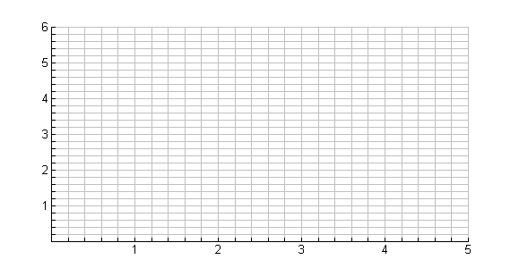

**Height**

In ft from

point of release

**Time**

In seconds



(0, 0) (1, 1.1) (2, 1.6) (3, 1.5) (4, 0.8)

Find the roots of this equation.

Find the axis of symmetry.

Find the turning point.

Do your answers appear to be accurate, based on your graph?

For Kyle’s second throw, the football scout/mathematician finds the equation of the graph to be:

$$y=-0.9x^{2}+3.42x$$

Graph this equation.



**Height**

In ft from

point of release

**Time**

In seconds



Find the roots of this equation, to find out how long the ball was in the air.

Find the axis of symmetry.

Find the turning point, to determine the maximum height of the ball.

Do your answers appear to be accurate, based on your graph?

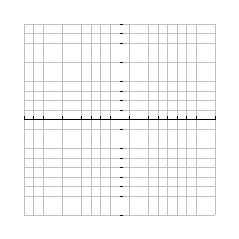For each equation given, graph the parabola. State the roots of the equation, the axis of symmetry and the turning point.



$y= -4x^{2}+x+3$

Roots:

Axis of symmetry:

Turning point:

Max/ Min ?





$y=x^{2}-2x-3$

Roots:

Axis of symmetry:

Turning point:

Max/ Min ?





$y=x^{2}+4x-5$

Roots:

Axis of symmetry:

Turning point:

Max/ Min ?