**PARABOLAS! (in action)**

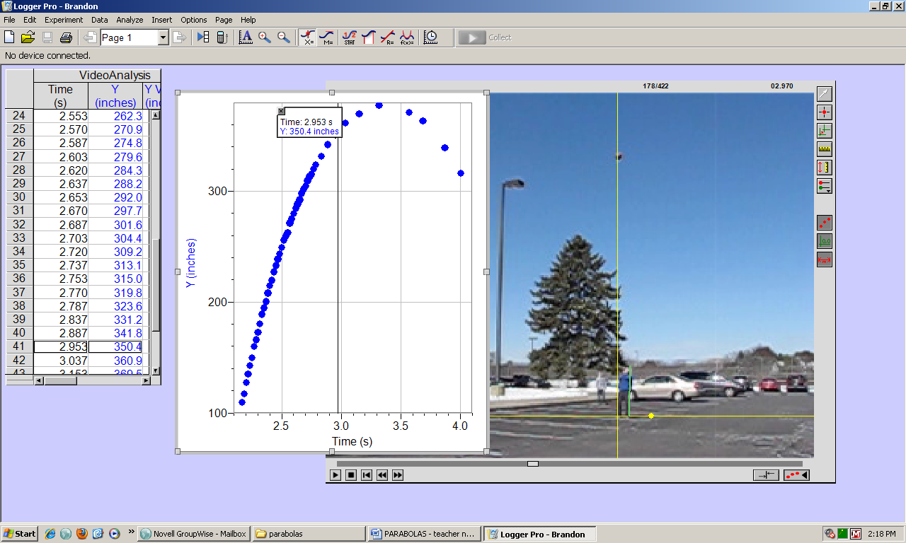

**Teacher Notes:** I asked 3 students to come out to the parking lot and toss a ball up into the air. The “goal” of the activity was to determine which ball went up the highest when tossed into the air. (The students were intentionally not told what exactly we were doing until after the recordings were made.)

Using a digital camera, record a student tossing a ball up into the air. Be sure to capture the full height of the student, the release, the full height of the ball thrown, and the ball bouncing off the ground. Transfer this recording from your camera to your desktop.

Open LoggerPro to analyze the data. Click on the top line menu – Insert – and select Movie… Enlarge the picture so that it takes up most of the visible area on the screen.

Below the picture, click on the button that has three red dots and an arrow – this will allow you to see additional buttons.

Click on the third button down on the right to set the origin. I set the origin at the foot of the student. (This will make the comparison later look very nice!)

Click on the fourth button down on the right to set up the scale. I clicked on the bottom of the student’s foot, and then just at the top of their head – to set up the scale. I then asked the student for their height, and entered the height in inches.

Now the fun part…. Using the scroll bar below the picture – find a frame where the ball has left the student’s hand. Click on the second button down on the right to ADD POINT. I then asked a student to come up and “chase” the ball with the cursor. Simply click on the center of the ball, and the software will record the details. Each time you click, the recording moves forward. In this way, a student sitting at the computer can “chase” the ball by clicking on it over and over again. If you wish to skip around, you can use the scroll bar at the bottom. You can use as many points as you would like. (If you take lots of points, the analysis at the end looks better.)

On the window with the data, I clicked on the “X” column and hit delete. This moved the “Y” column next to the Time column to make it much easier to read. In this case the x axis will be time, and the y axis will be the height. I selected a few points and wrote them on the worksheet (attached). We used 8 points, and did not use any points near the top, but we did use two points that were on the way down.

Students used their calculators to enter the points under STAT 1: Edit. Together we set up the window. For this particular exercise, XMIN: 0, XMAX: 5, XScl: 0.5, YMIN:0, YMAX: 500, YScl:100 Then we graphed the points by hitting 2nd , Y= , 1: to turn ON the first plot.

Once this was done, we used the calculator to create an equation to model the height based on time. STAT, right arrow once to the CALC MENU, 5: QuadReg ENTER. This gave us the equation. Be sure to have students WRITE the equation on their paper. (At this point, several students realized that they had made typing errors because their numbers did not match mine. I took a few moments to “proof” the list of points that they had entered.)

We entered the equation under Y1= , and graphed it. (Many students were impressed that it went right through the points.) Then we turned the points off by hitting 2nd, Y= , 4: PlotsOff, ENTER. Hit Graph again to be sure that all students are now looking at just the parabola.

Using 2nd, TRACE get to the CALC MENU. Hit 4 to find the maximum. Have all students write down the turning point of the parabola. Discuss the meaning of this turning point. This represents the highest point on the graph! Lastly, have the students write down what the maximum height of the ball was – first in inches, then convert to feet.

Done. ☺

Students have now seen a

REASON to create an equation,

and find the turning point!

…and they *want* to complete

the second example!!!!

I then played around with the windows and showed the students the graph, created by LoggerPro, of height based on time – side by side with the recording, and the data points. (I thought this was cool!)

Click on the top line menu ANALYZE then REPLAY to watch the movie & the blue dots on the graph happen at the same time. Then you can click on EXAMINE to show any point on the graph and where it is on the movie. (…very cool)

We then compared the different tosses, and laughed about the reasons each may/may not have gone up as high.

NAME:

TRIAL #



Data

|  |  |
| --- | --- |
| TIME (X) | HEIGHT (Y) |
|  |  |
|  |  |
|  |  |
|  |  |
|  |  |
|  |  |
|  |  |
|  |  |
|  |  |
|  |  |
|  |  |

Enter this list of points into your calculator by hitting STAT 1: EDIT

The TIME values should be listed under L1, and HEIGHT under L2.

Enter the points for this trial.

By hitting STAT Calc 5: QuadReg,

find the quadratic equation, or model, for this set of data.

On the graph paper shown, graph this equation.

Find the turning point.

What is the maximum height of the ball in this trial?