Algebra 1 Functions and Graphing Summary
There are six types of functions we have studied this year, each with it’s own unique characteristics.
- What the equation “looks” like.
- How the range values in the table change as the domain values increase.
- What the graph looks like and the behavior of the graph.
- Over what $x$ intervals is the function increasing, decreasing or staying constant?
- Where the value of the function is positive or negative $f\left(x\right)>0$ vs. $f\left(x\right)<0$. (above $x-axis$ vs. below $x-axis$)
- Domain and range of the function (Non- restricted vs. restricted domains.)

Function 1: Linear Function

Parent Function $y=x$
General equation $y=mx+b,$where $m$ is the slope or the average rate of change
The average rate of change is constant (Can be positive, negative, or zero)

Graph of $y=x$ Graphs in the form $y=mx+b$ where $m$ is the slope and $b$ is the y-intercept.
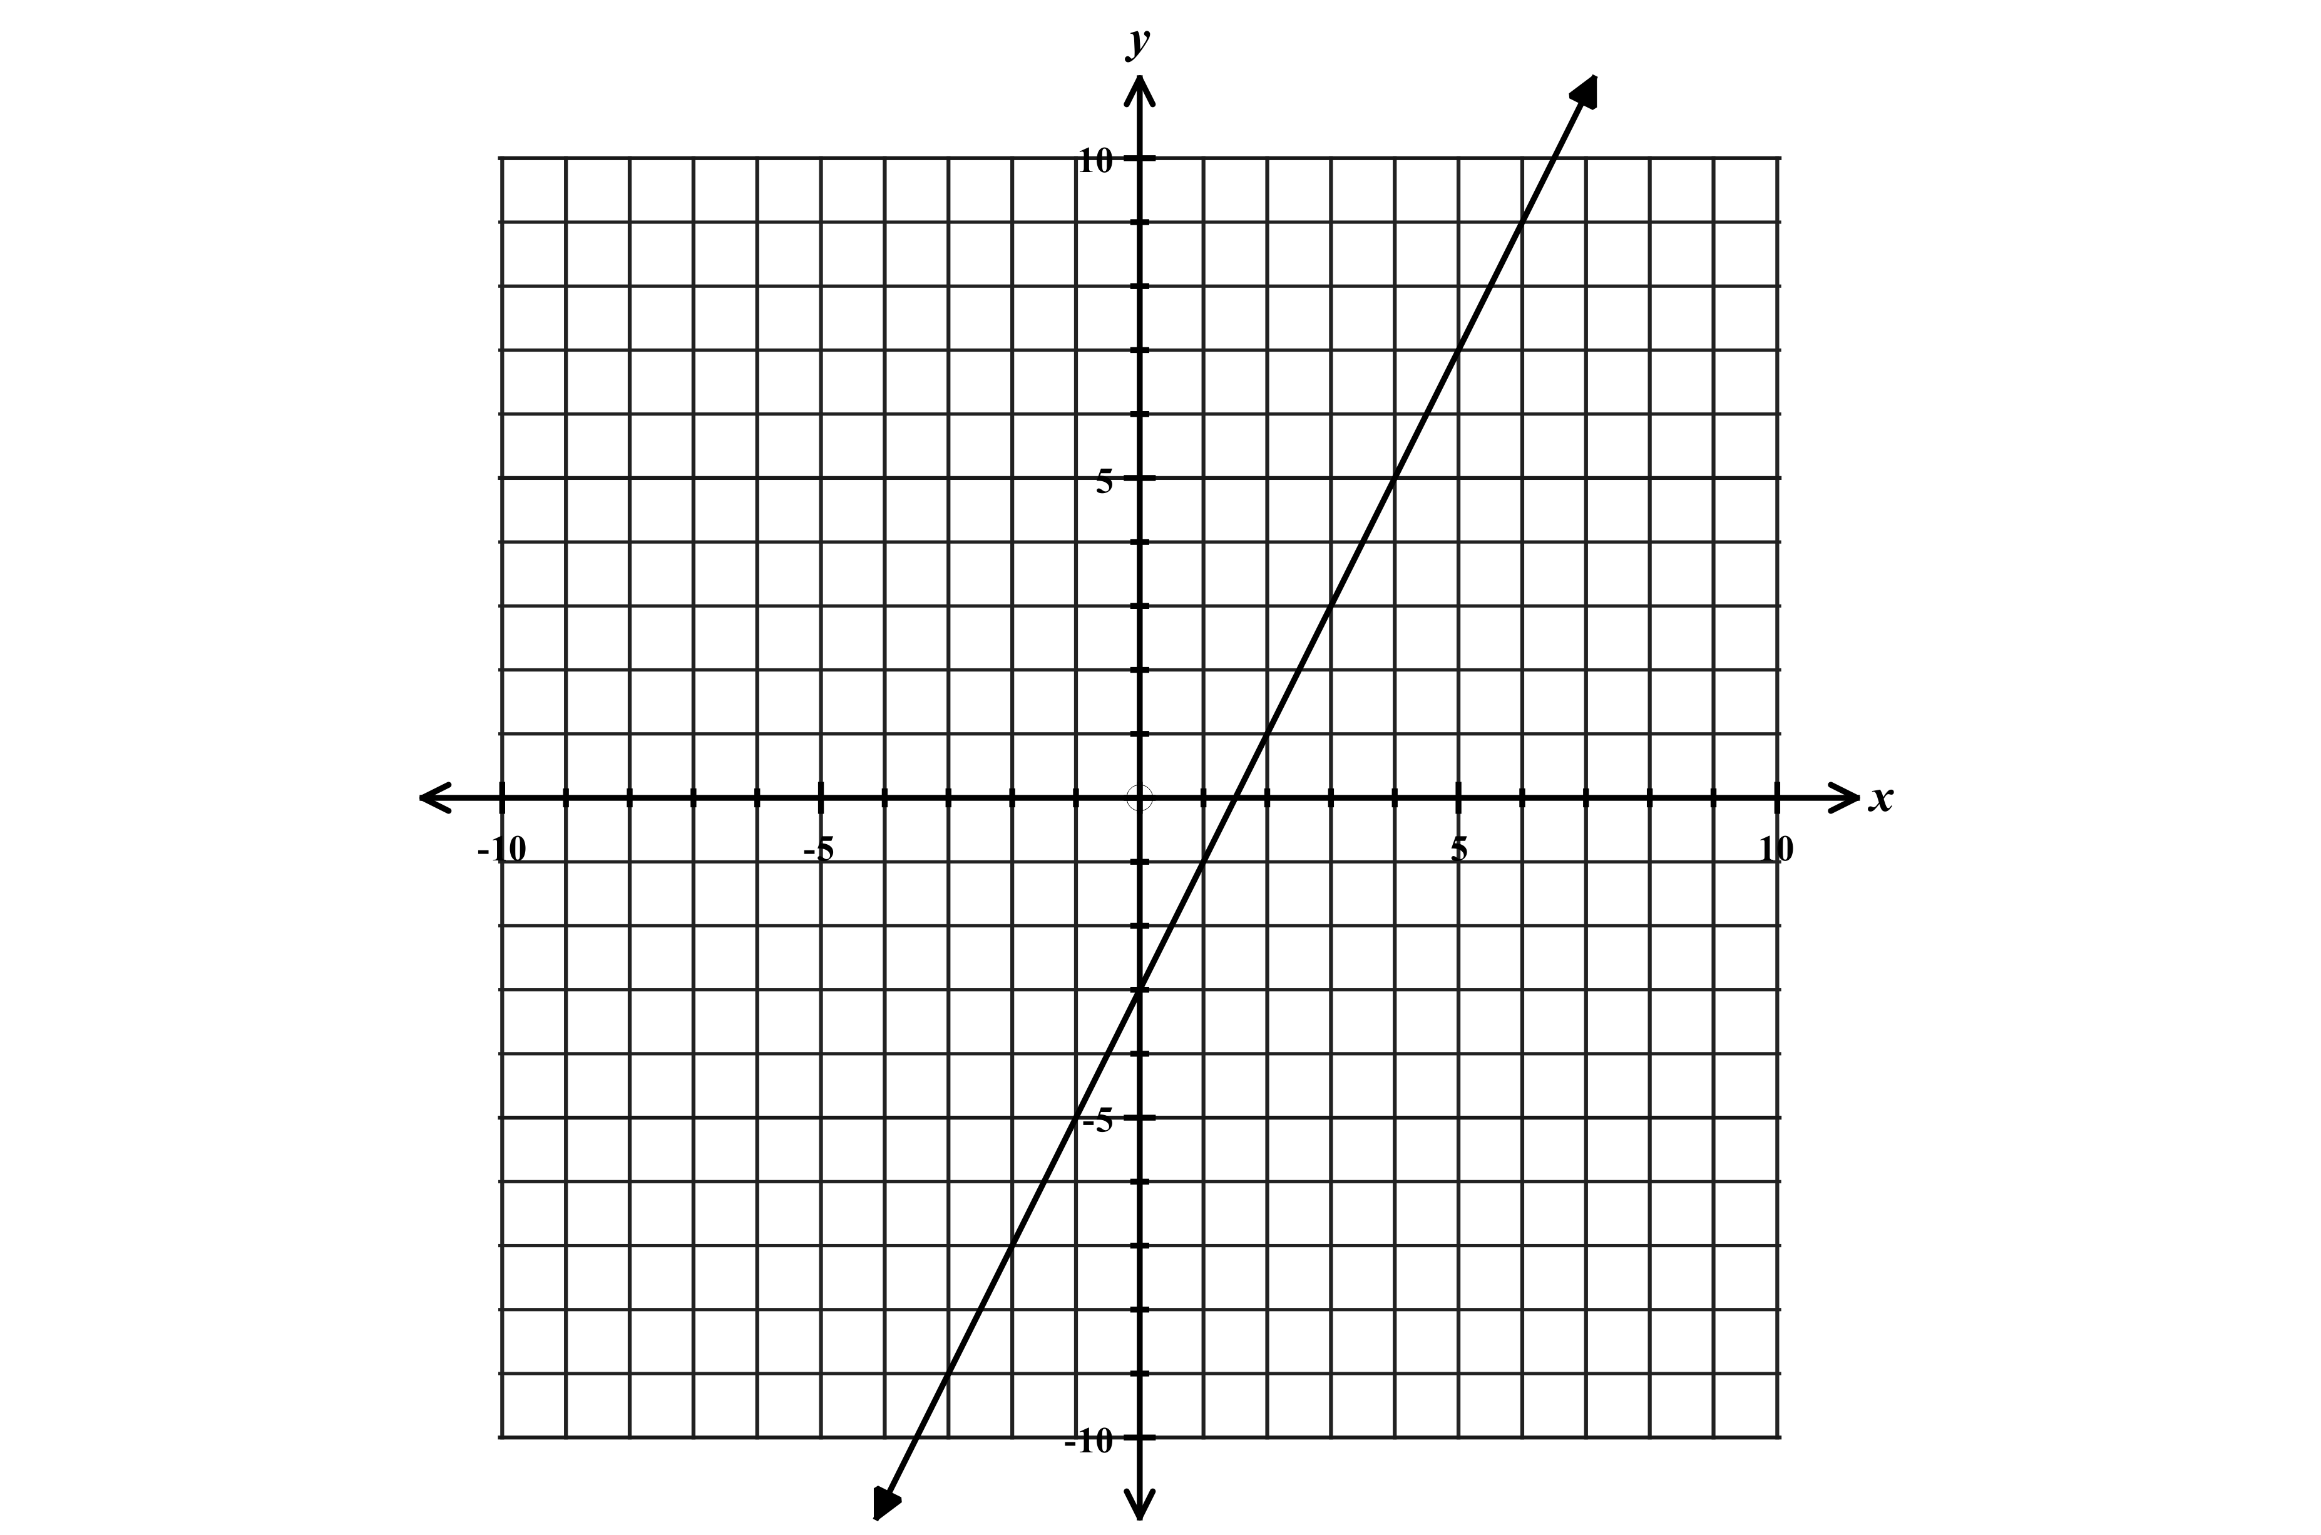
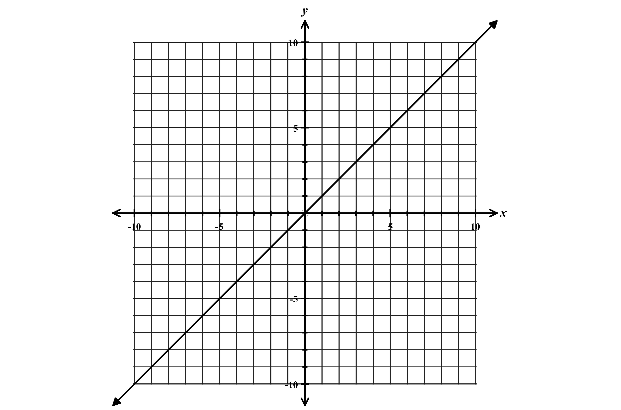
$y=2x-3$ $m=2 (m>0) and b=-3$

Table

$$x$$ | -2 | -1 | 0 | 1 | 2 | 3
$$y$$ | -7 | -5 | -3 | -1 | 1 | 3

+2 constant change
Table shows a constant rate of change.
For each change in $x$, the $y$ value changes
by equal amounts.

Variations of linear functions
$m<0$ $m=0$ Horizontal Line
Negative slope Slope of zero
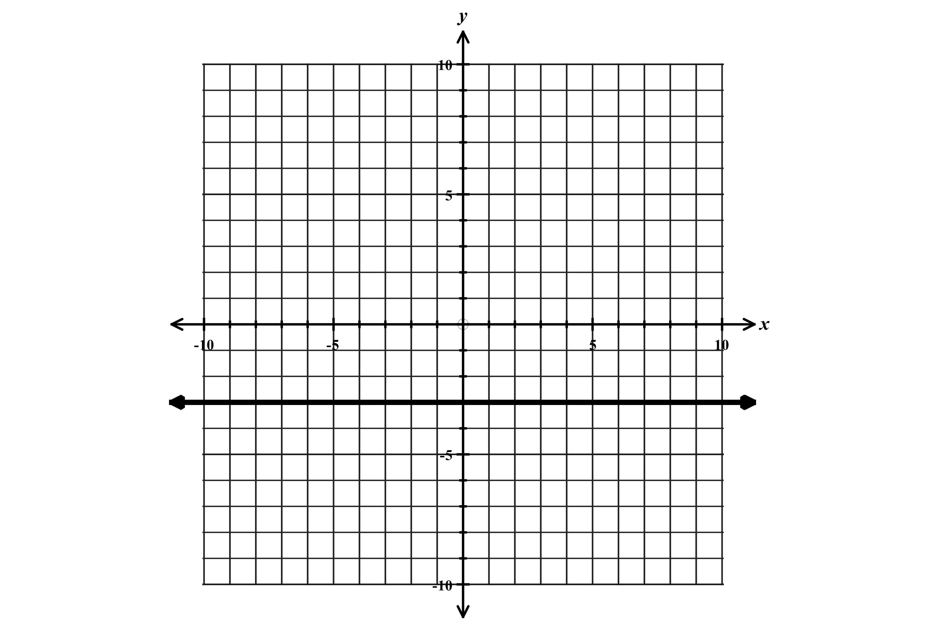
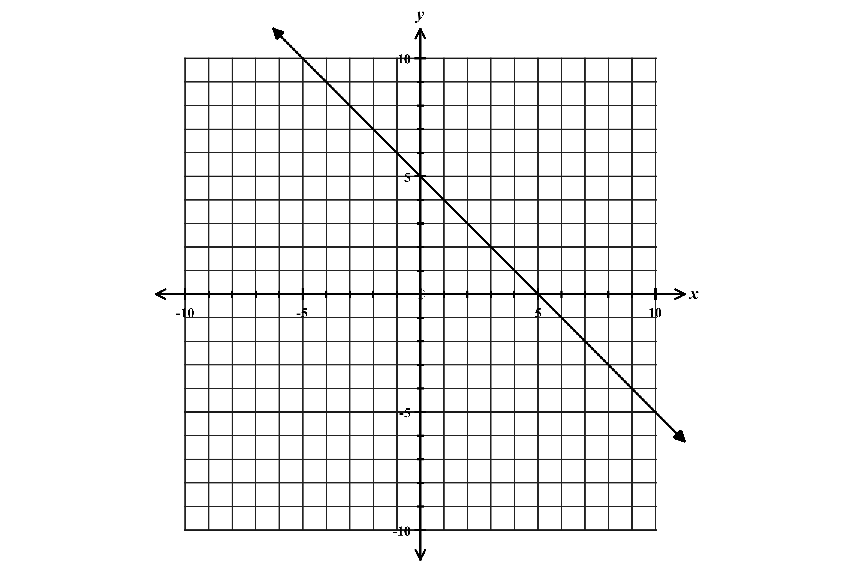
Example: $y=-x+5$ $m=-1 and b=5$ Example $y=-3$

$$x$$ | $$y$$
-2 | -3
-1 | -3
0 | -3
1 | -3
2 | -3
$$x$$ | $$y$$
-2 | 7
-1 | 6
0 | 5
1 | 4
2 | 3

Function 2: Absolute Value Function

Parent function $y=\left|x\right|$ General Equation $y=a\left|x-c\right|+d$
$$x$$ | $$y$$
-3 | 3
-2 | 2
-1 | 1
0 | 0
-1 | 1
-2 | 2
-3 | 3

$$x$$ | $$y$$
-8 | 1
-7 | 0
-6 | -1
-5 | -2
-4 | -3
-3 | -2
-2 | -1
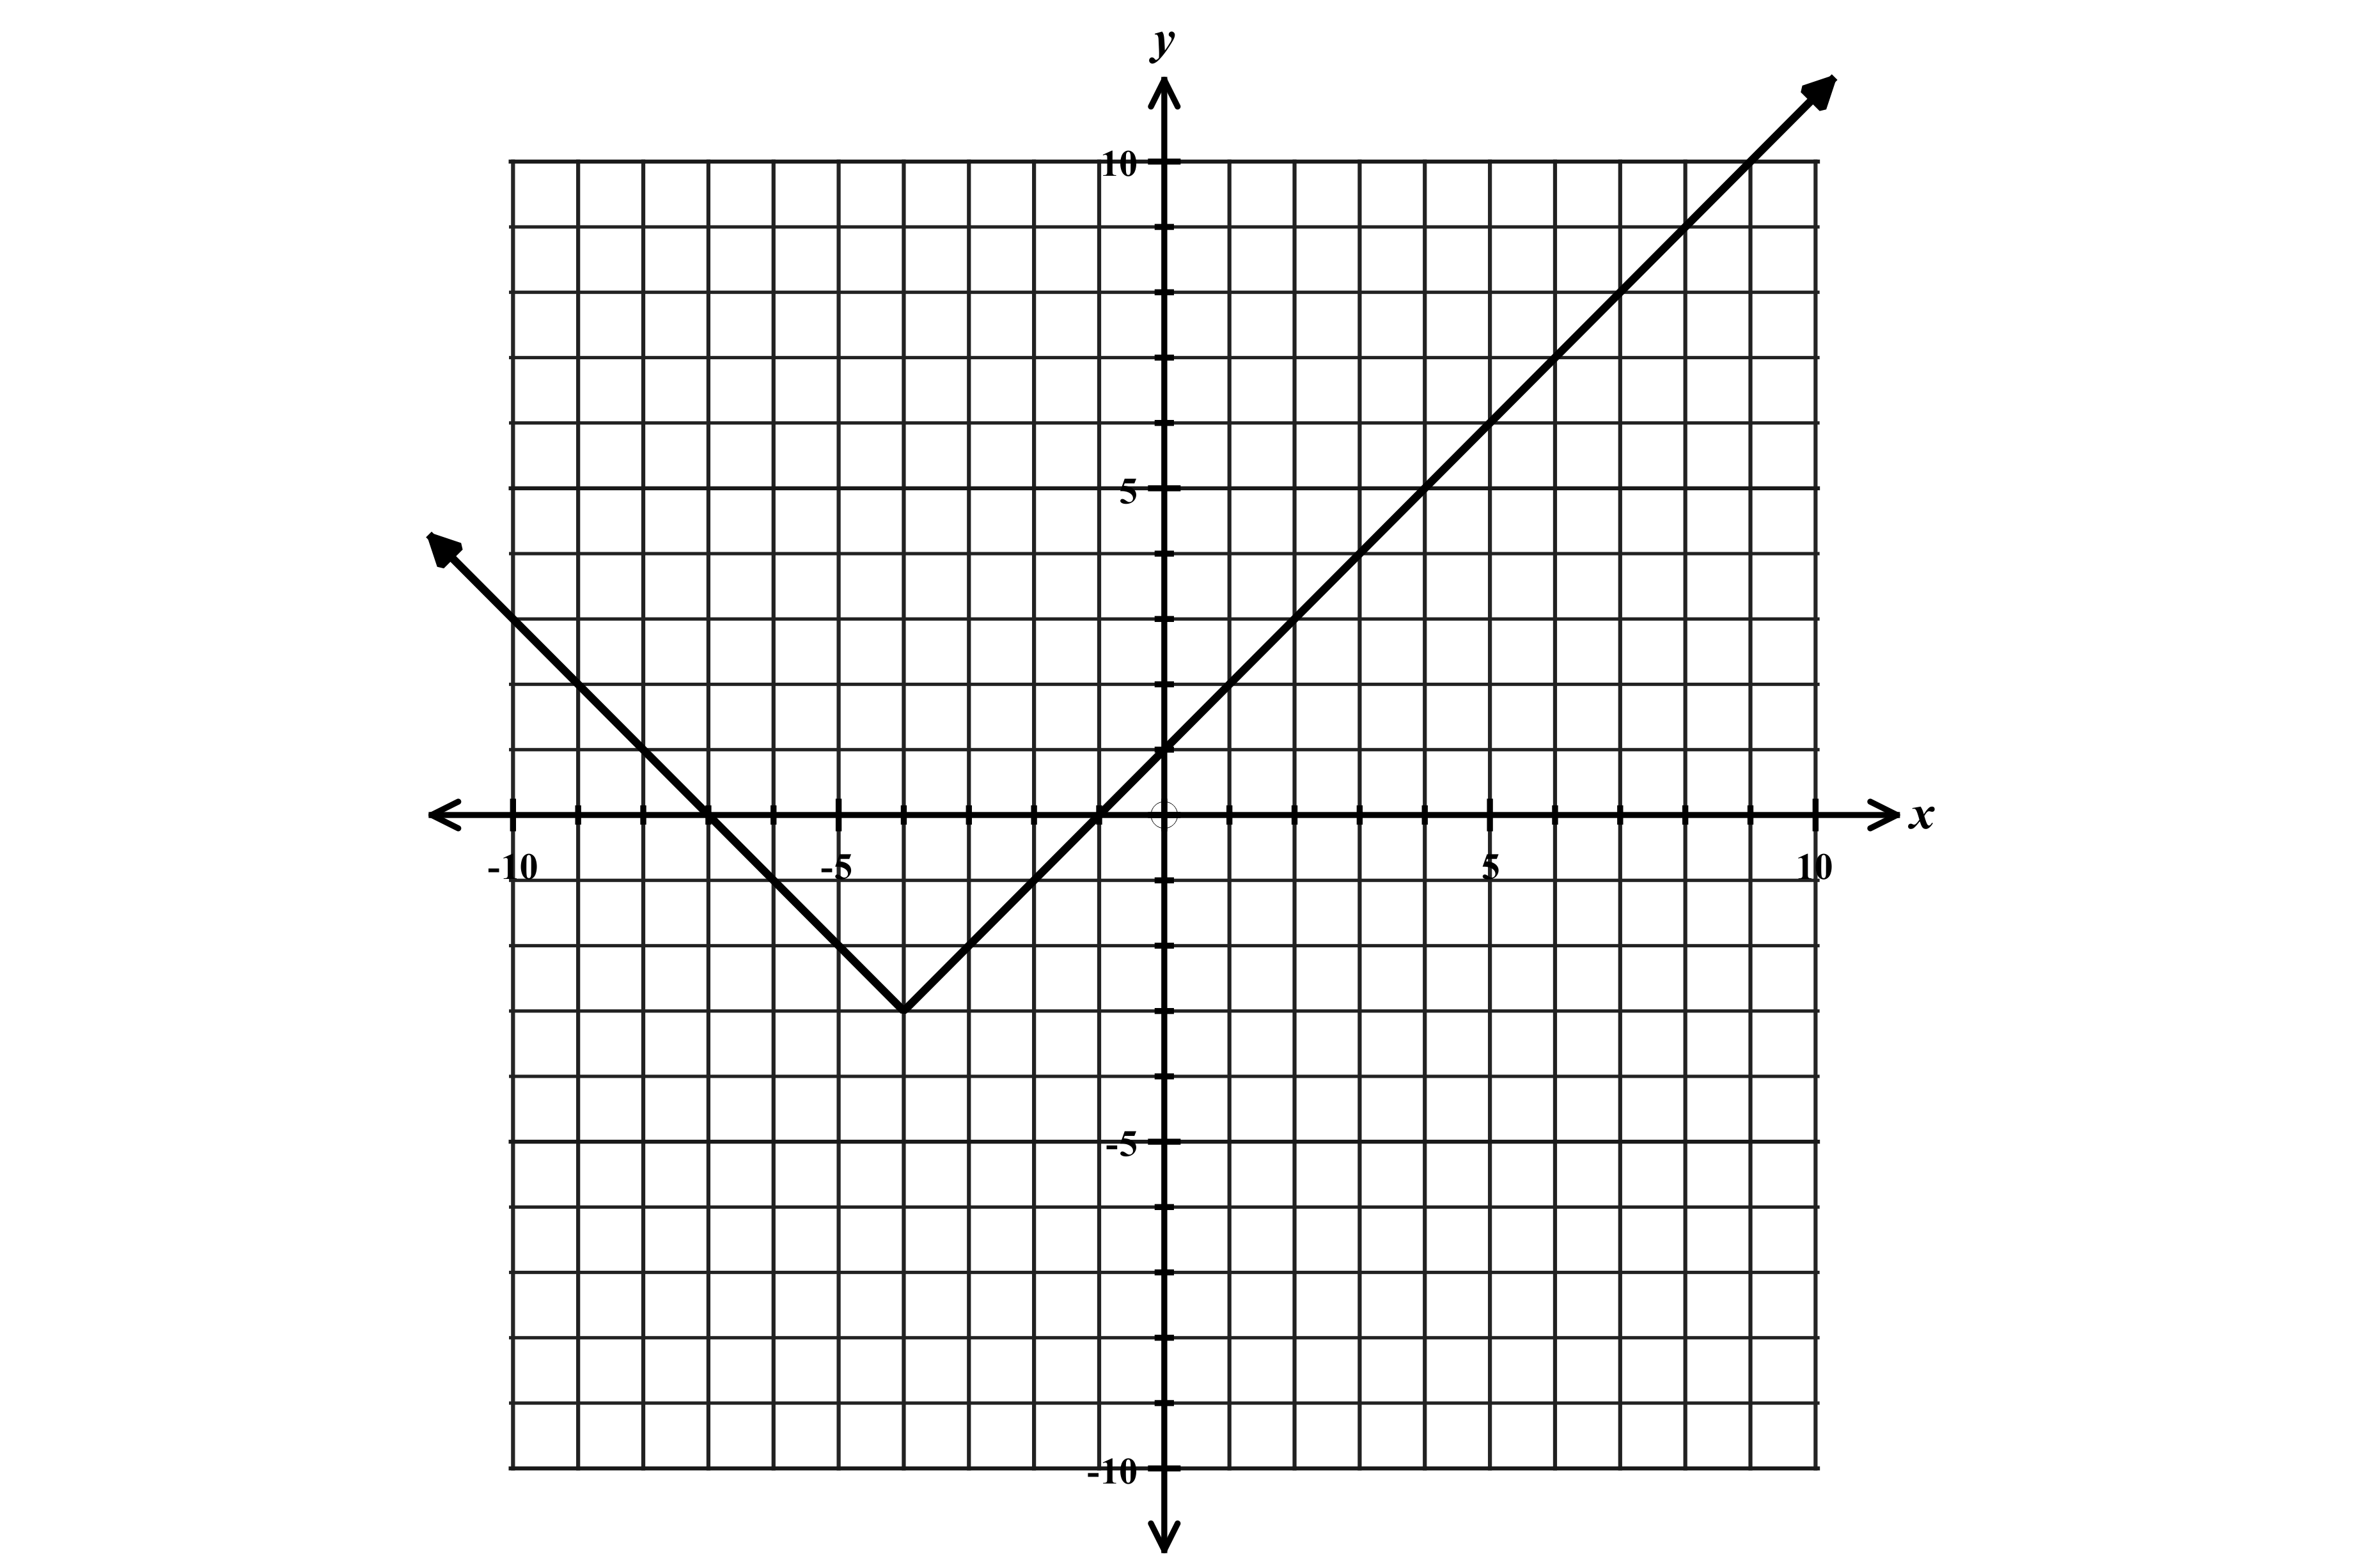
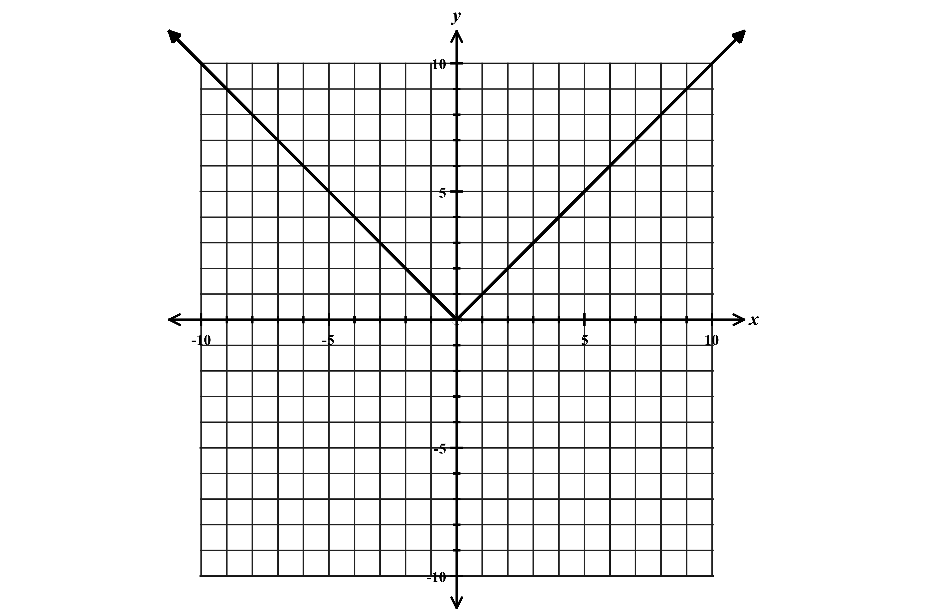
Graph of $y=\left|x\right|$ Graphs in the form $y=\left|x-a\right|+b$ Example: $y=\left|x+4\right|-3$

Vertex $(0,0)$ Vertex $(-4,-3)$
Increasing over interval $x>0$ or $(0,∞)$ Increasing over the interval $x>-4$ or $(-4,∞)$
Decreasing over interval $x<0$ or $(-∞,0)$ Decreasing over the interval $x<-4$ or $(-∞,4)$
Think of this graph as a piecewise linear function $f\left(x\right)=\left\{\begin{aligned}x when x>-4 \\ -x when x<-4\end{aligned}\right.$
$f\left(x\right)=\left\{\begin{aligned}x when x>0 \\ -x when x<0\end{aligned}\right.$ so slope is 1 when $x>0$ and -1 when $x<0$ Shifted left 4 down 3. Zeros at $x=-7 and x=-1$
Value of function is positive: $f\left(x\right)>0$ when $x<0 and x>0$Value of function is negative when $-7<x<-1$
Domain $-∞<x<∞$ or $(-∞,∞)$ Range $0≤y<∞$ or $[0,∞)$ Domain $(-∞,∞)$ Range $y≥-3$ or $[-3,∞)$

When leading coefficient is less than 0. When leading coefficient is greater or less than 1.
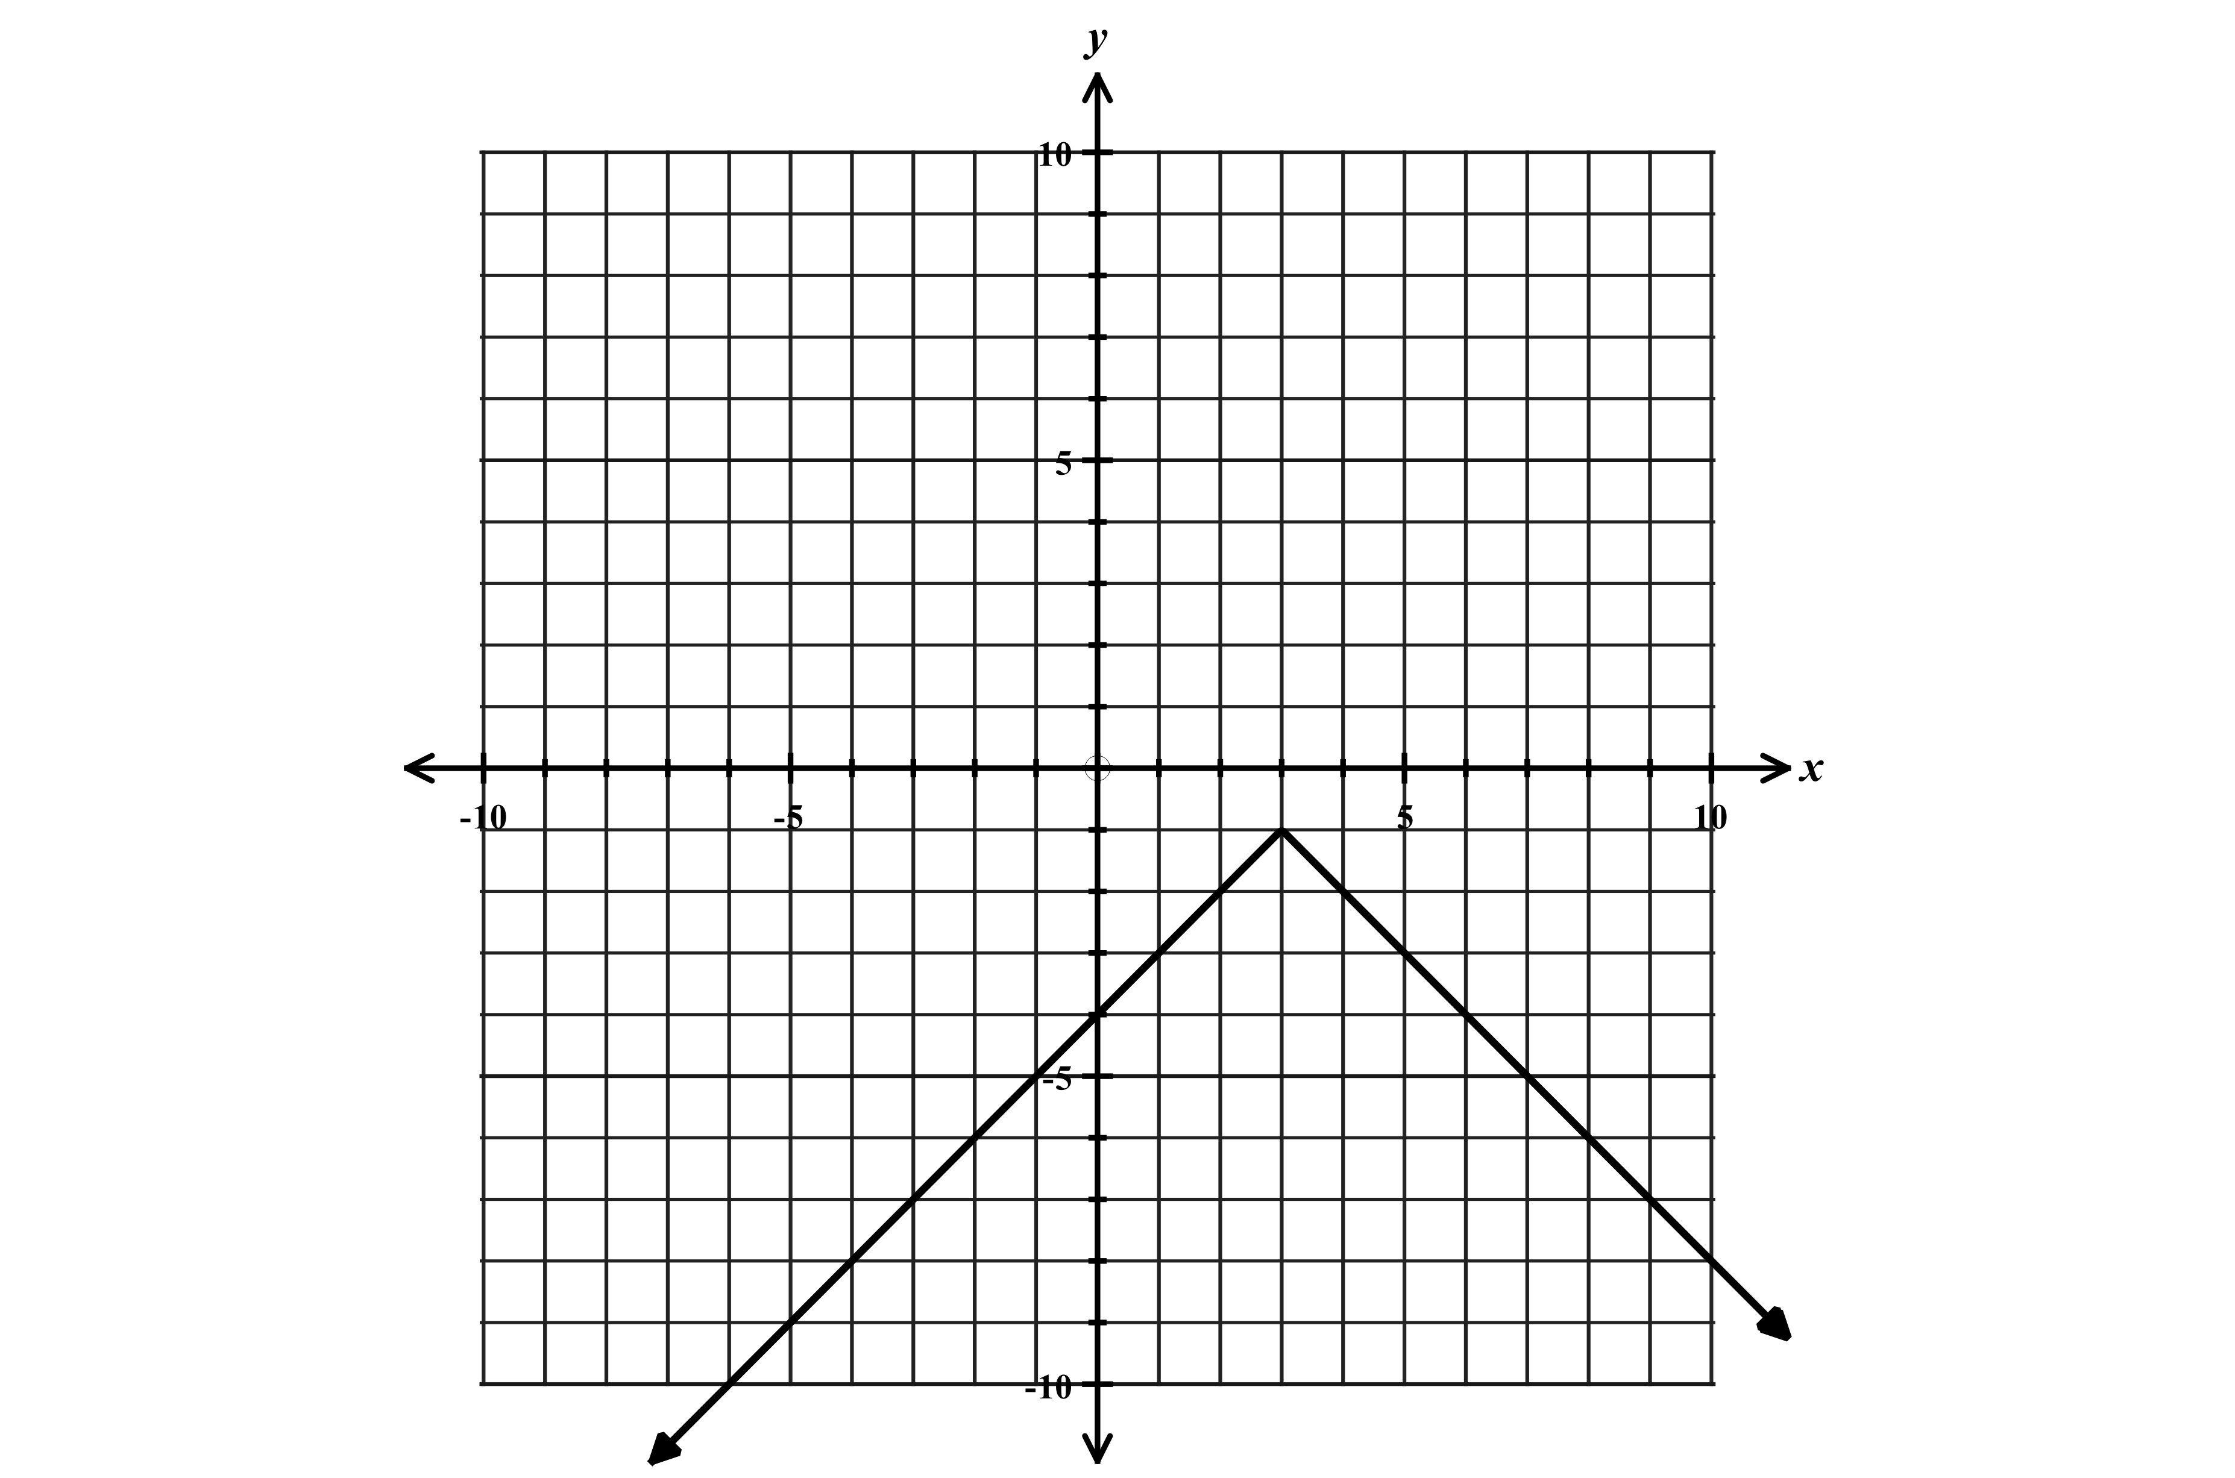
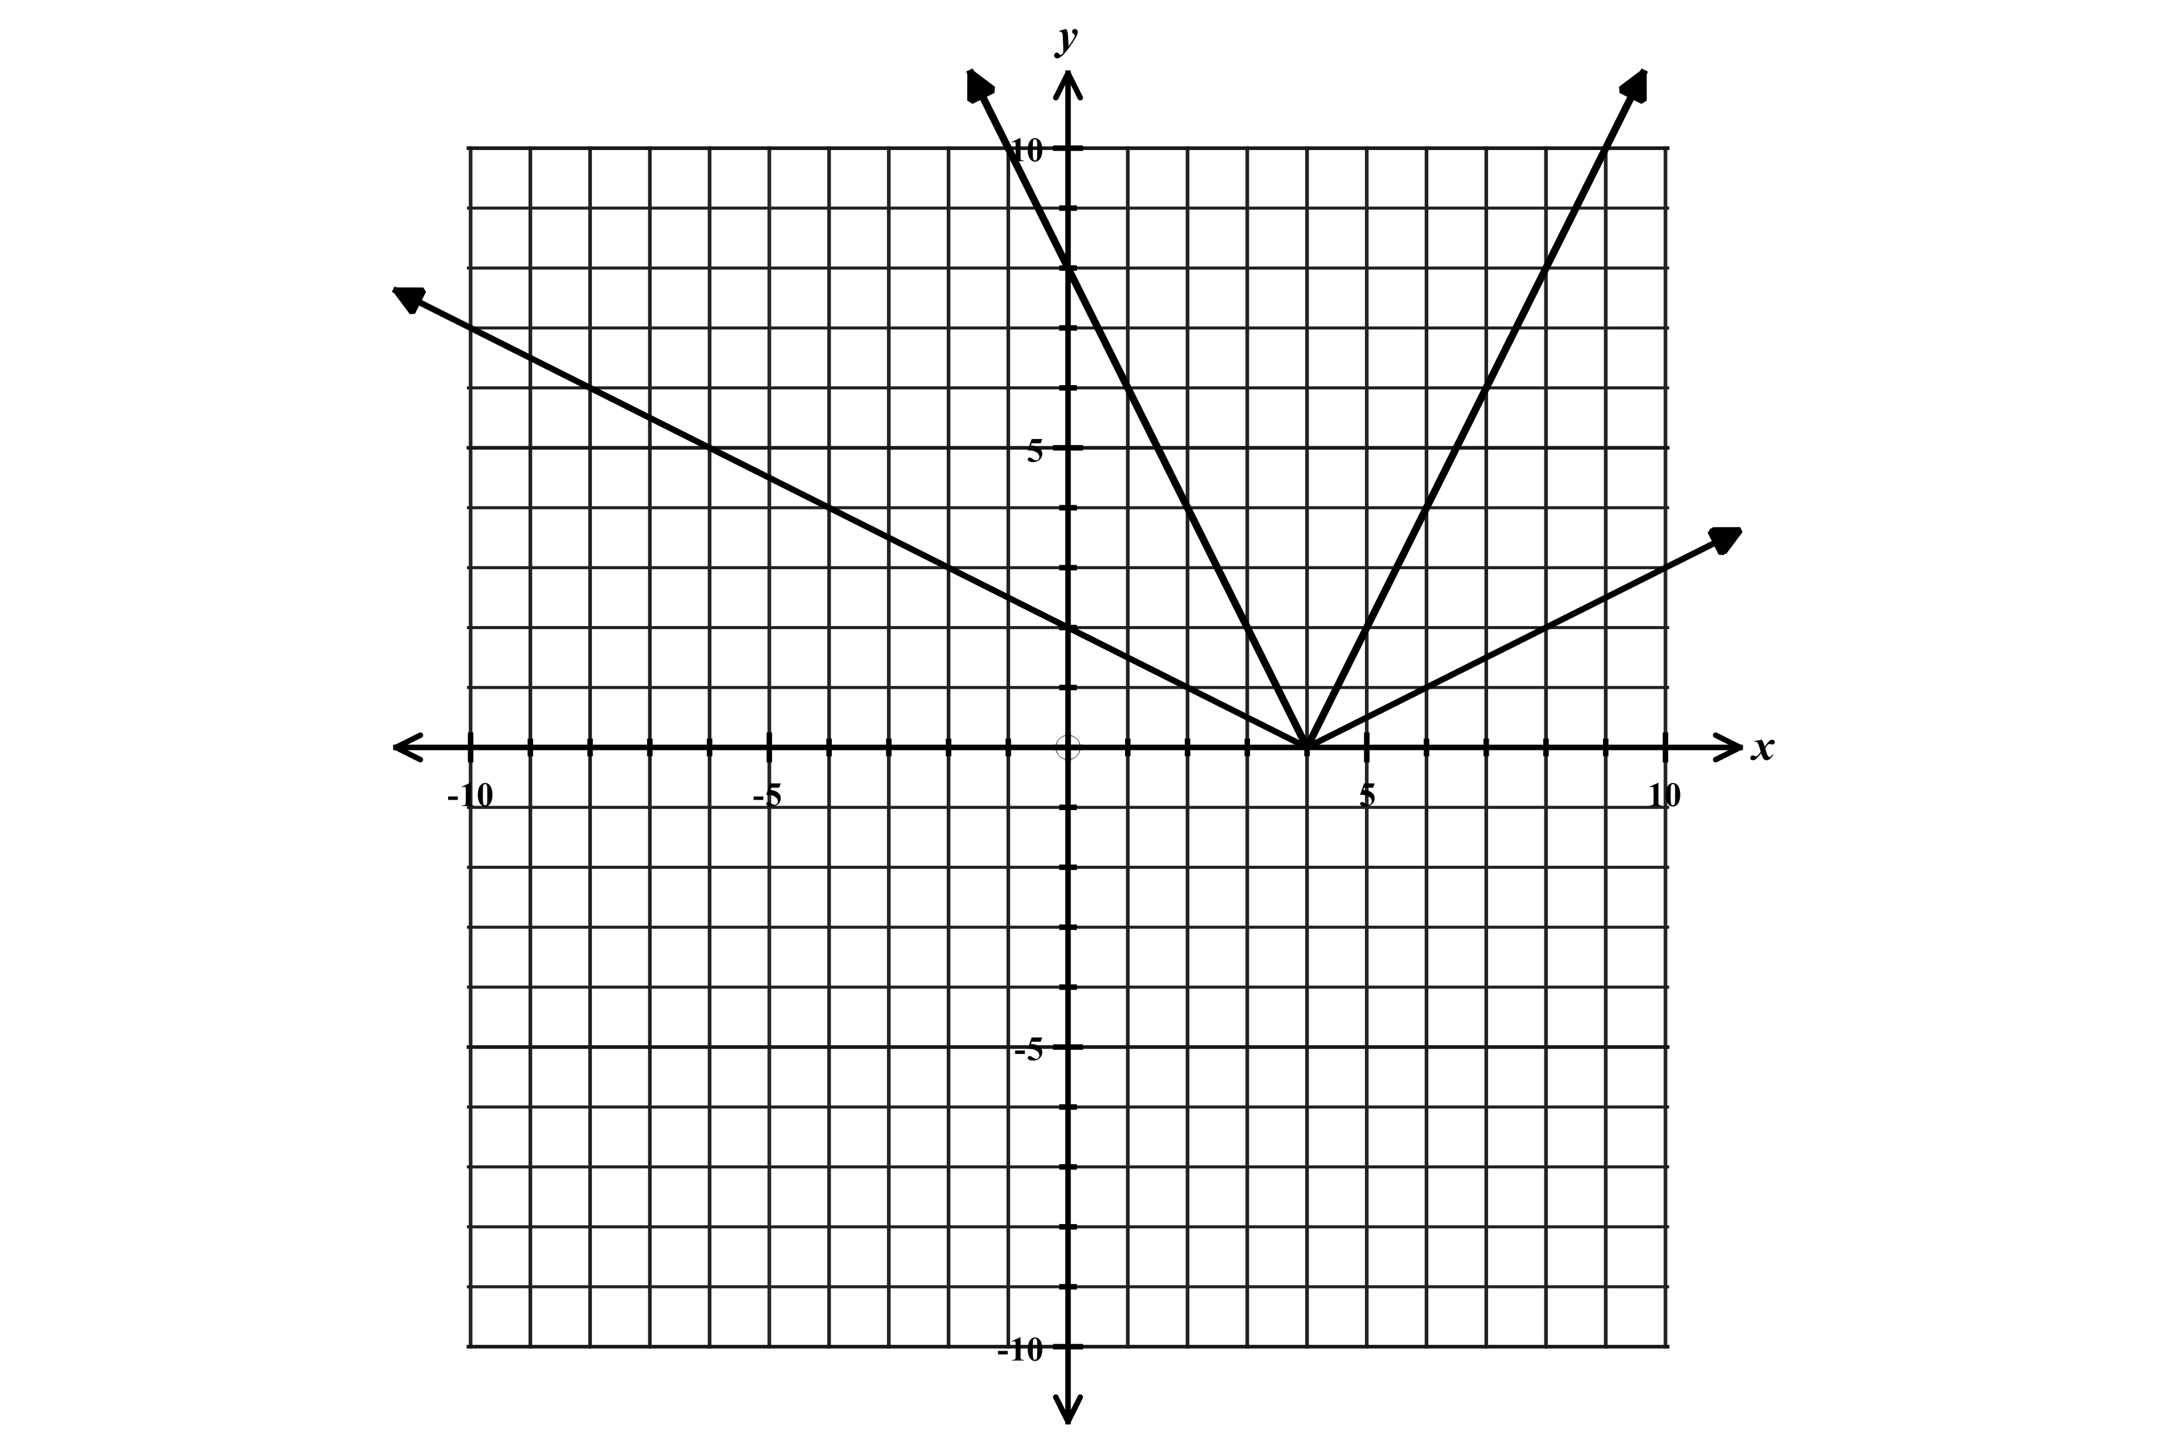
$y=-\left|x-3\right|-1$ $f\left(x\right)=2\left|x-4\right|$ and $g\left(x\right)=\frac{1}{2}\left|x-4\right|$
$f(x)$
$g(x)$

Increasing over the interval $x<3$ or $(-∞,3)$ $f(x)$ is narrower or “compressed”
Decreasing over the interval $x>3$ or $(3,∞)$ $g(x)$ is wider or “stretched”
Value of function is always negative $f\left(x\right)<0$ for all values of $x$. Both graphs are shifted right 4 units
Domain $-∞<x<∞$ or $(-∞,∞)$ Range $y≤-1$ or $(-∞,1]$ vertex is $(4,0)$
Graph is shifted right 3 units and down 1 unit so vertex is $(3,-1)$
Function 3: Exponential Function

Parent function $y=b^{x}$ General Equation $y=a{(b)}^{x}$ where $a$ is the y-intercept and $b$ is the growth or decay factor.

Rate of change is not constant!

$$x$$ | $$y$$
-3 | $$1/8$$
-2 | $$1/4$$
-1 | $$1/2$$
0 | 1
1 | 2
2 | 4
3 | 8
4 | 16
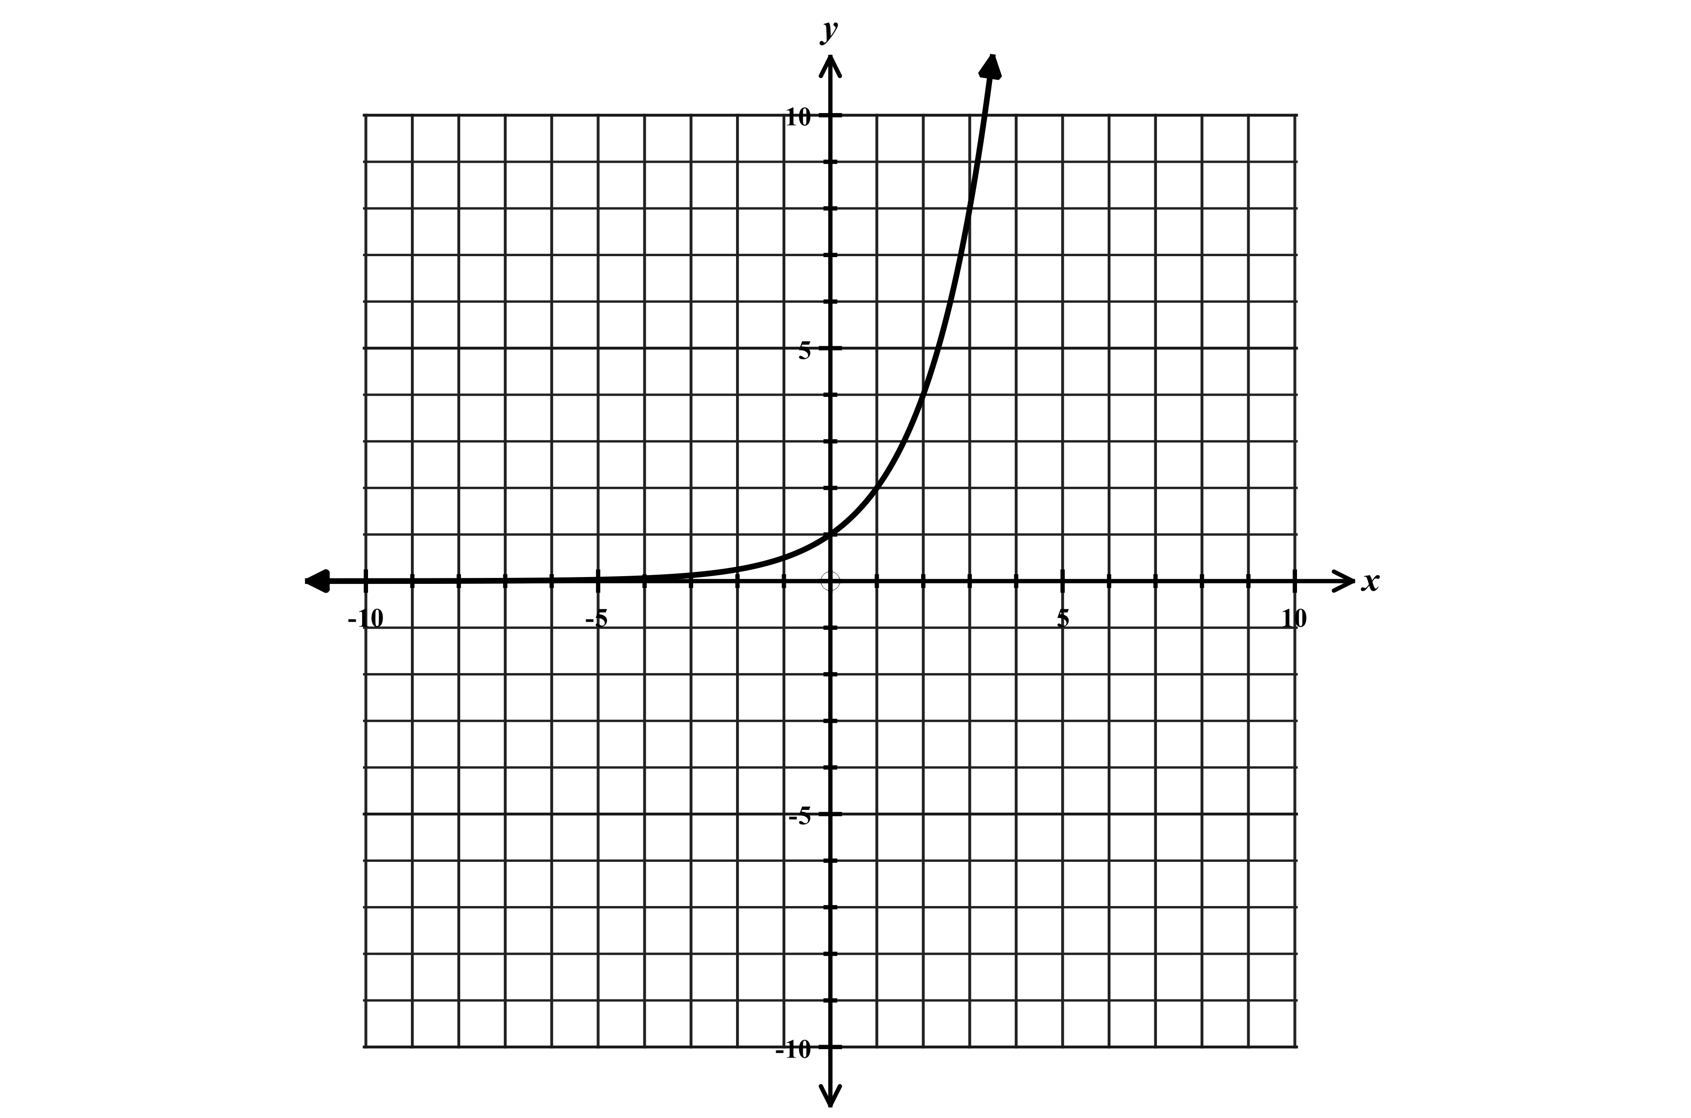
Graph of $y=2^{x}$ Graphs in the form $y=a{(b)}^{x}$ Example: $y=3{(2)}^{x}$
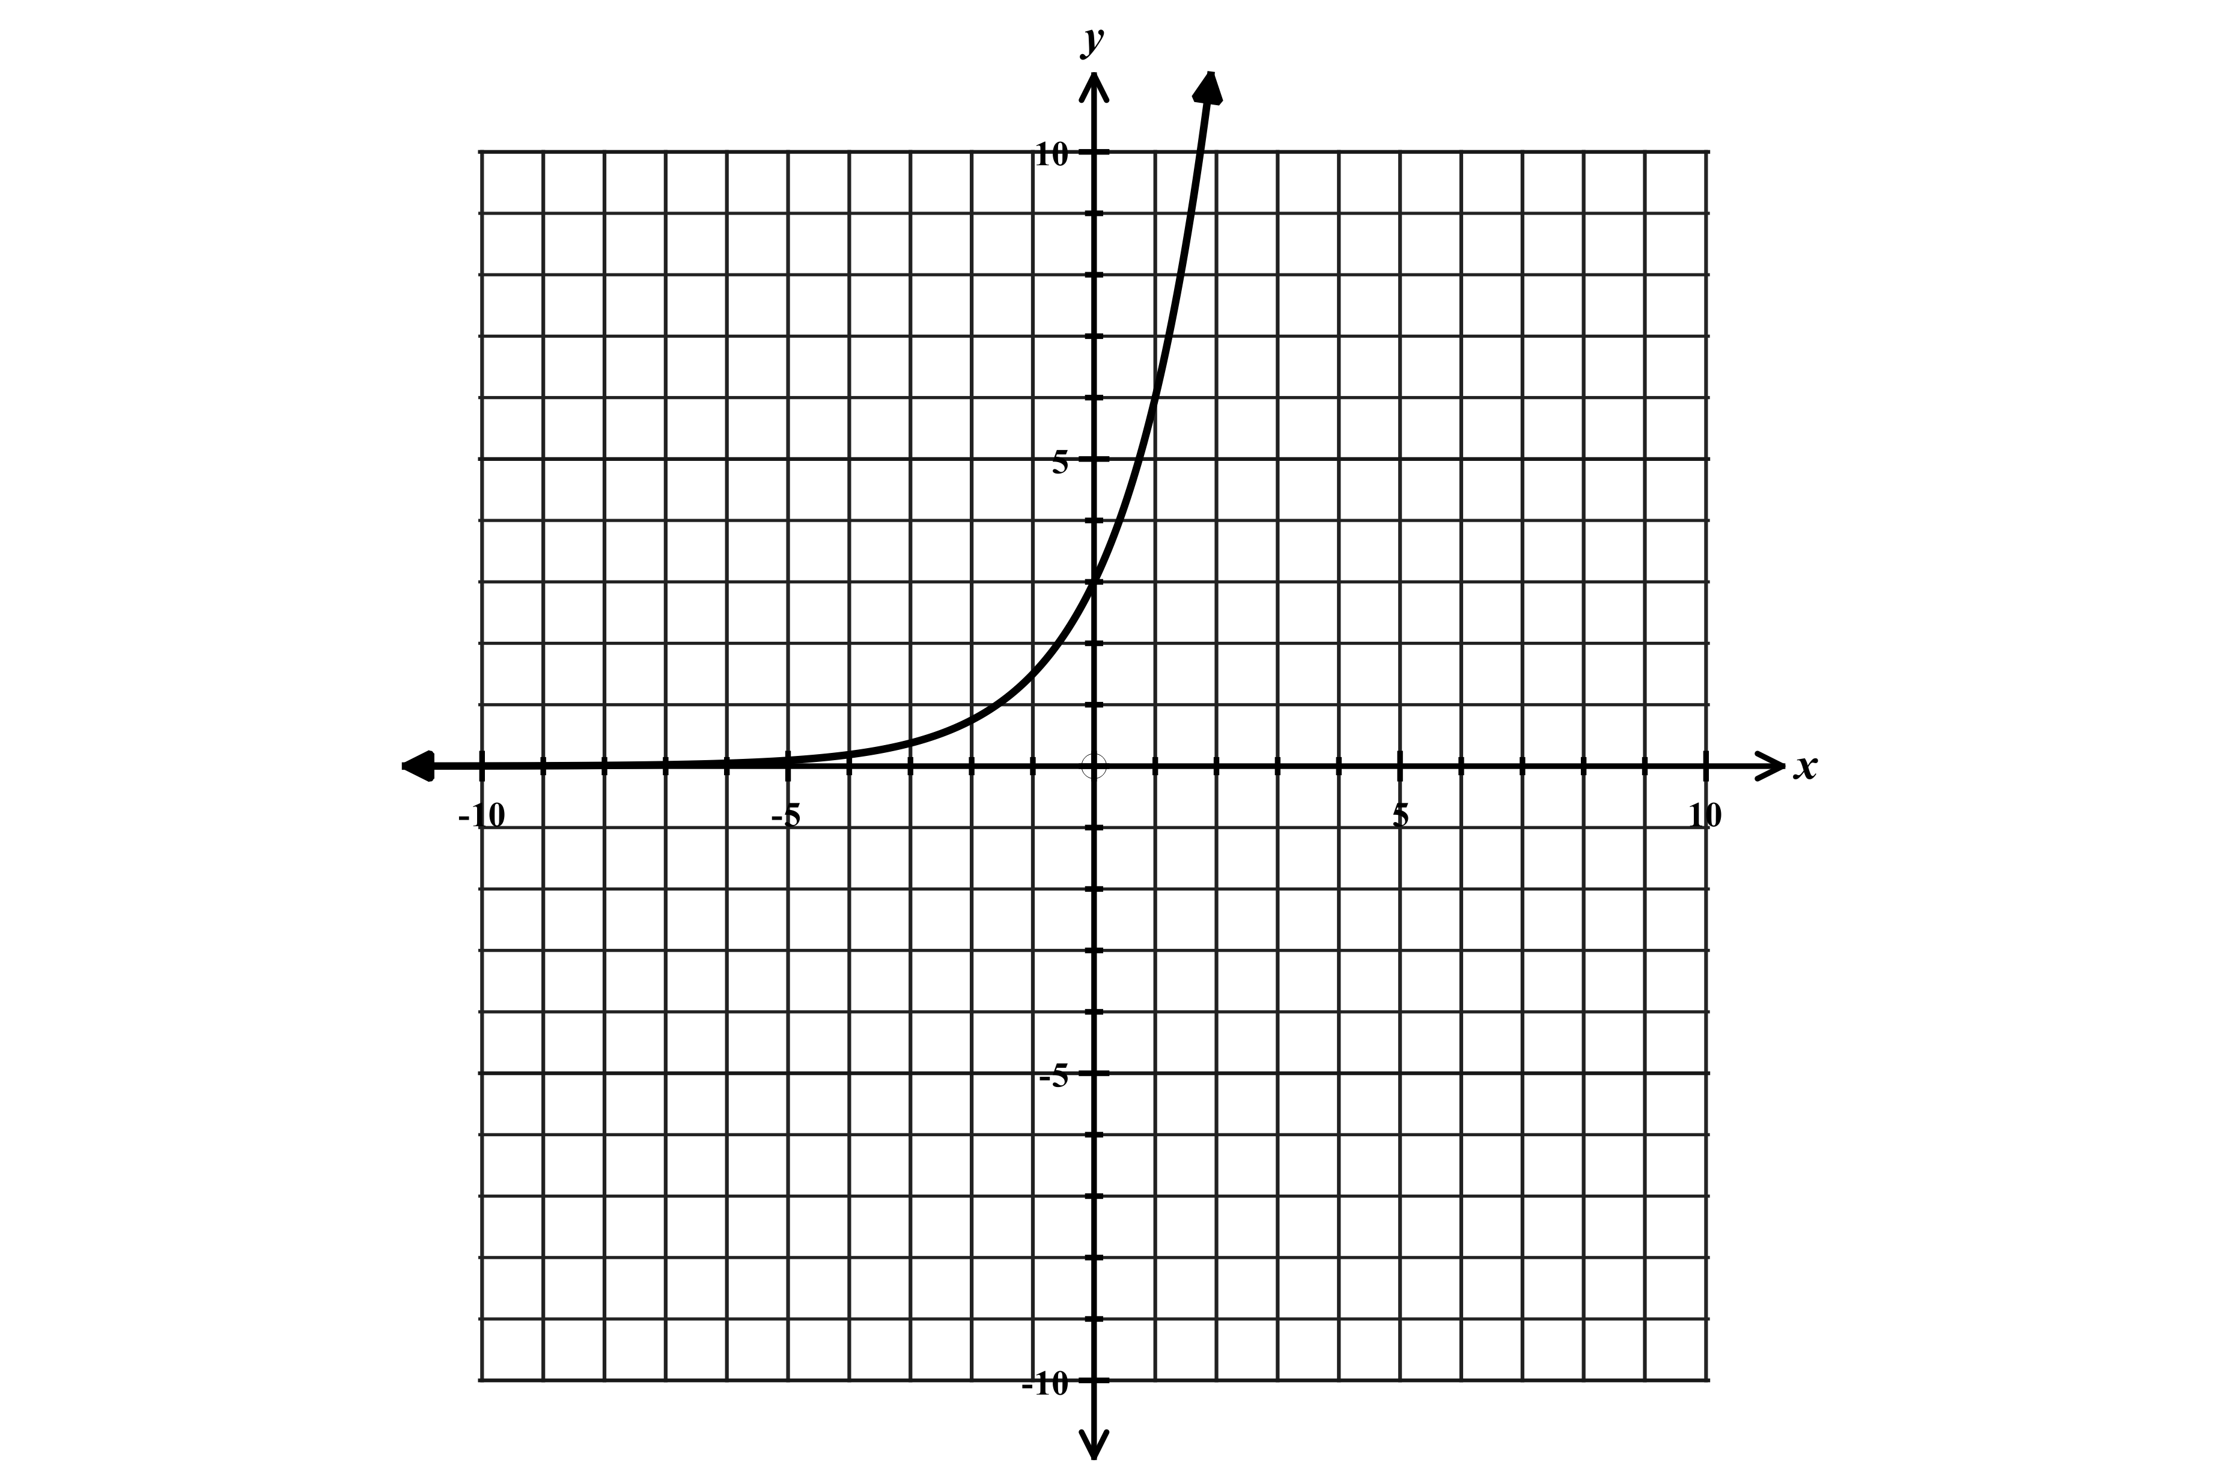

Increasing over all values of $x$ or $(-∞,∞)$ Graph is the same as $y=2^{x}$ with the exception of $b$ value
Value of the function is always positive $:f\left(x\right)>0$ for all values of $x$. y-intercept is 3 because of leading coefficient of 3.
y-intercept of function is 1 (because when $x=0$, $2^{0}=1$) Exponential growth with a growth factor of 2.
This graph displays exponential growth with a growth factor of 2. Domain and range is same as $y=2^{x}$.
Domain $-∞<x<∞$ or $(-∞,∞)$ Range $y>0$or $(0,∞)$

Examples when a and b values change.
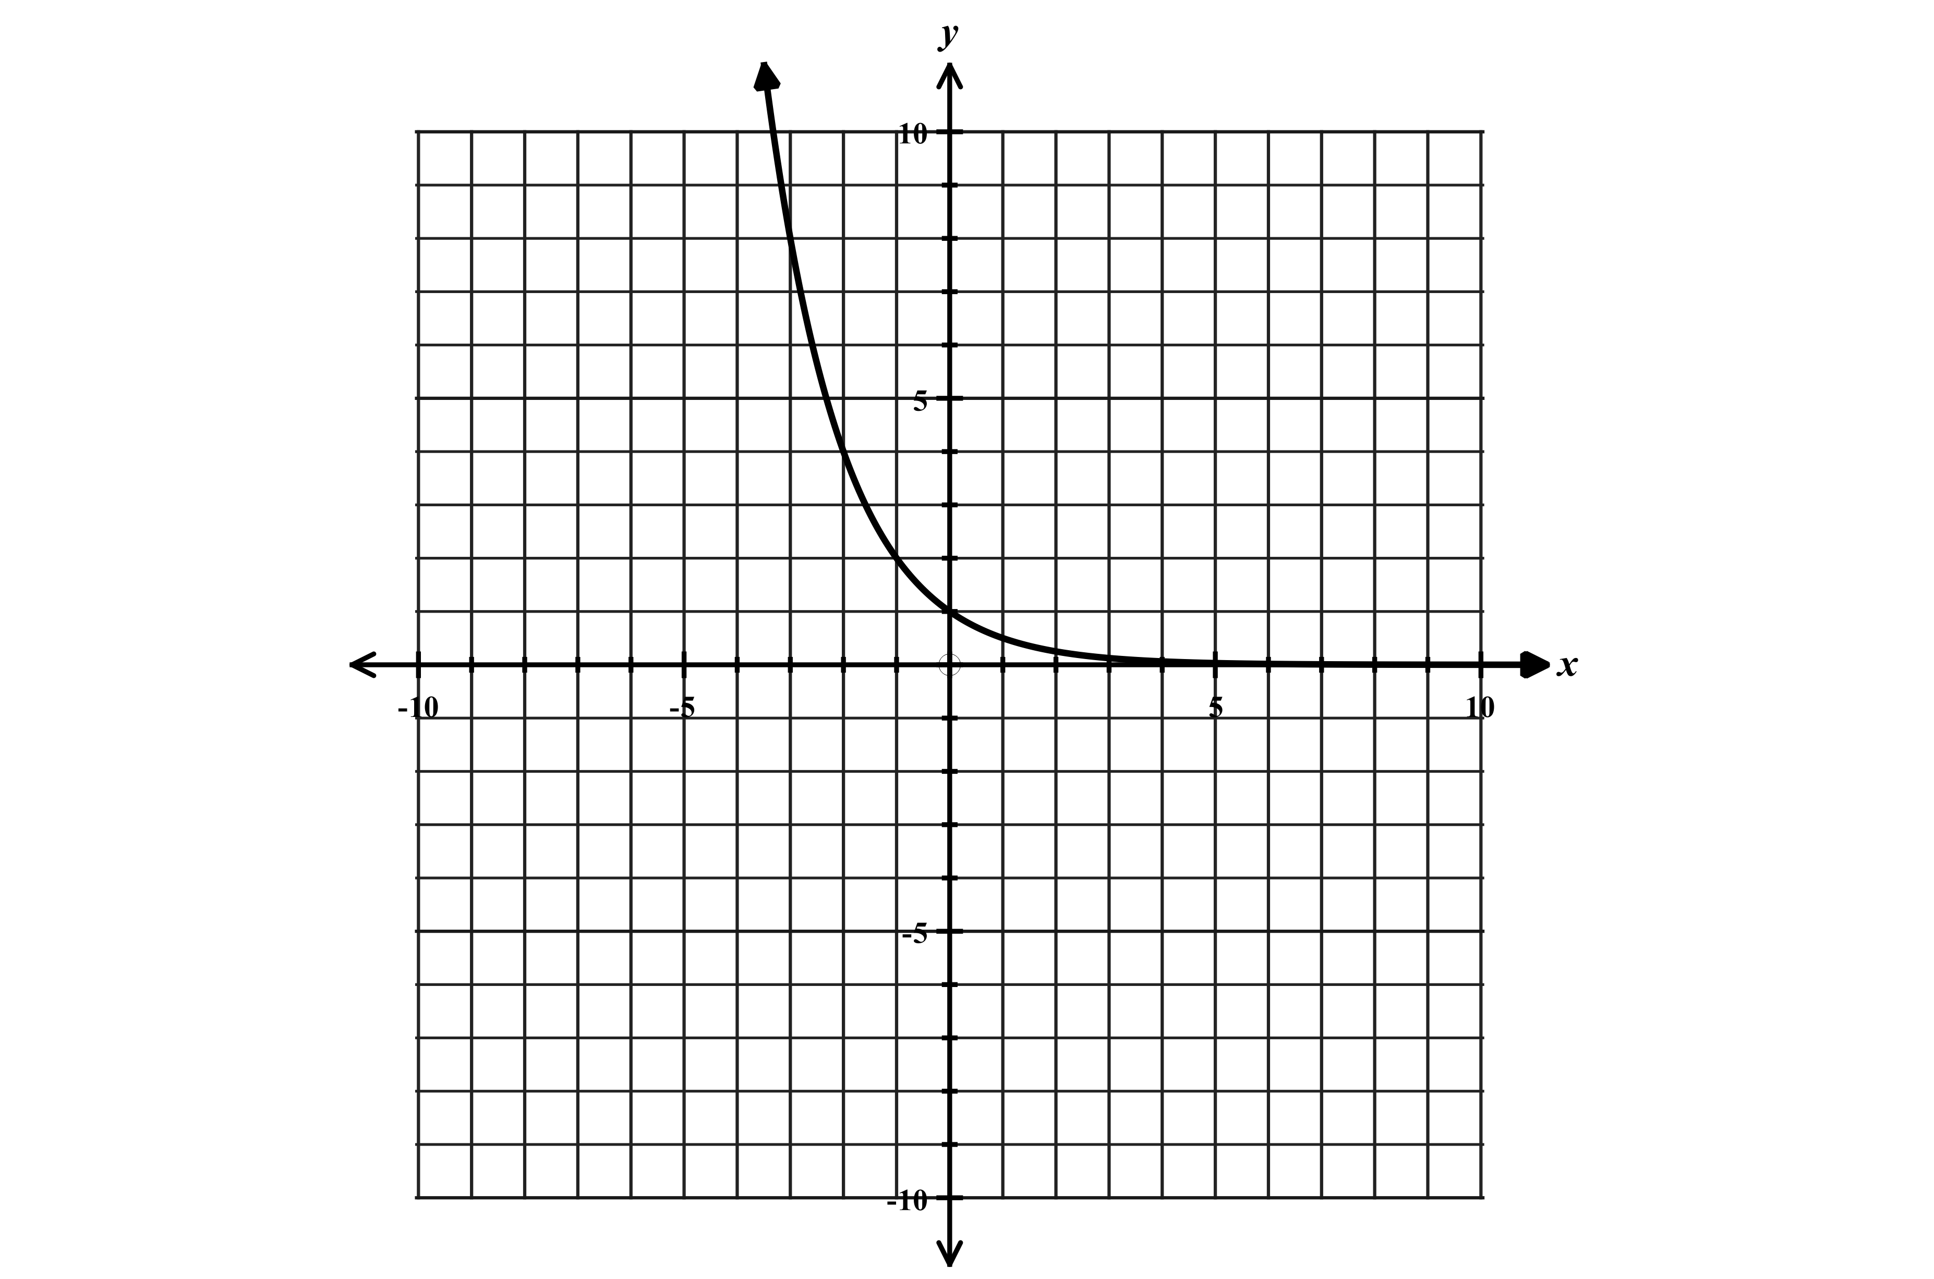
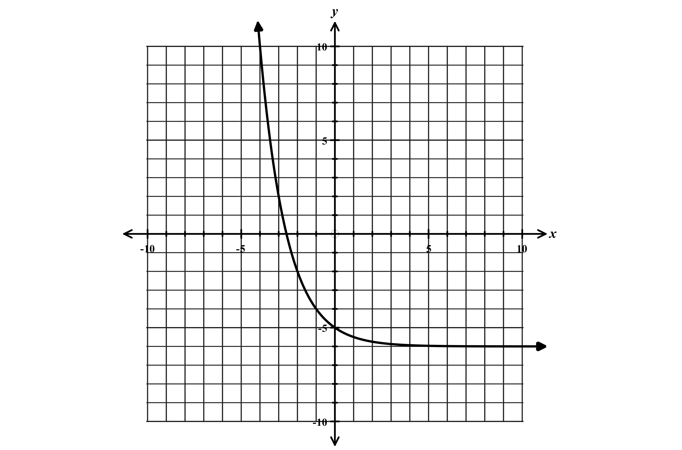
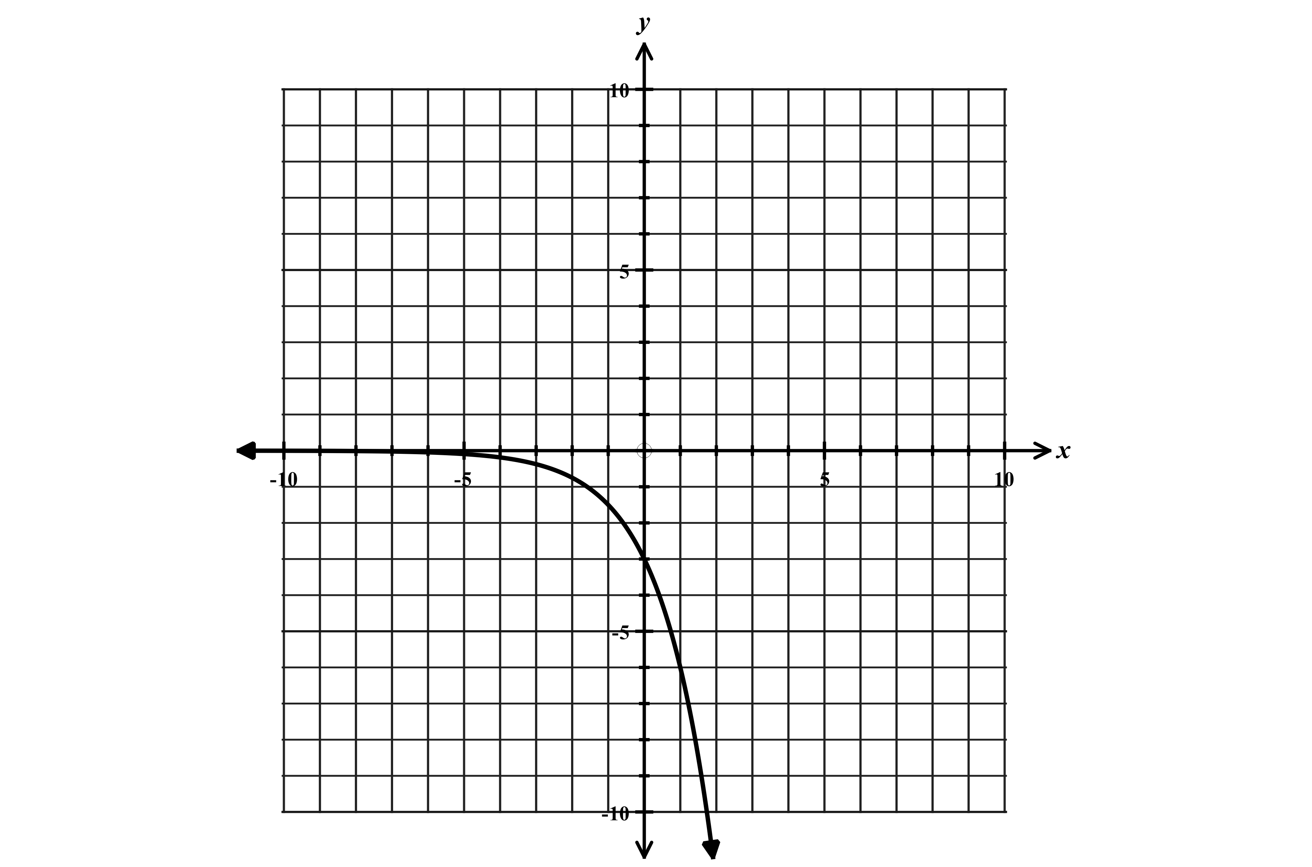
$y=-3{(2)}^{x}$ $y={\left(\frac{1}{2}\right)}^{x}$ $y={\left(\frac{1}{2}\right)}^{x}-6$

Graph is “flipped” Exponential decay Same as $y={\left(\frac{1}{2}\right)}^{x}$ but shifted down 6
y-intercept is -3 Decay factor is $1/2$

Function 4: Quadratic Function

Parent Function: $y=x^{2}$ Standard form Equation: $y={ax}^{2}+bx+c$
$$x$$ | $$y$$
-3 | -9
-2 | -4
-1 | -1
0 | 0
1 | -1
2 | -4
3 | -9
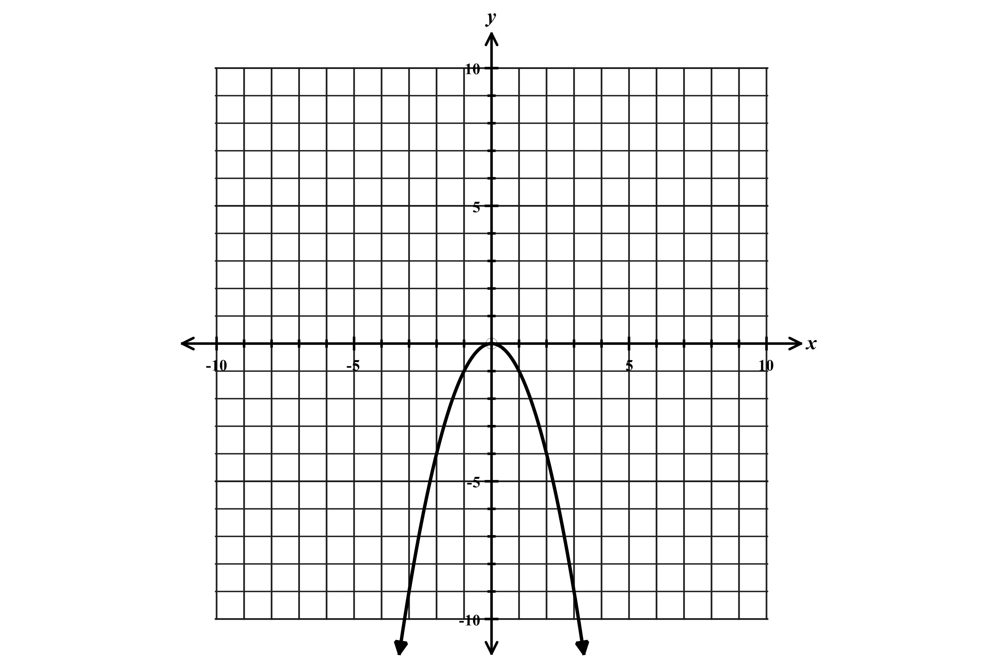
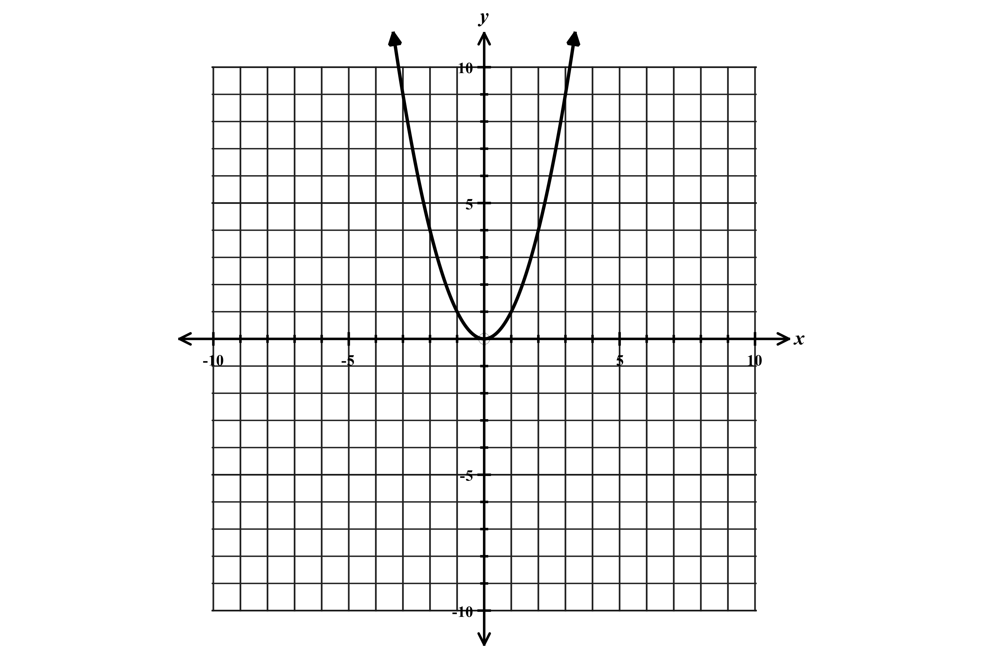
Graph of $y=x^{2}$ Graph of $y=-x^{2}$
$$x$$ | $$y$$
-3 | 9
-2 | 4
-1 | 1
0 | 0
1 | 1
2 | 4
3 | 9

Vertex $(0,0)$: Minimum point (opens up) Vertex $(0,0)$ maximum point (opens down)
Increasing over the interval $x>0$ or $(0,∞)$ Increasing over the interval $x<0$ or $(-∞,0)$
Decreasing over the interval $x<0$ or $(-∞,0)$ Decreasing over the interval $x>0$ or $(0,∞)$
Domain $-∞<x<∞$ or $(-∞,∞)$ Domain $-∞<x<∞$ or $(-∞,∞)$
Range $y≥0$ or $[0,∞)$ Range $y≤0$ or $(-∞,0]$
Axis of symmetry: $x=0$ ($y-axis)$ Axis of symmetry: $x=0$ ($y-axis)$

Shifting, compressing, and stretching quadratics
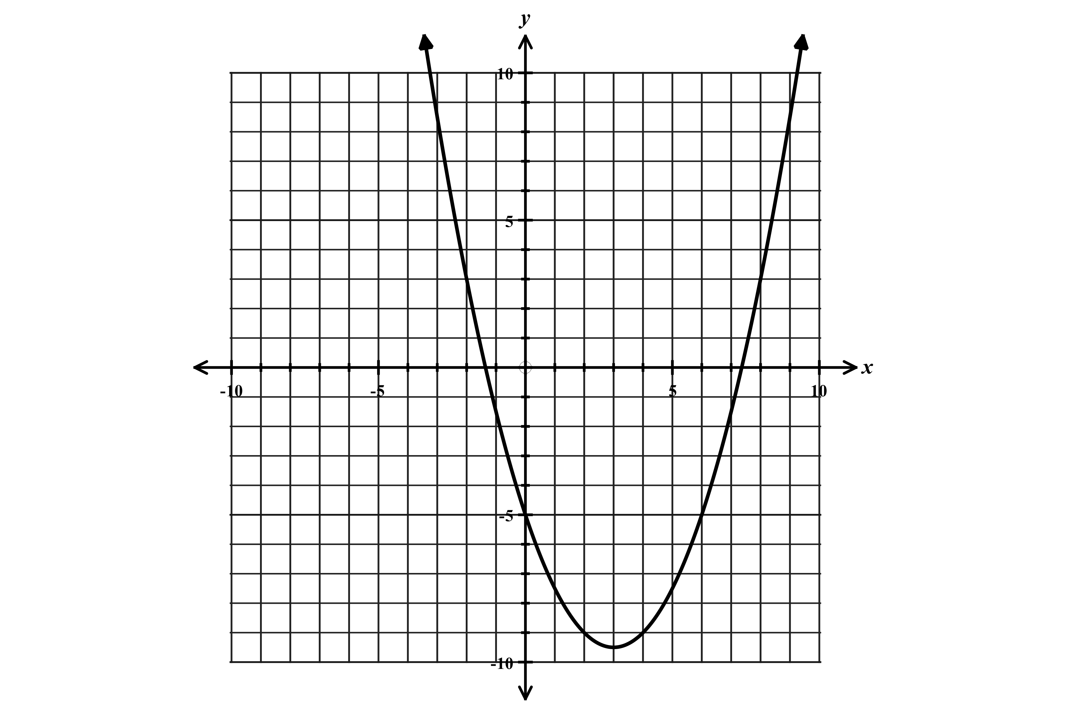
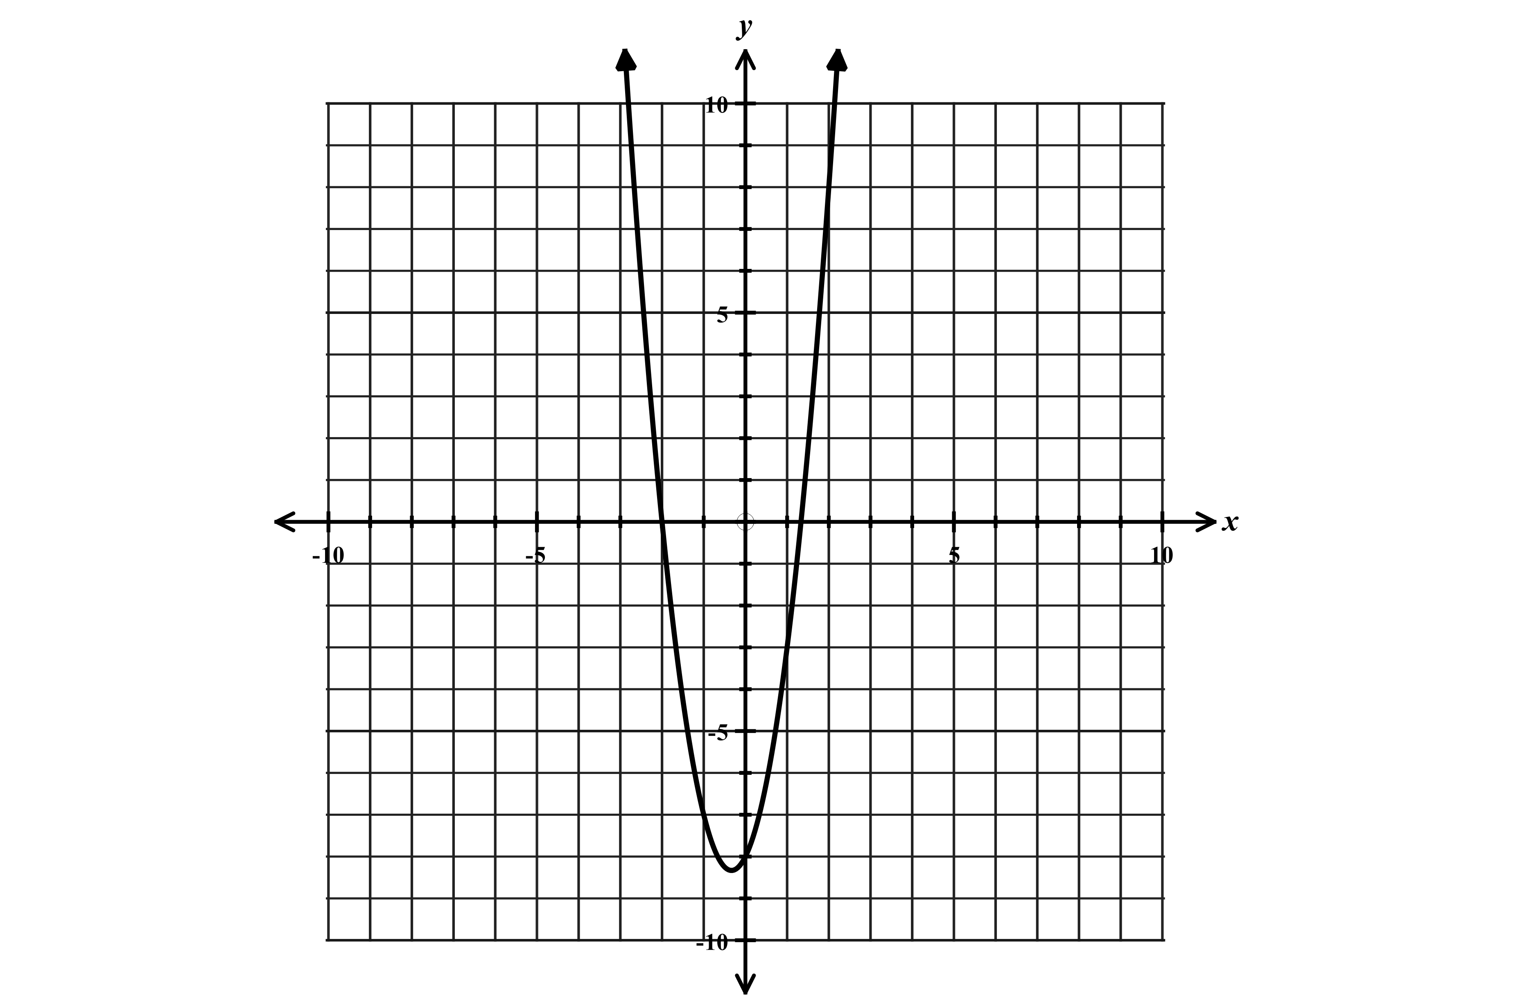
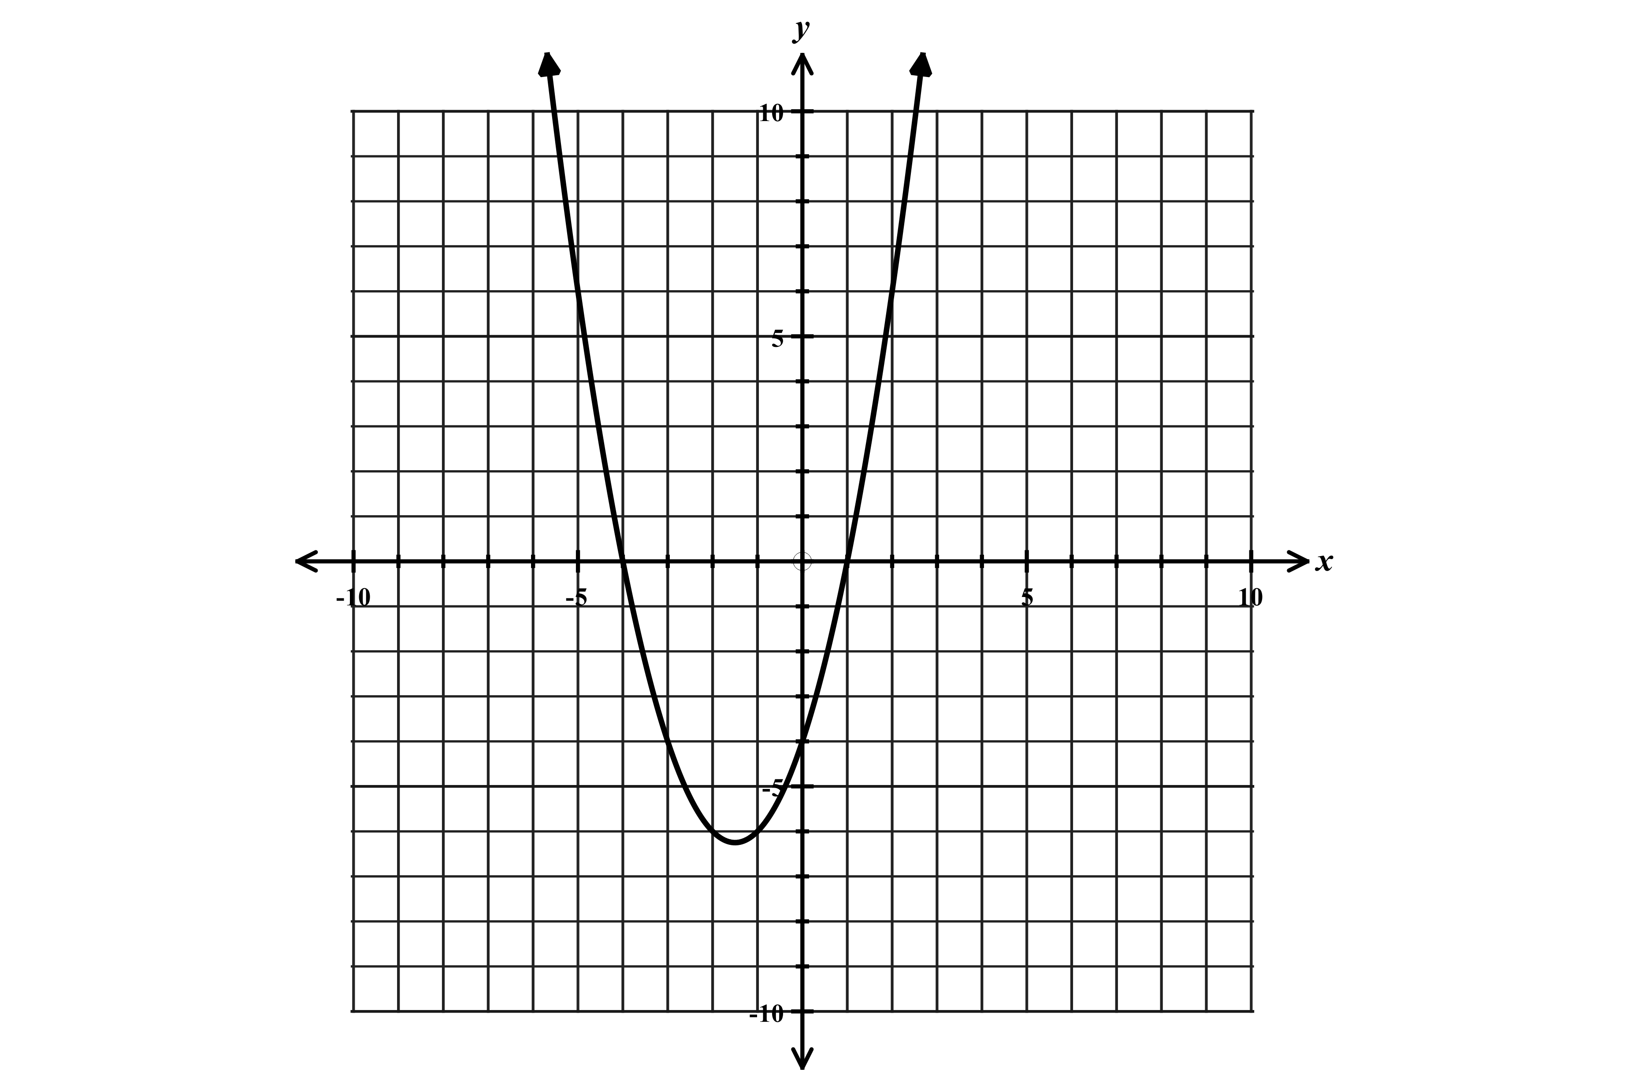
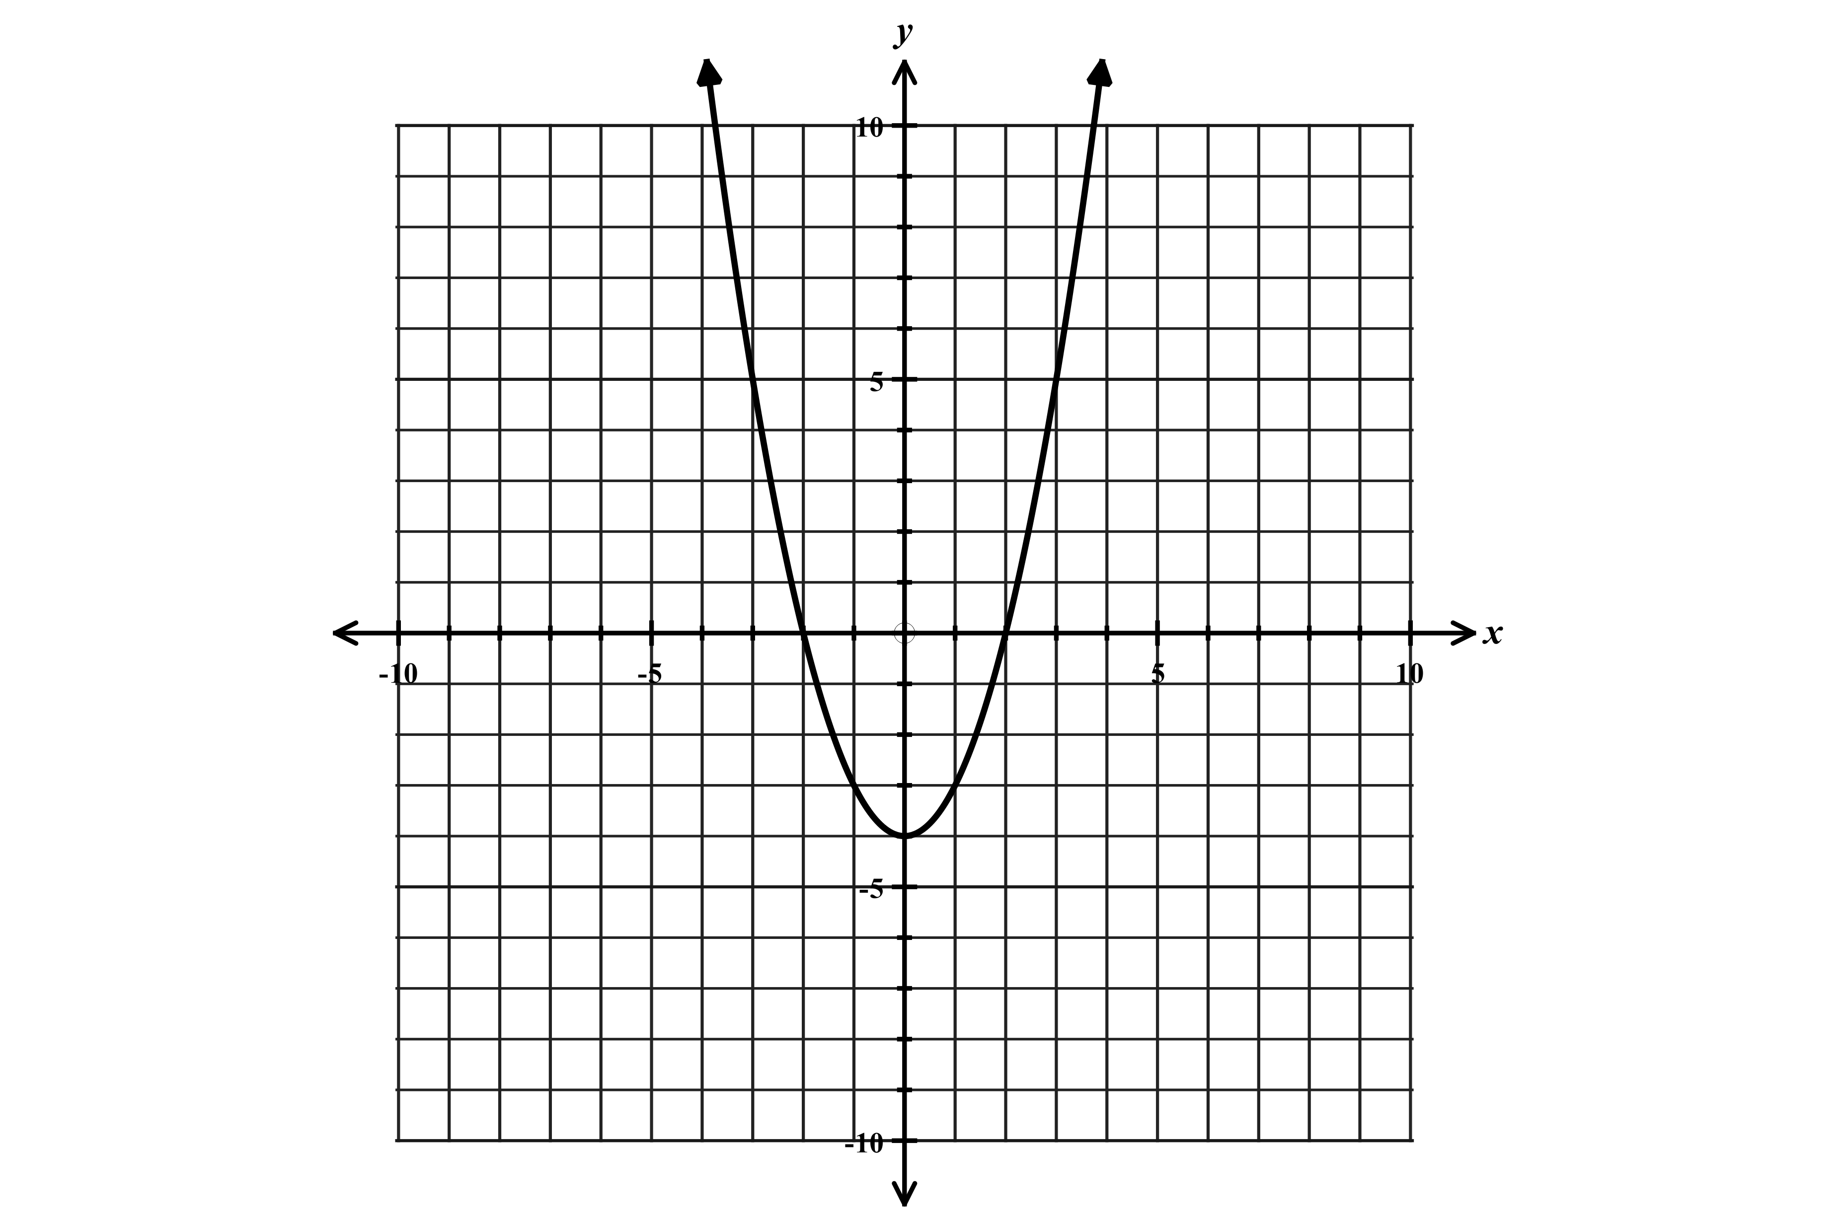
$y=x^{2}-4$ $y=x^{2}+3x-4$ $y=3x^{2}+x-4$ $y=\frac{1}{2}x^{2}-2x+3$

Shifted down 4 units Shifted left and down “Compressed” “Stretched”
“More narrow” “Wider”
$a>1$ $0<x<1$

Roots of a quadratic
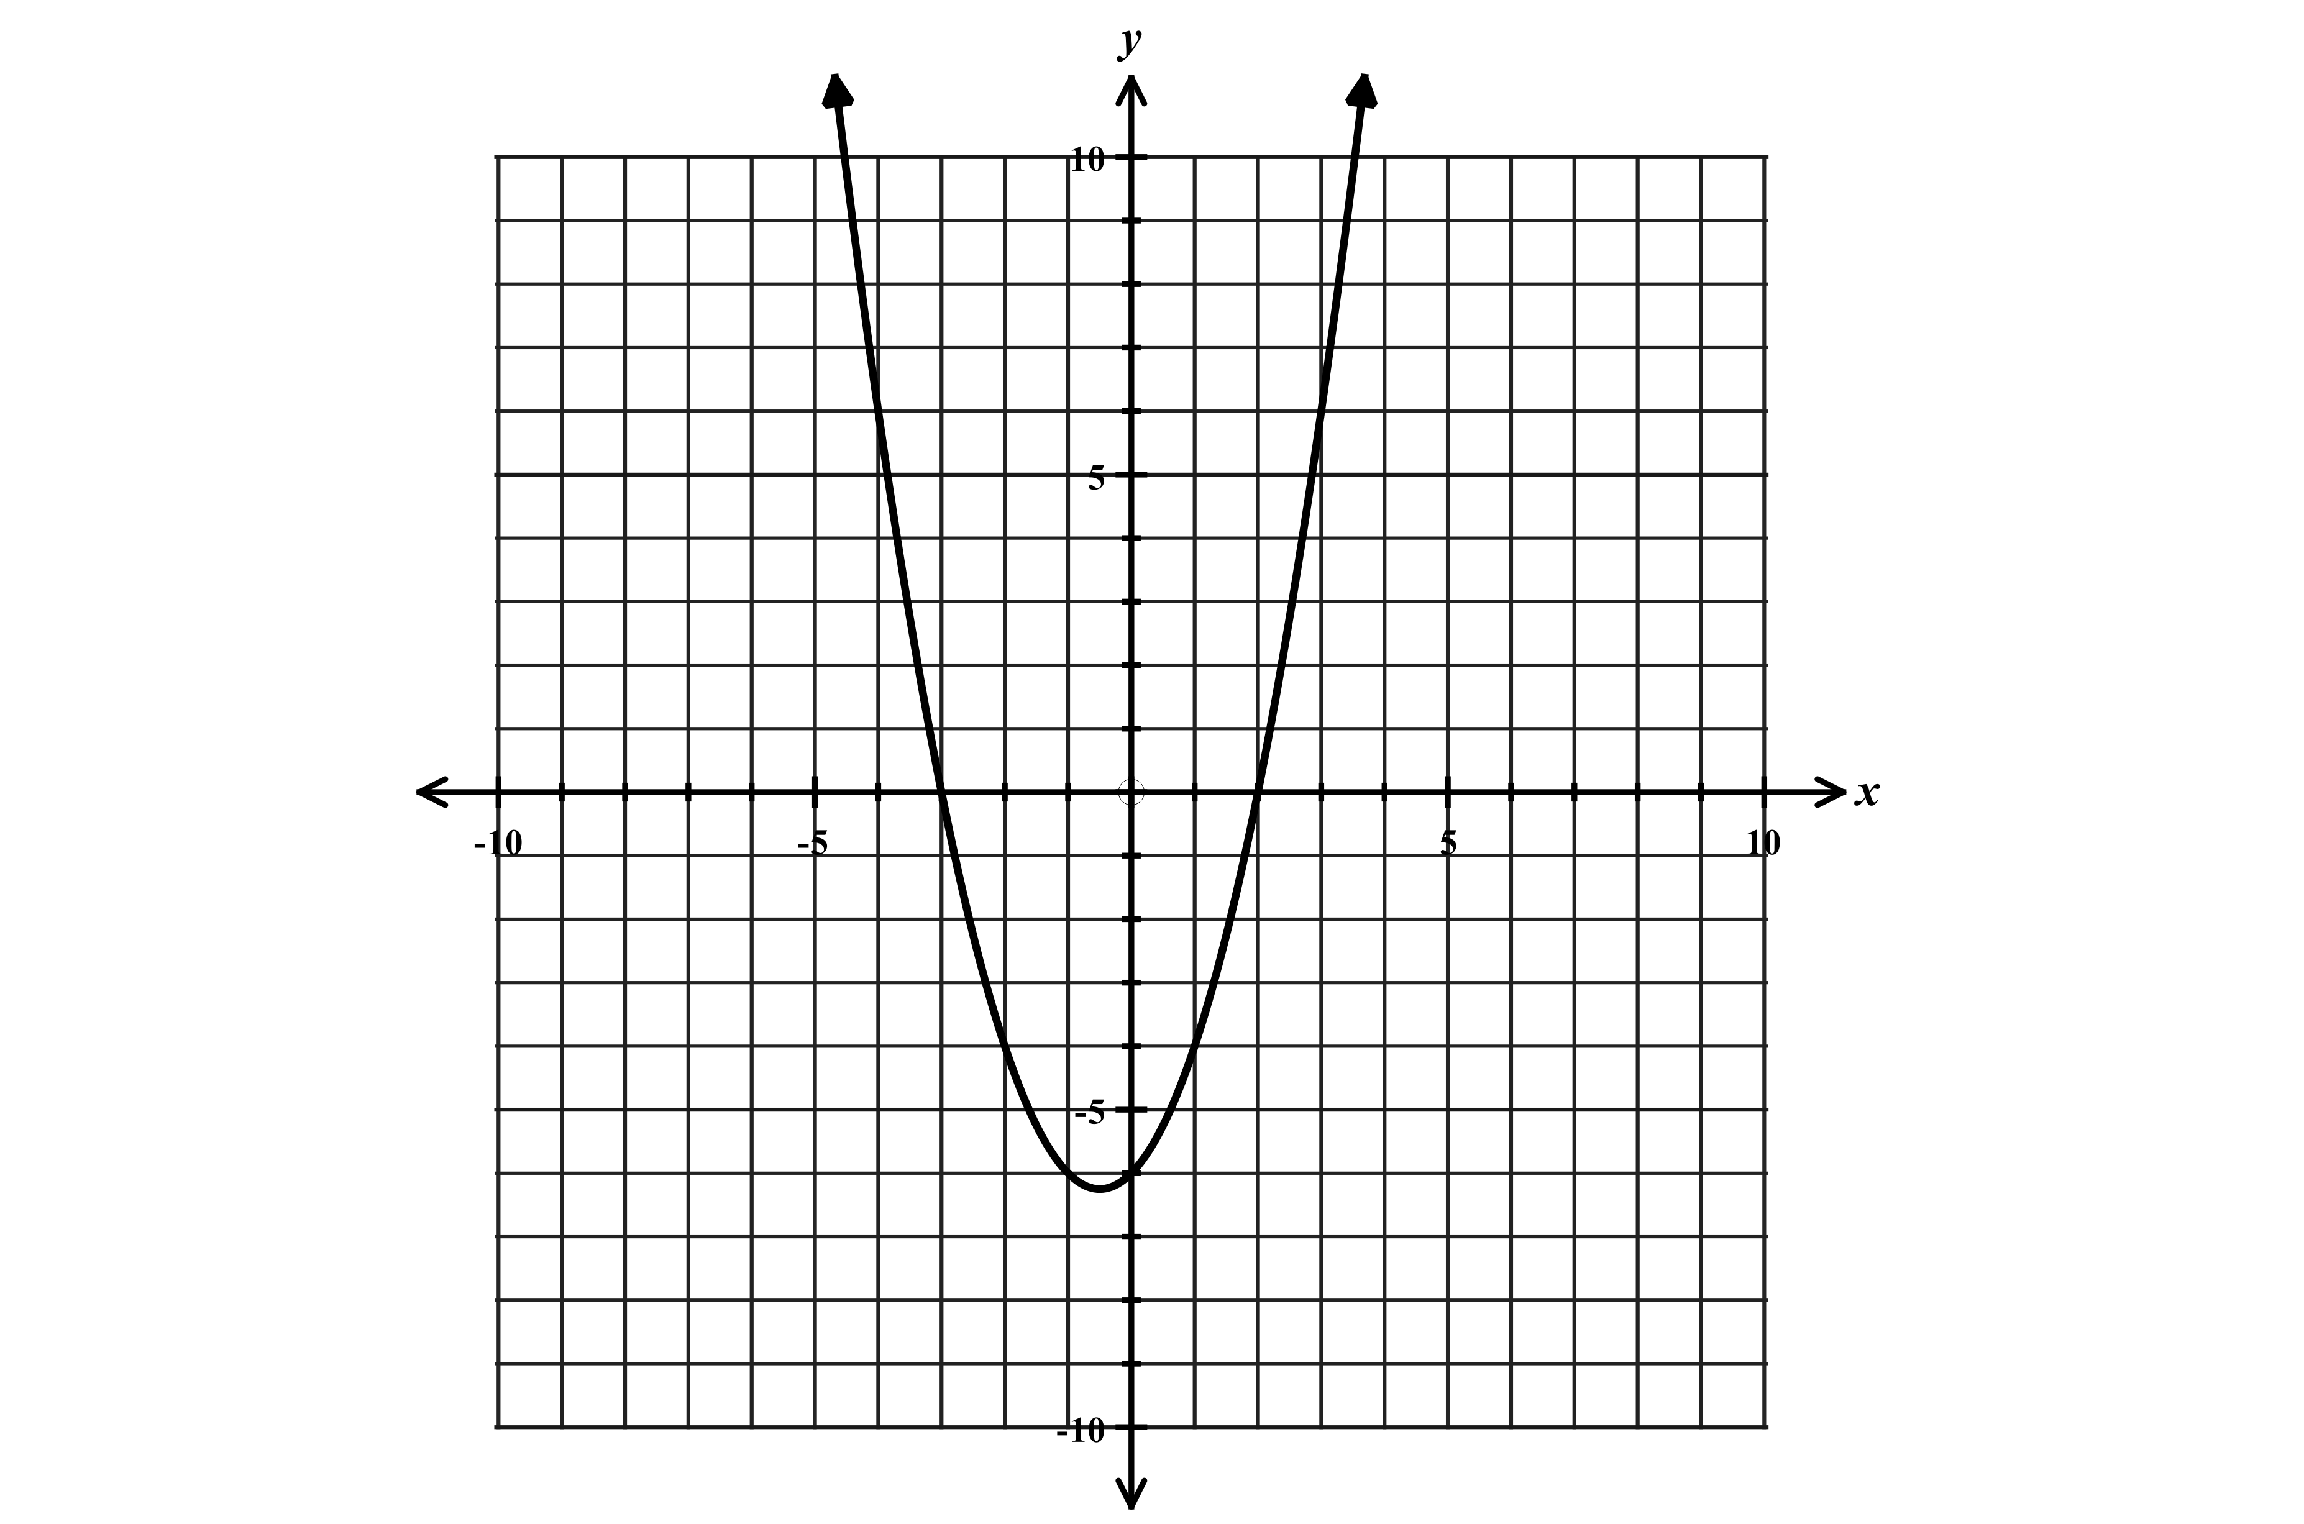
$y=x^{2}+x-6$ $y=3x^{2}-2x-8$ $y=x^{2}+4x-2$
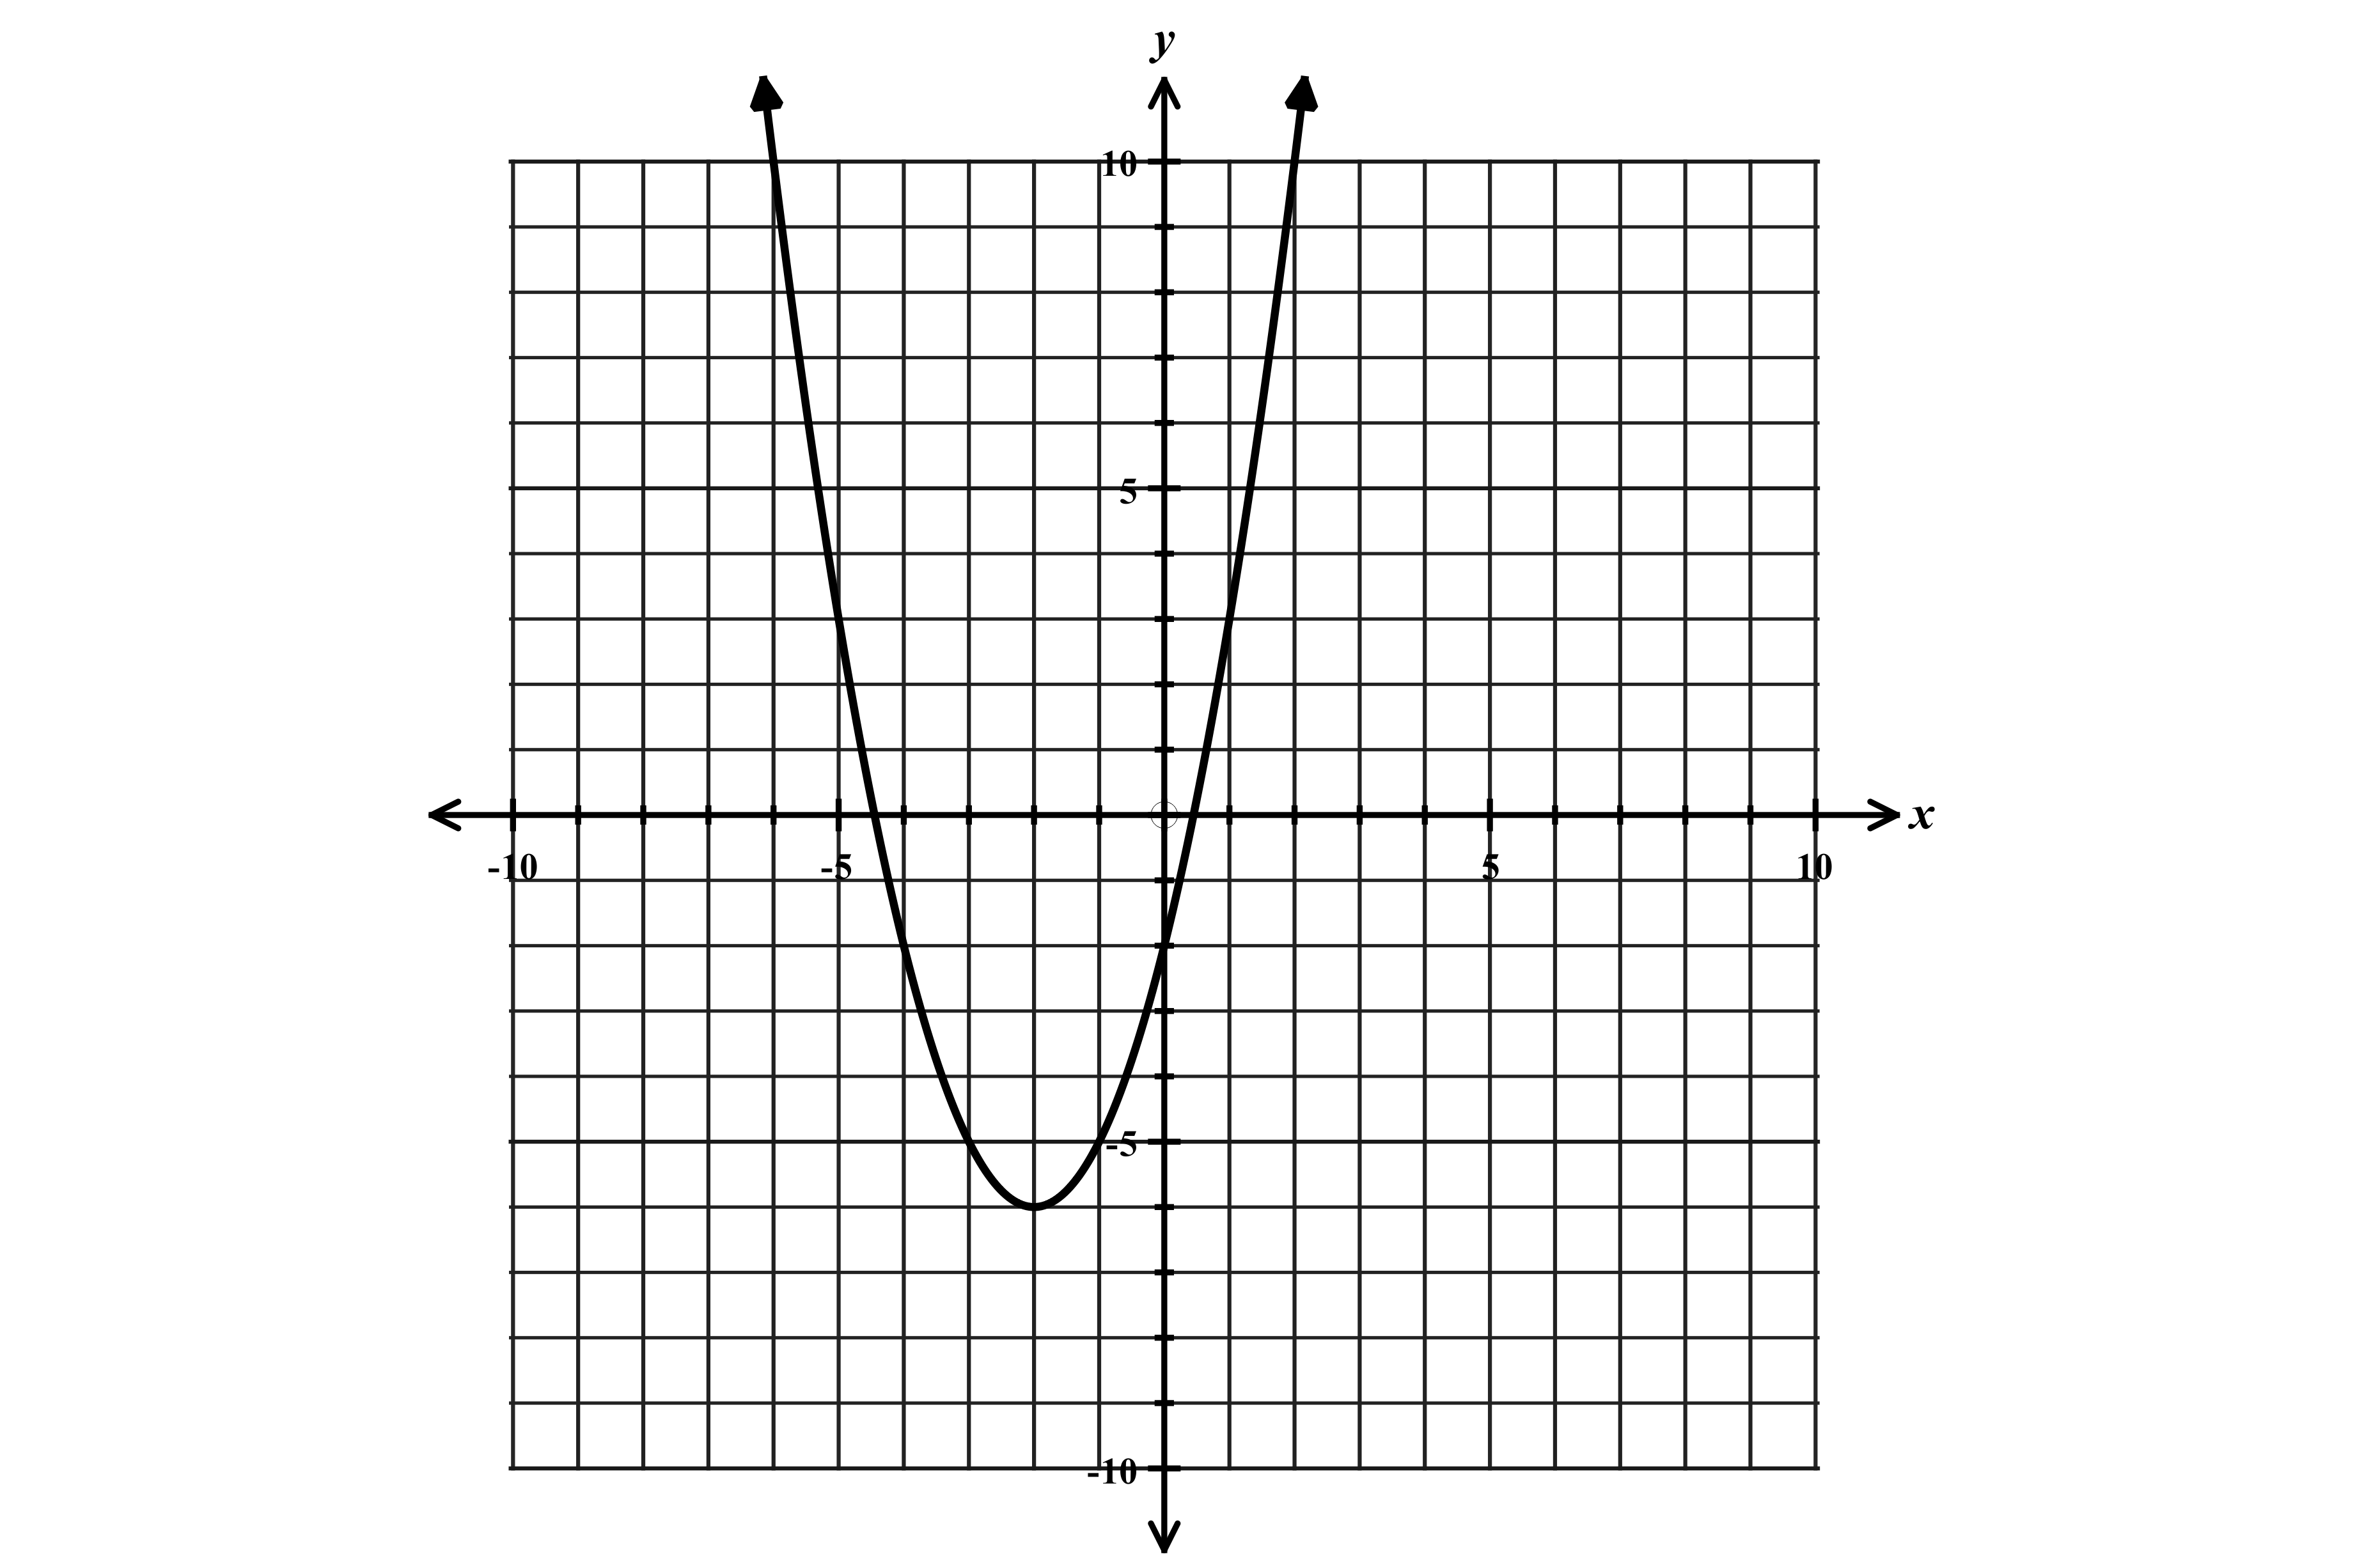
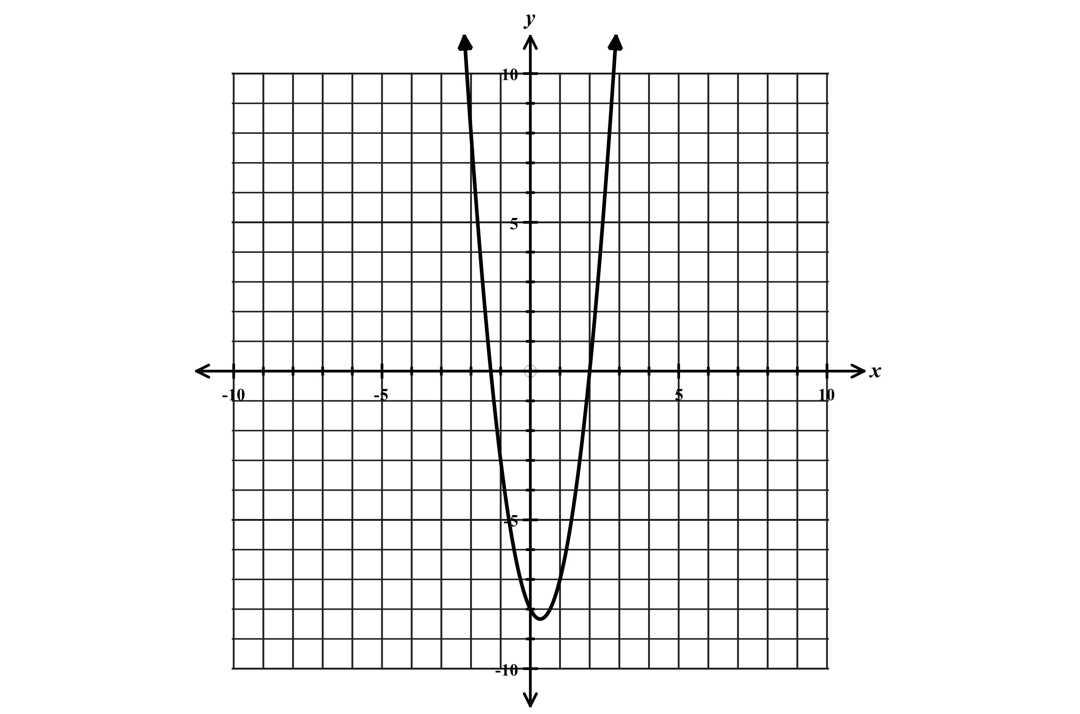

Two rational roots Two rational roots Two irrational roots – Won’t factor
Factored form of equation $y=(x+3)(x-2)$ Factored form $y=(3x+4)(x-2)$ Need completing the square
Roots $x=-3 and x=2$ or $\left\{-3,2\right\}$ Roots $x=-\frac{4}{3} and x=2$ or $\left\{-\frac{4}{3},2\right\}$ Quadratic formula

Vertex form of a quadratic
$$y={(x-h)}^{2}+k$$

$y={(x-5)}^{2}$ $y={(x+4)}^{2}-5$ $y=-2{\left(x-4\right)}^{2}+8$
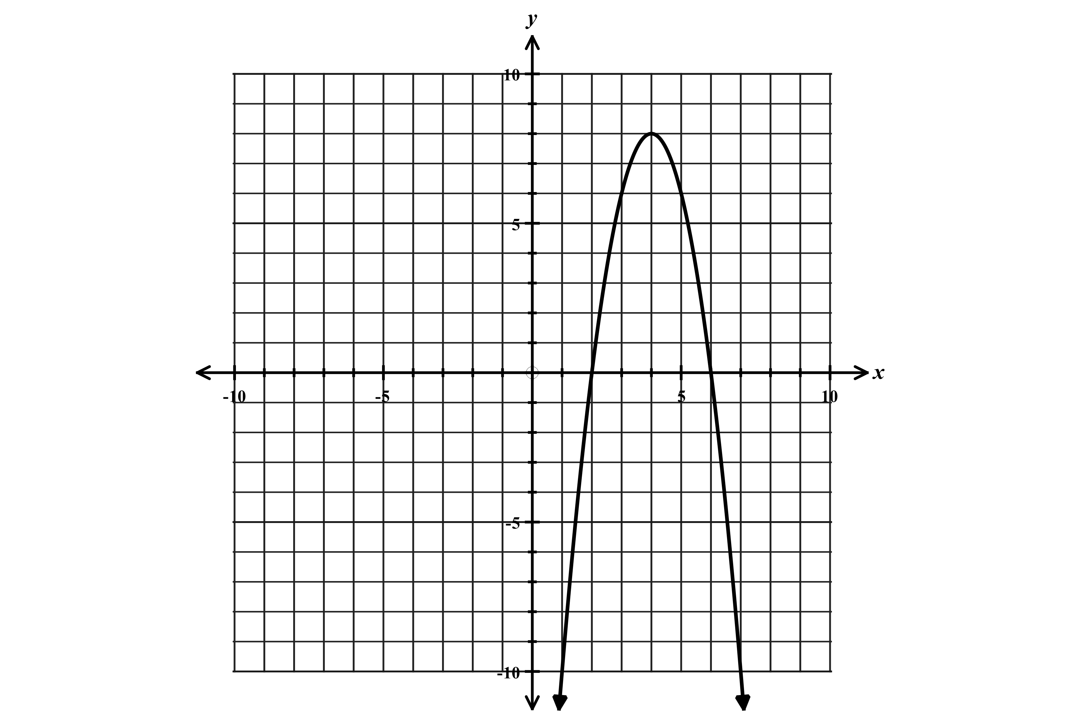
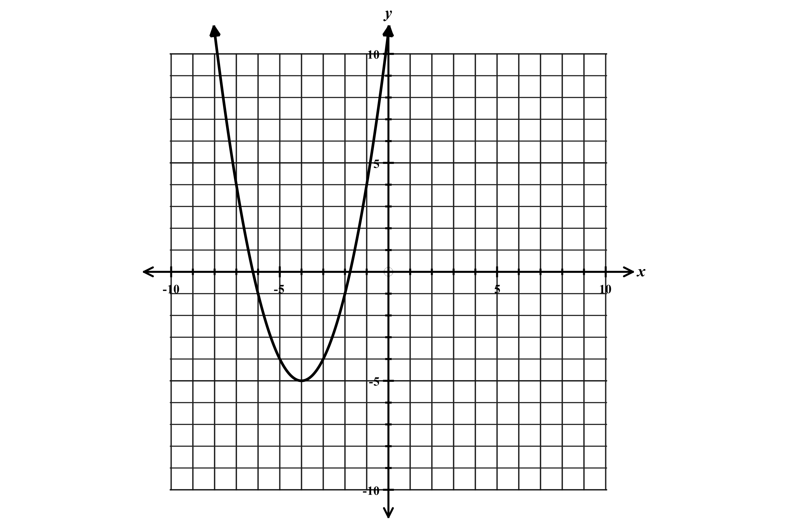
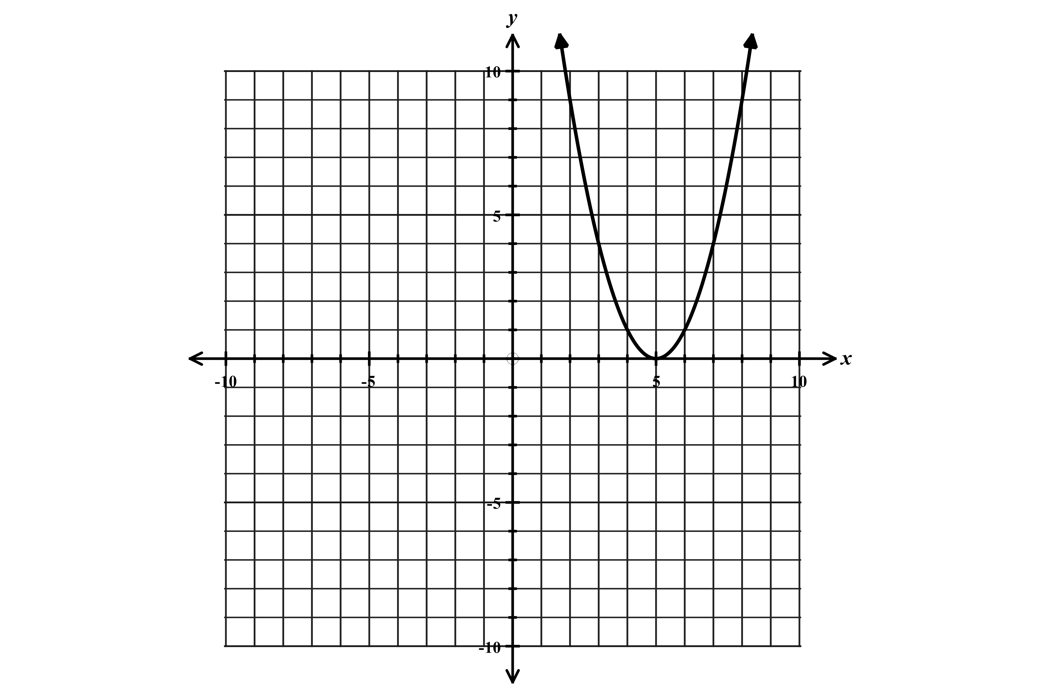

Vertex: $(5,0)$ Vertex: $(-4,-5)$ Vertex: $(4,8)$
Shifted right 5 units Shifted left 4 units and down 5 units Shifted right 4 units and up 8 units
Domain: $-∞<x<∞$ or $(-∞,∞)$ Domain: $-∞<x<∞$ or $(-∞,∞)$ Flipped: $a<0$: a is negative
Range: $y≥0$ or $[0,∞)$ Range: $y≥-5$ or $[-5,∞)$ Compressed or narrower
Domain: $-∞<x<∞$ or $(-∞,∞)$
Range: $y≤8$ or $(-∞,8]$

Function 5: Square root function

Parent Function: $y=\sqrt{x}$ General form of square root function: $y=a\sqrt{x-c}+d$
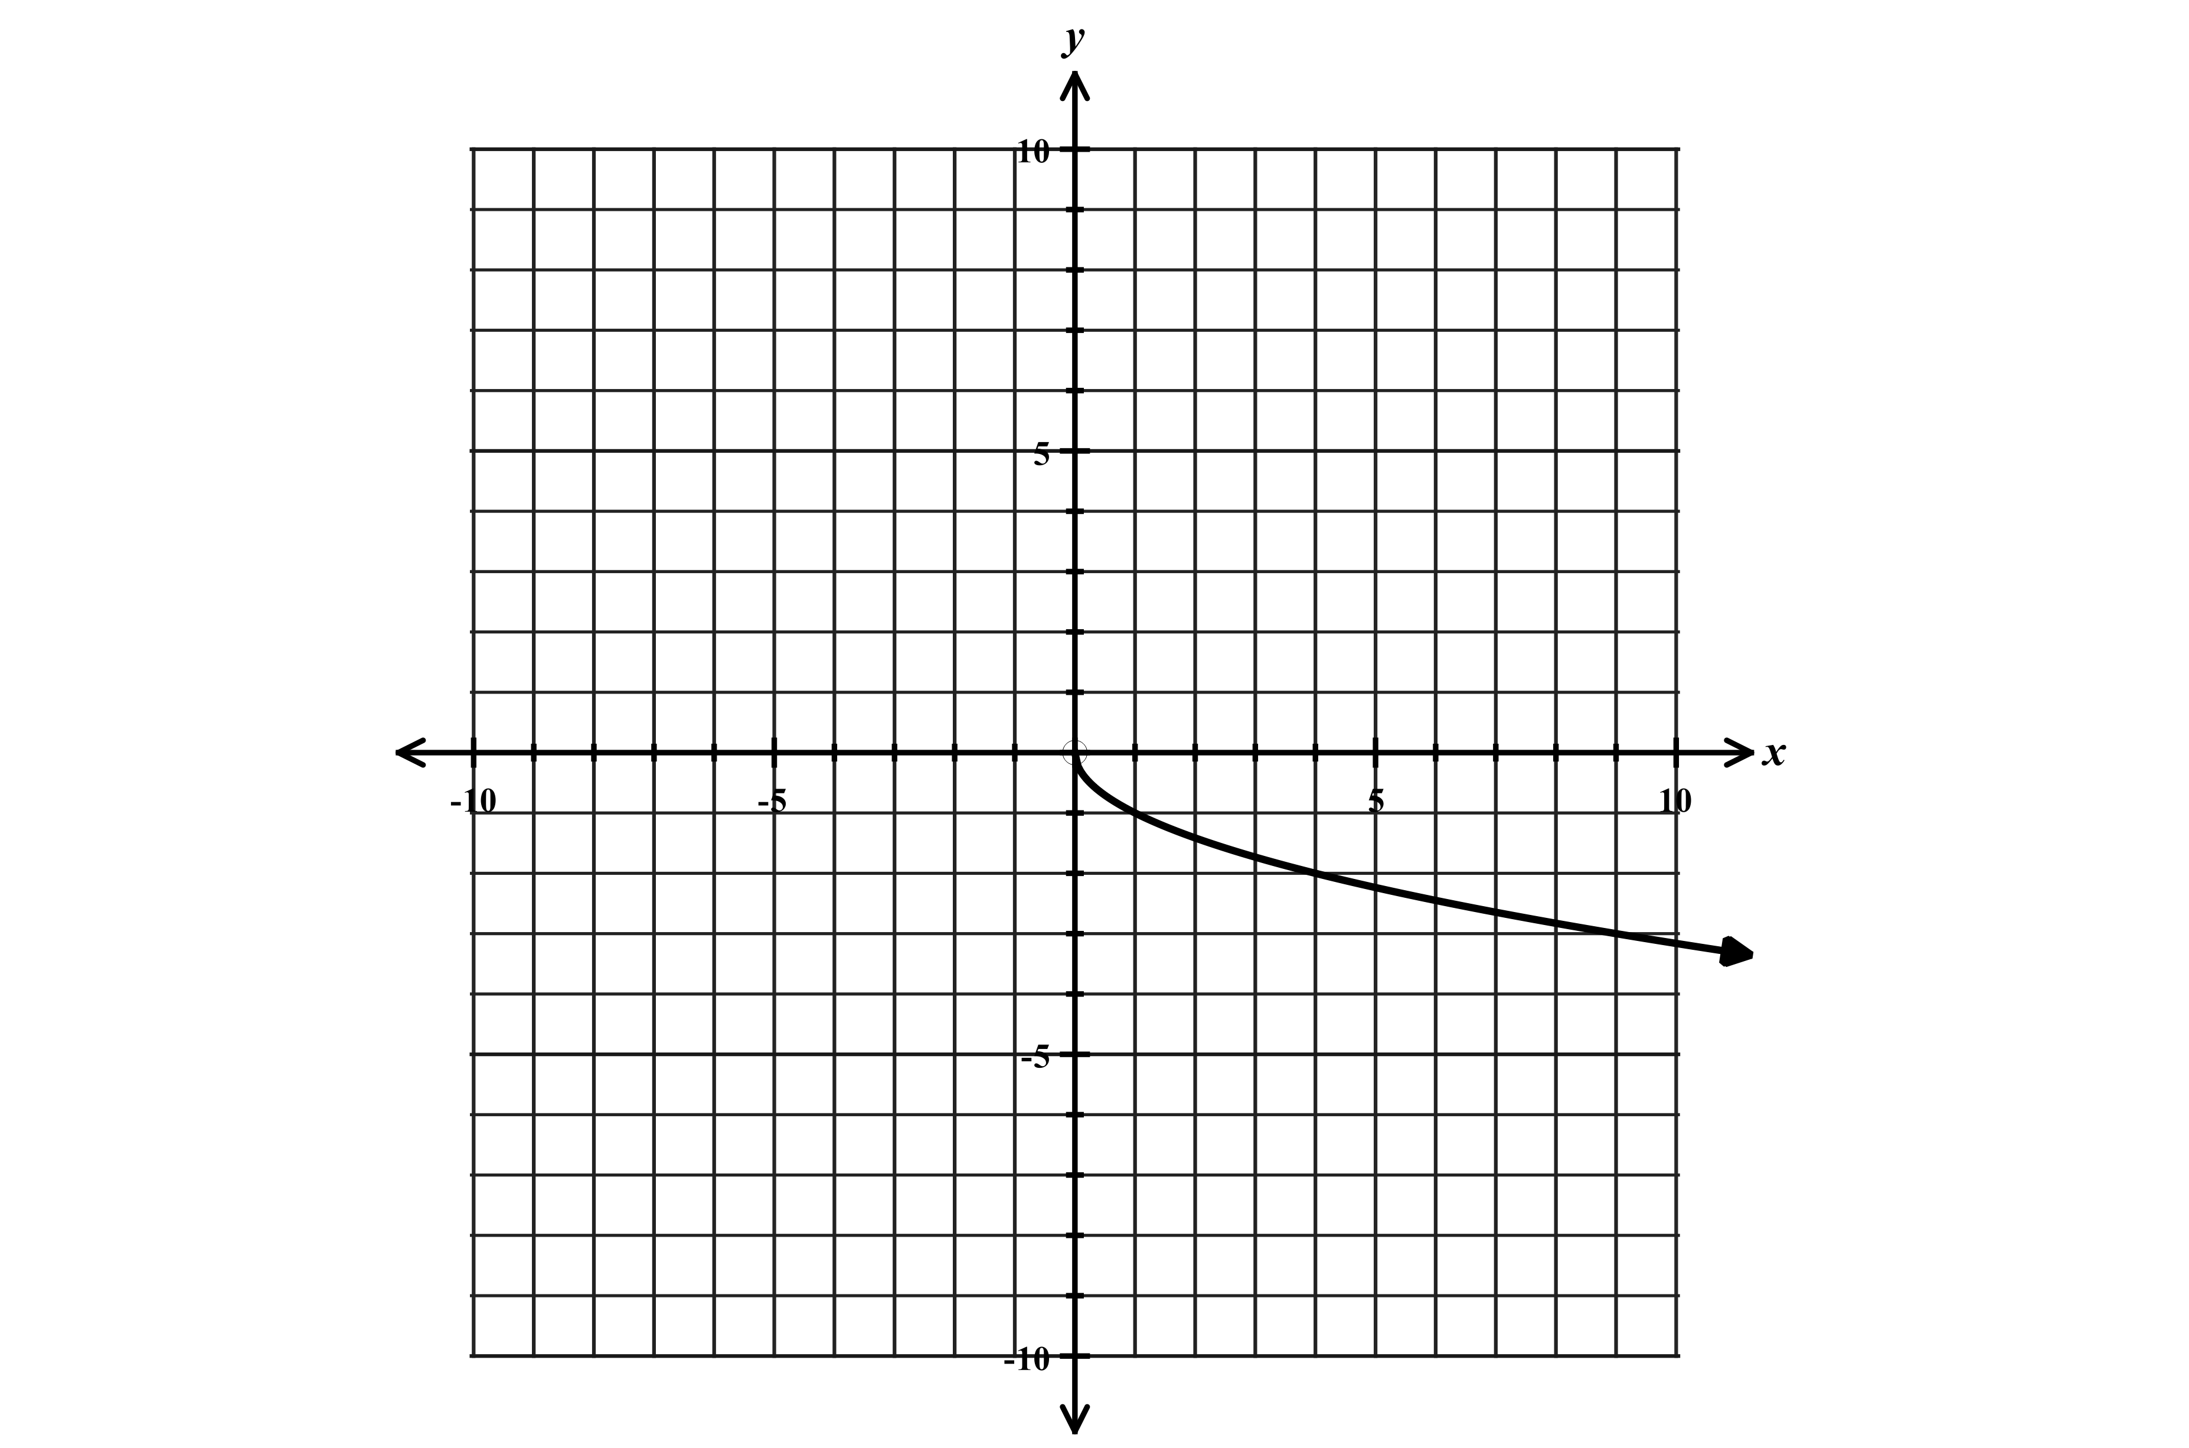
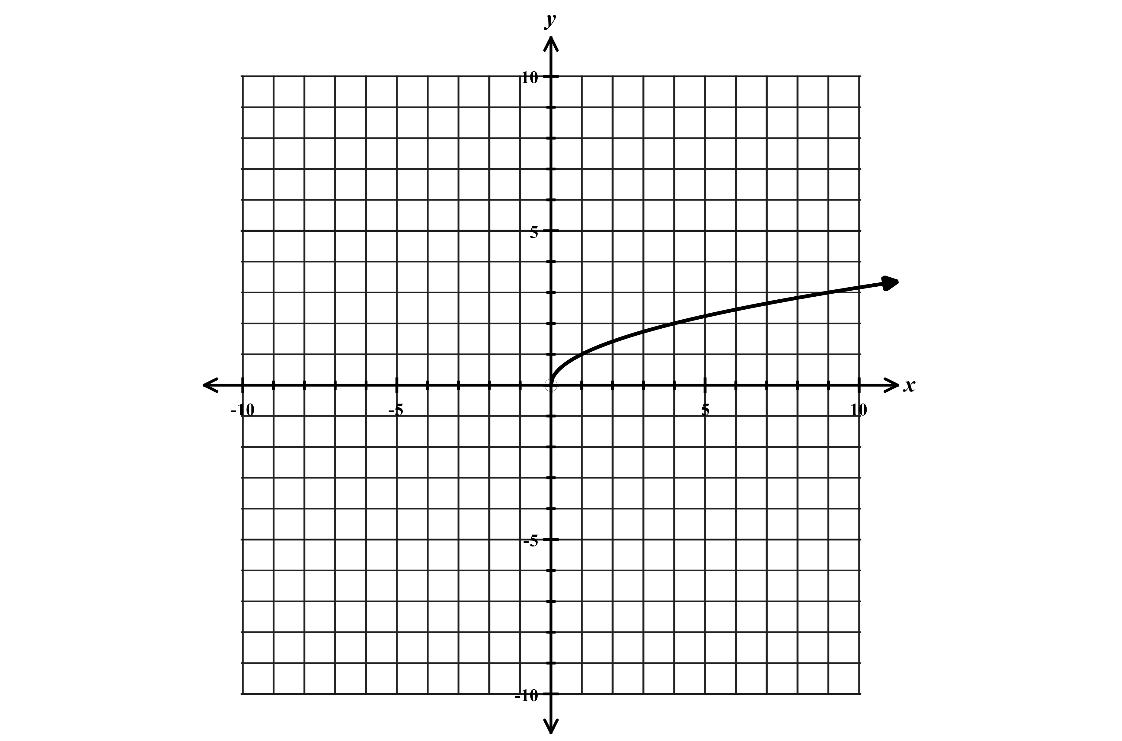
Graph of $y=\sqrt{x}$ Graph of $y=-\sqrt{x}$

Increasing over the interval $x>0$ or $\left(0,∞\right)$ Decreasing over the interval$x>0$ or $\left(0,∞\right)$ “Flipped”
$$x$$ | $$y$$
0 | 0
1 | 1
4 | 2
9 | 3
16 | 4
25 | 5
Domain $0≤x<∞$ or $[0,∞)$ Domain $0≤x<∞$ or $[0,∞)$
Range $0≤y<∞$ or $[0,∞)$ Range $-∞<y≤0$ or $(-∞,0]$

Shifting, compressing, and stretching square root functions

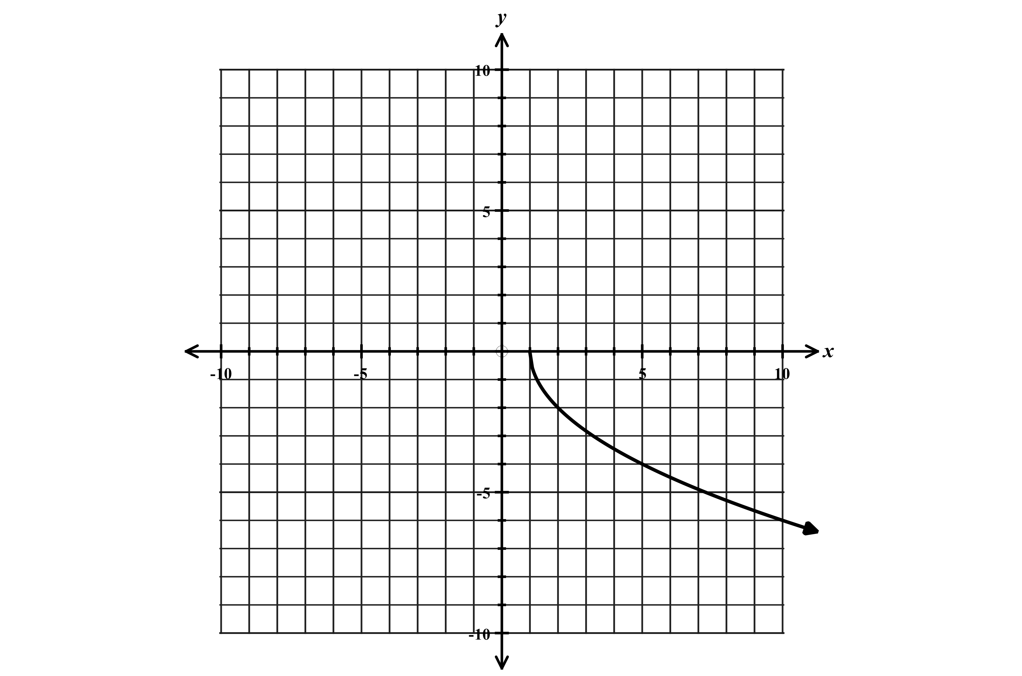
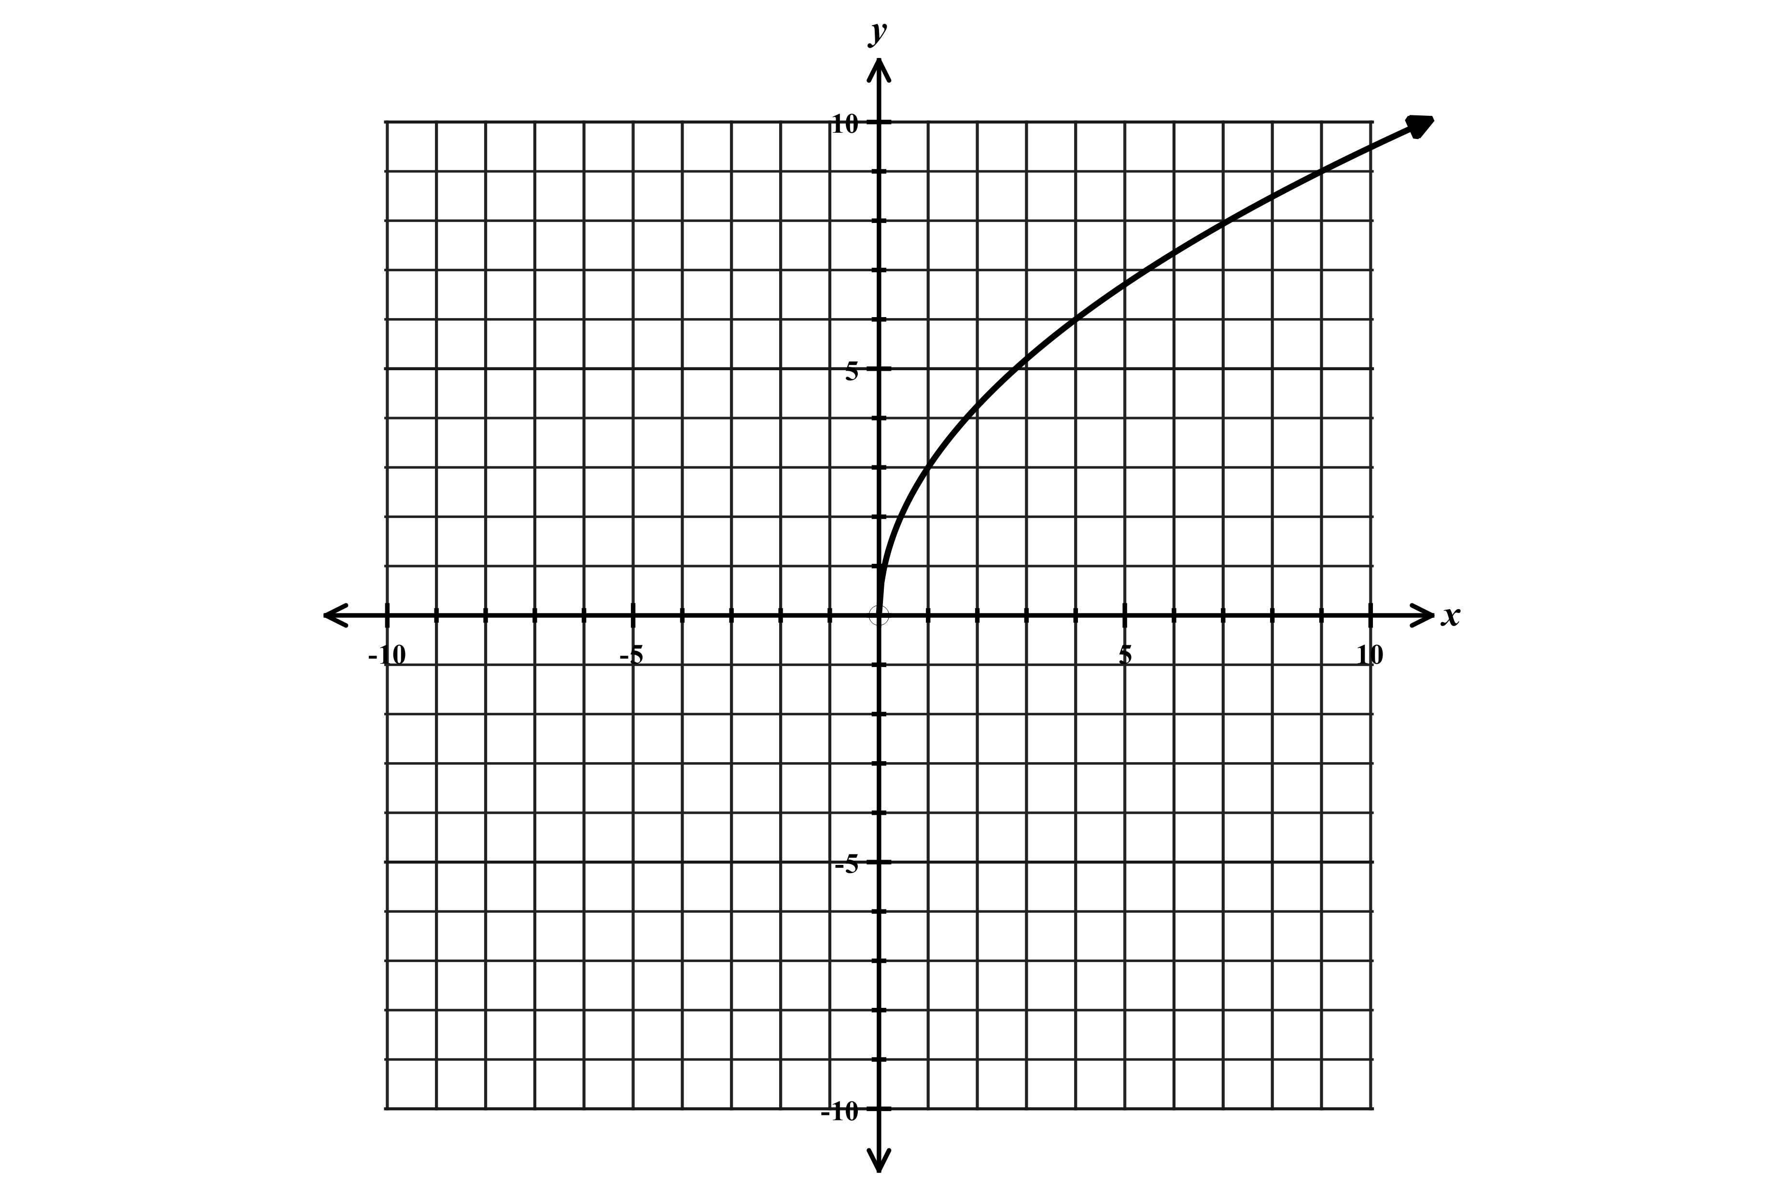
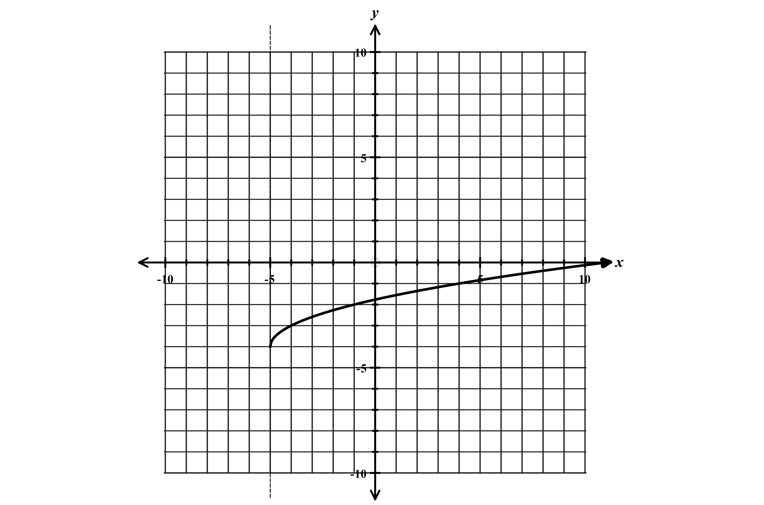
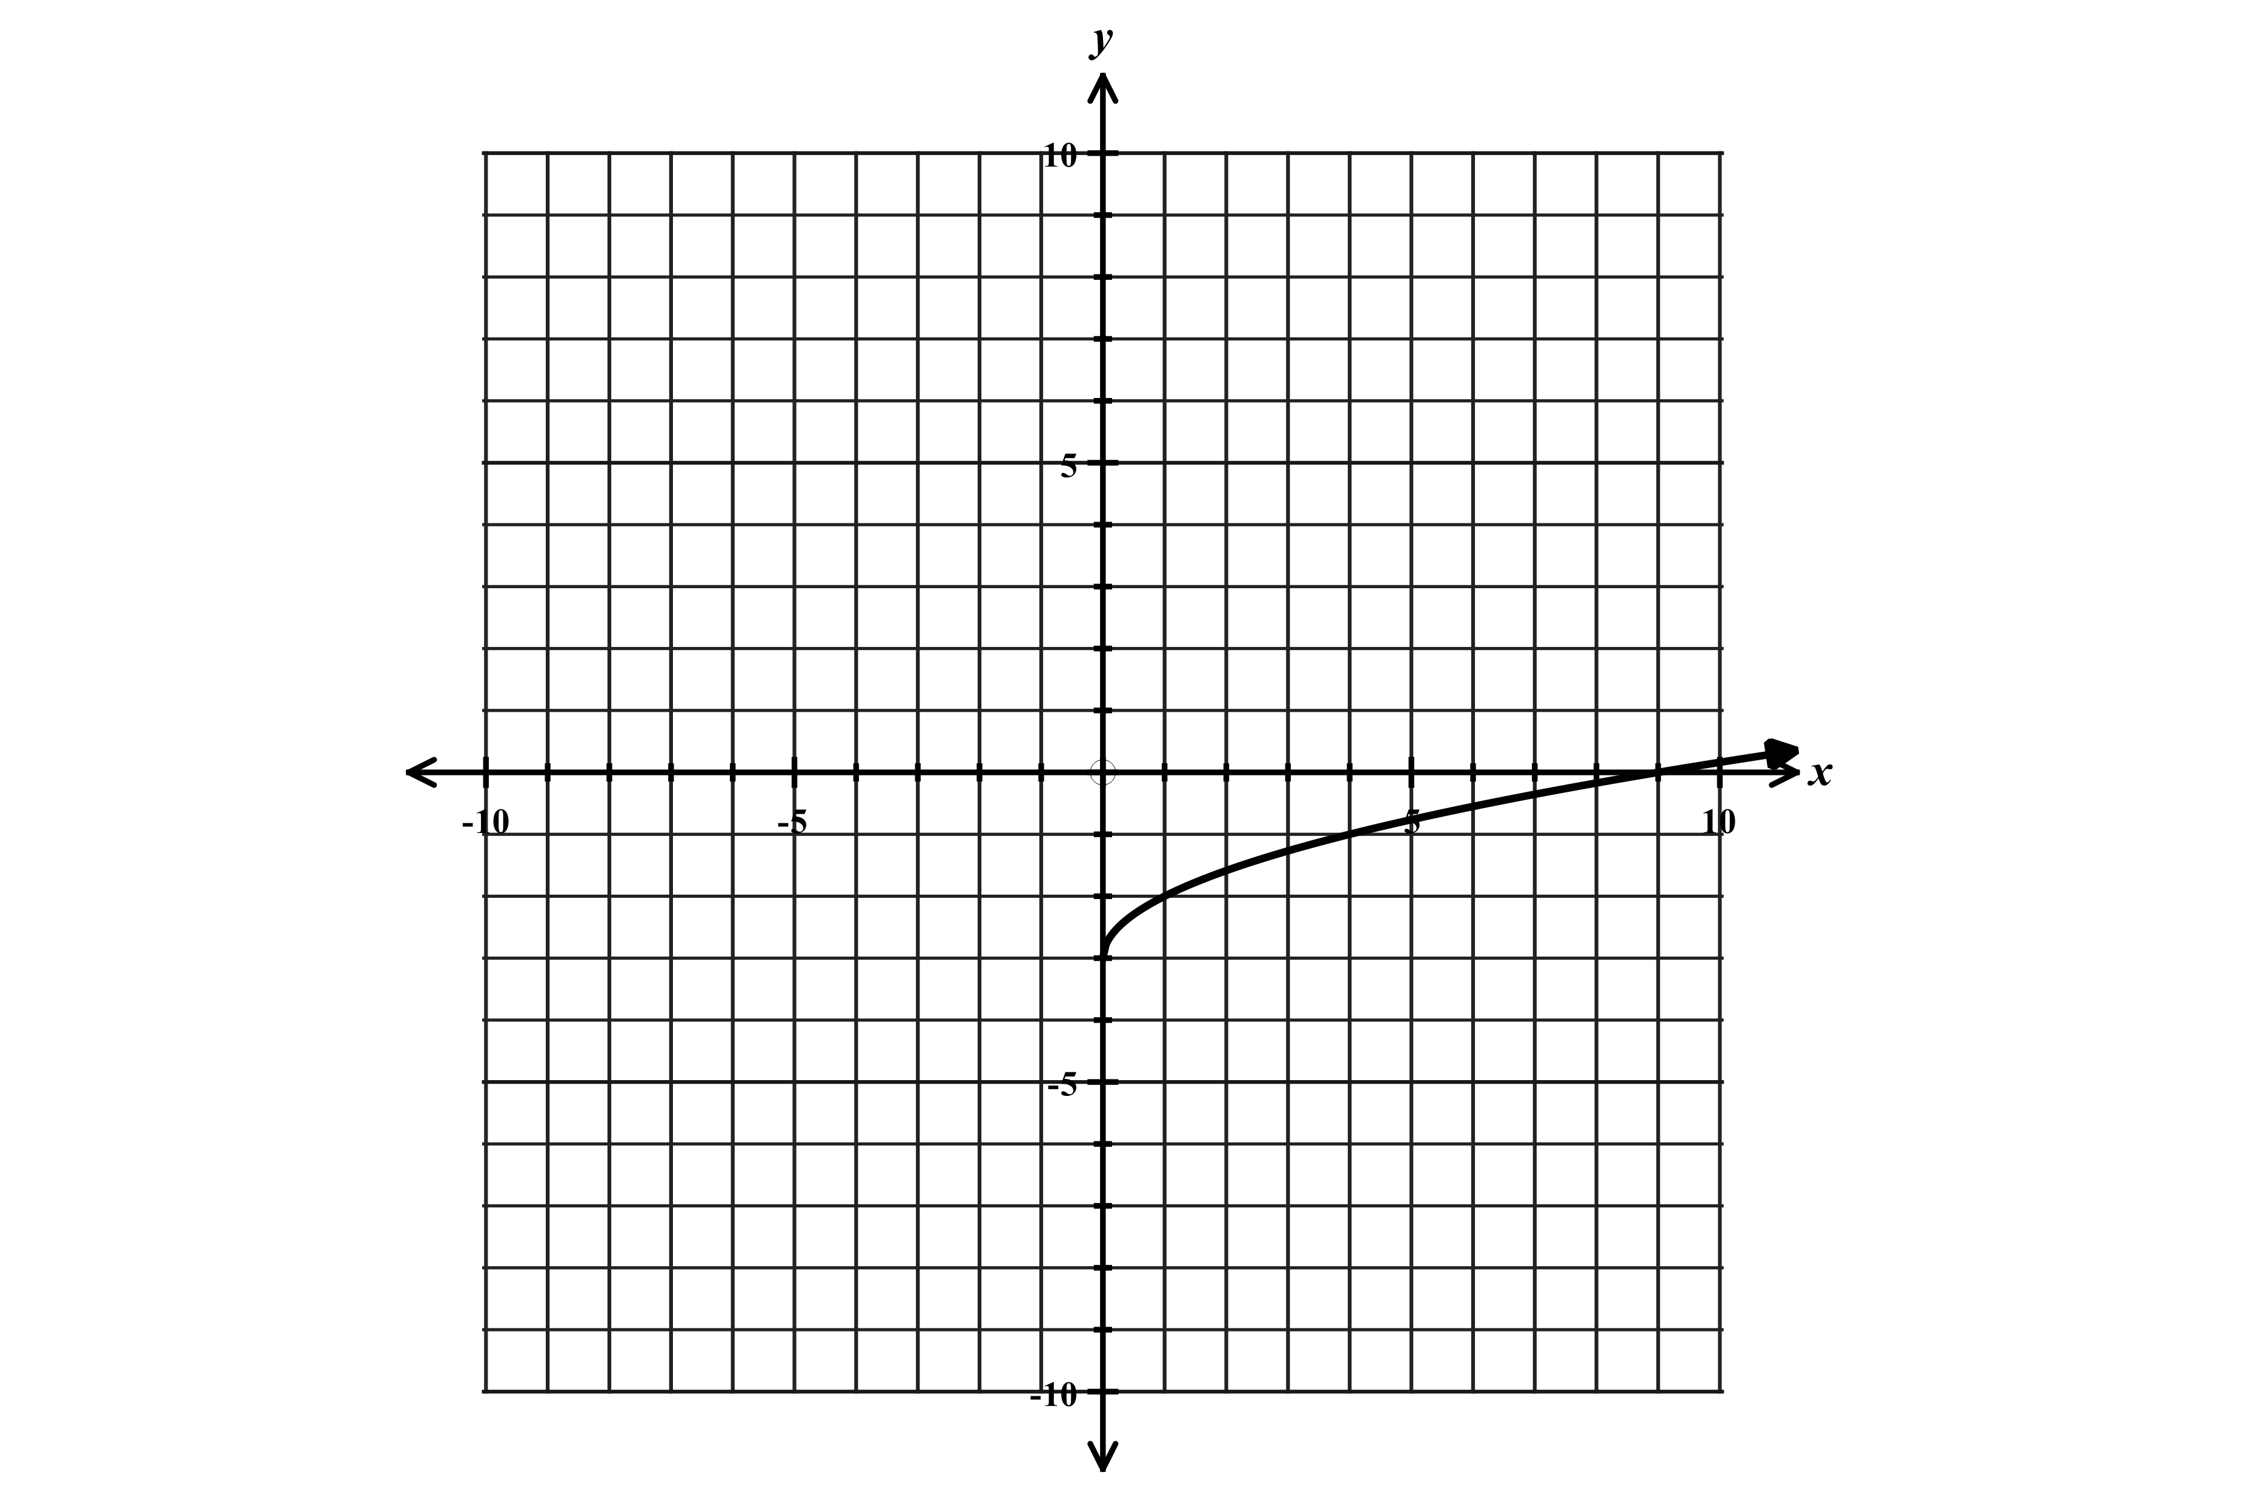
$y=\sqrt{x}-3$ $y=\sqrt{x+5}-4$ $y=3\sqrt{x}$ $y=-2\sqrt{x-1}$

Shifted down 3 units Shifted left 5 down 4 Stretched vertically Flipped, stretched, and right 1
Domain $x≥0$ or $[0,∞)$ Domain $x≥-5$or $[-5,∞)$ Domain $x≥0$ or $[0,∞)$ Domain $x≥1$ or $[1,∞)$
Range $y≥-3$ or $[-3,∞)$ Range $y≥-4$or $[-4,∞)$ Range $y≥0$ or $[0,∞)$ Range $y≤0$ or $(-∞,0]$

Function 6: Cube root function

Parent function: $y=\sqrt[3]{x}$ General form of a cube root function $y=a\sqrt[3]{x-c}+d$

Graph of $y=\sqrt[3]{x}$ Graph of $y=-\sqrt[3]{x}$
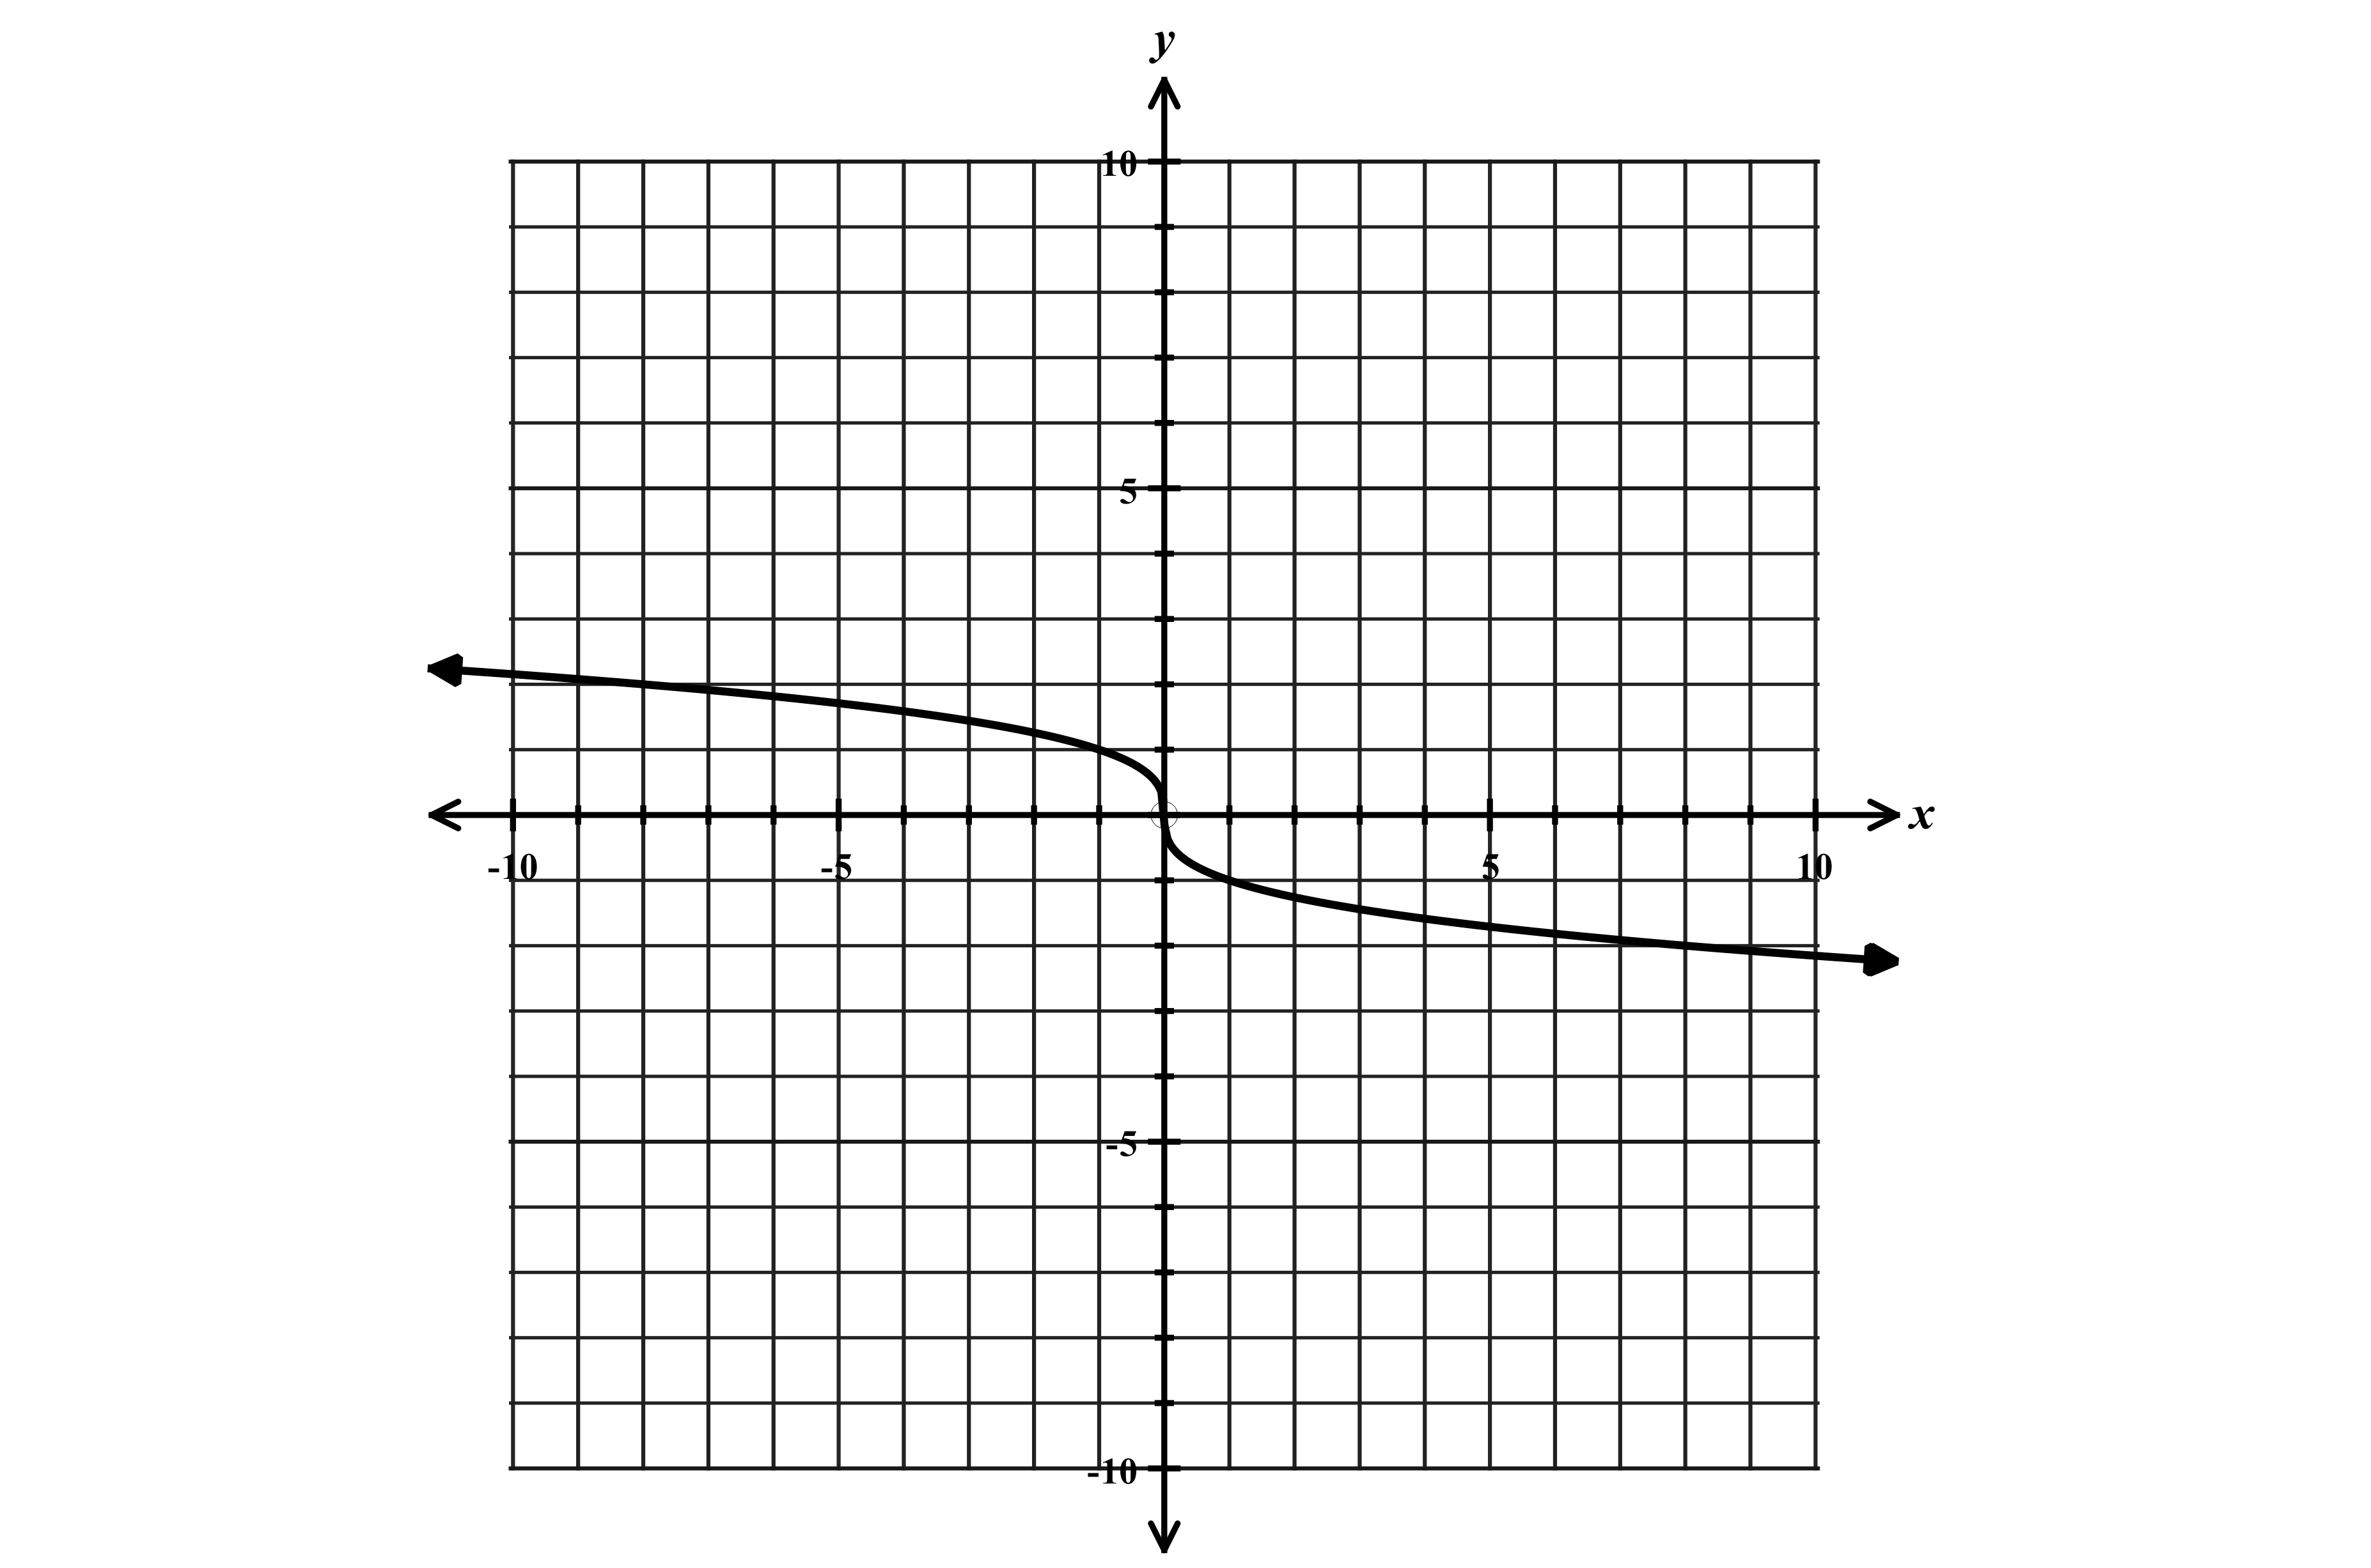
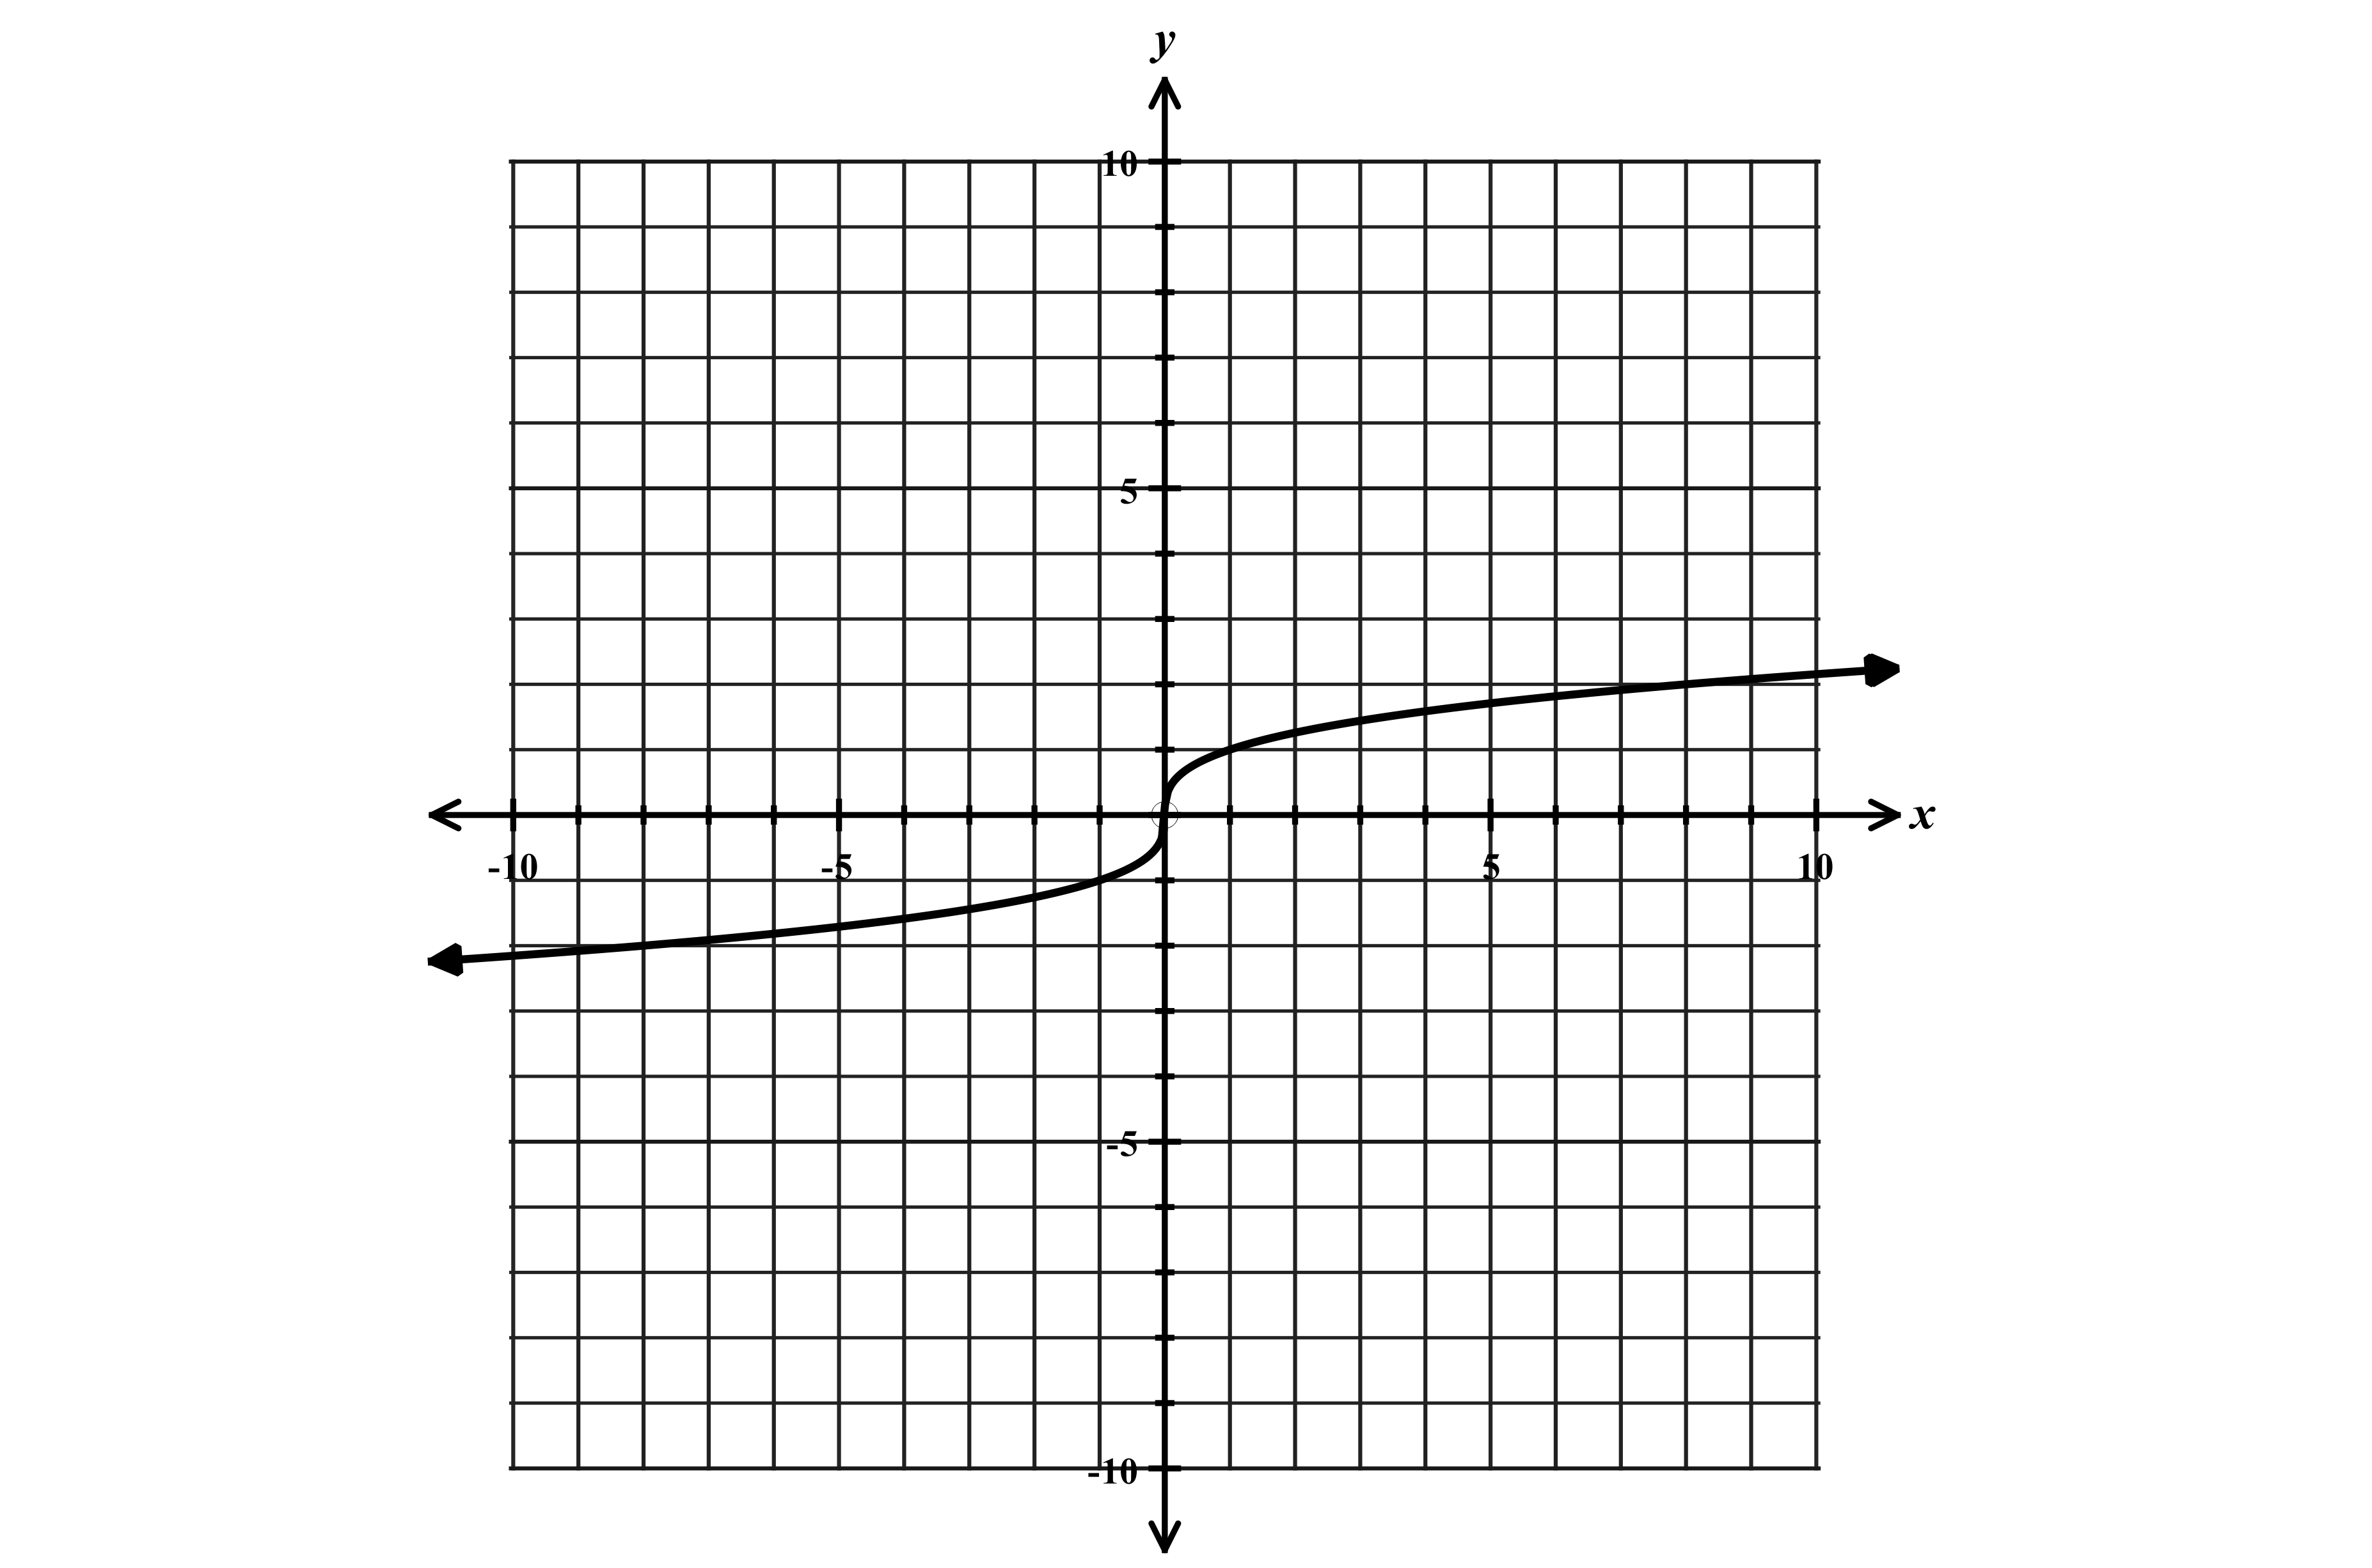

$$x$$ | $$y$$
-8 | -2
-1 | -1
0 | 0
1 | 1
8 | 2
27 | 3

Domain: $-∞<x<∞$ or $(-∞,∞)$ Domain: $-∞<x<∞$ or $(-∞,∞)$
Range: $-∞<y<∞$ or $(-∞,∞)$ Range: $-∞<y<∞$ or $(-∞,∞)$
Flipped (negative coefficient) $a<0$

Shifting, compressing, and stretching cube root functions

$y=\sqrt[3]{x}+5$ $y=\sqrt[3]{x-4}-5$ $y=2\sqrt[3]{x}$
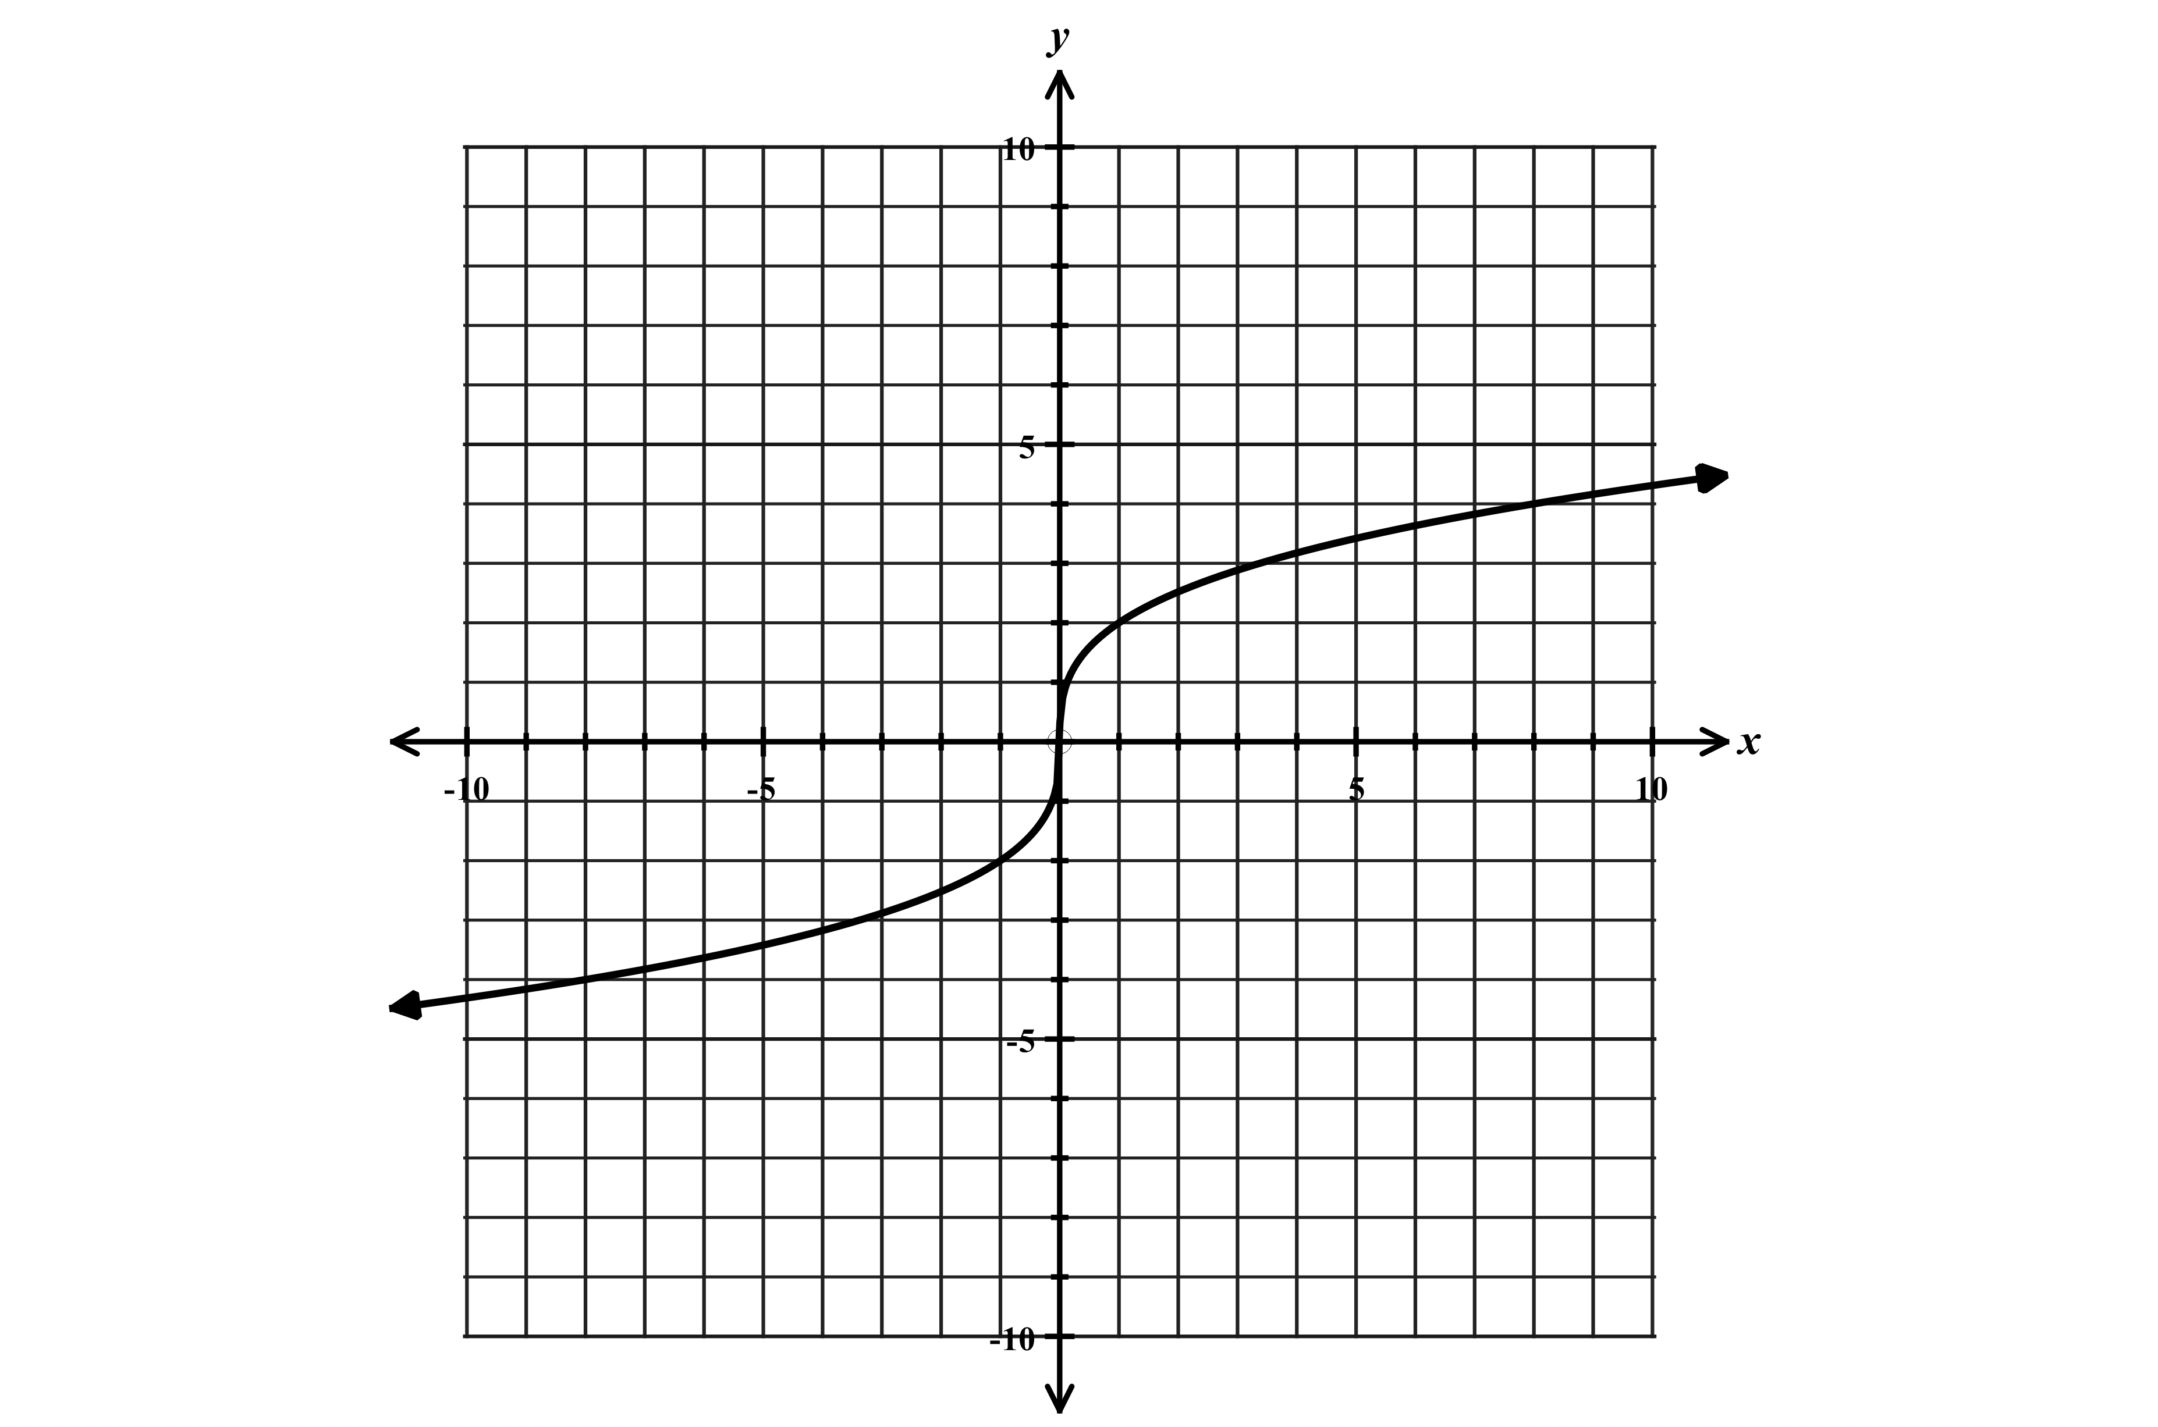
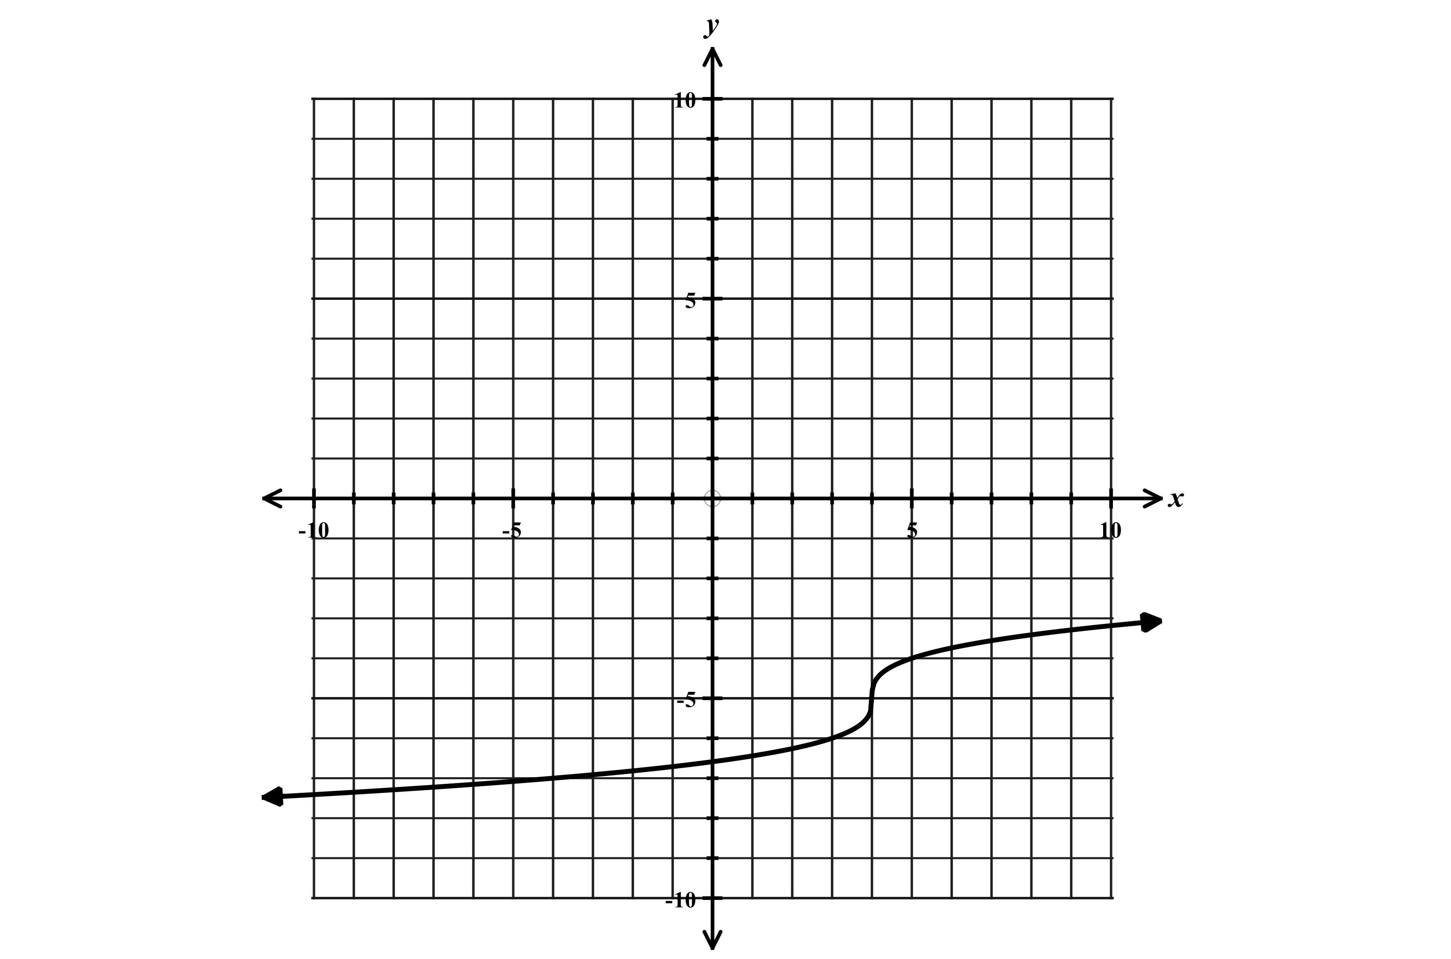
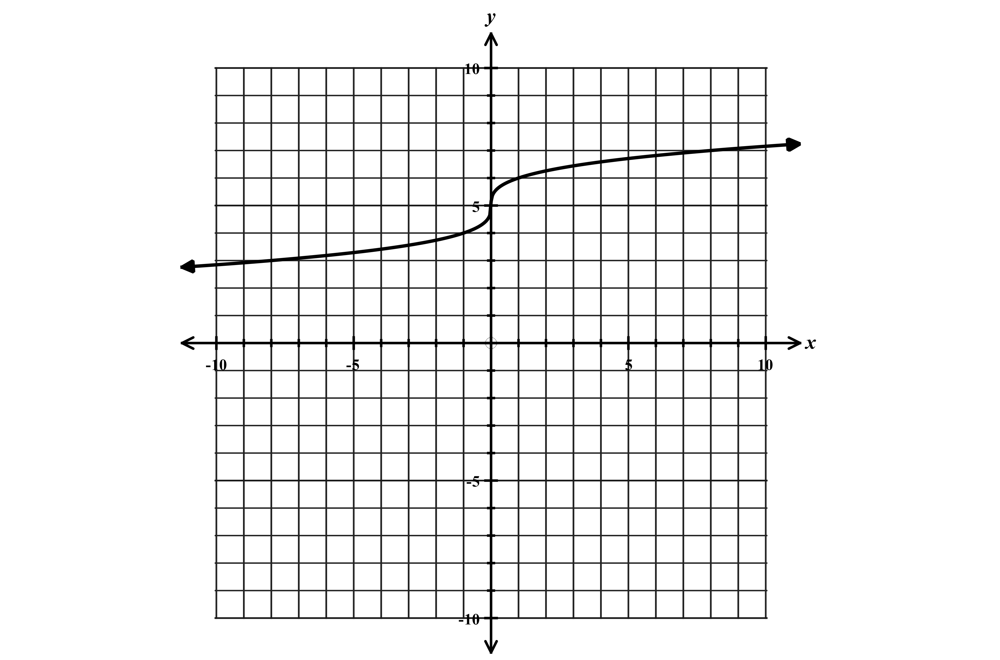

Shifted up 5 units Shifted right 4 units and down 5 stretched vertically

Restricting the Domain of Functions and the Effect on the Range

Often times we are asked to restrict the domain of a function and only graph the function over a specified interval.

The examples below show how to determine the range of a function when the domain is restricted.
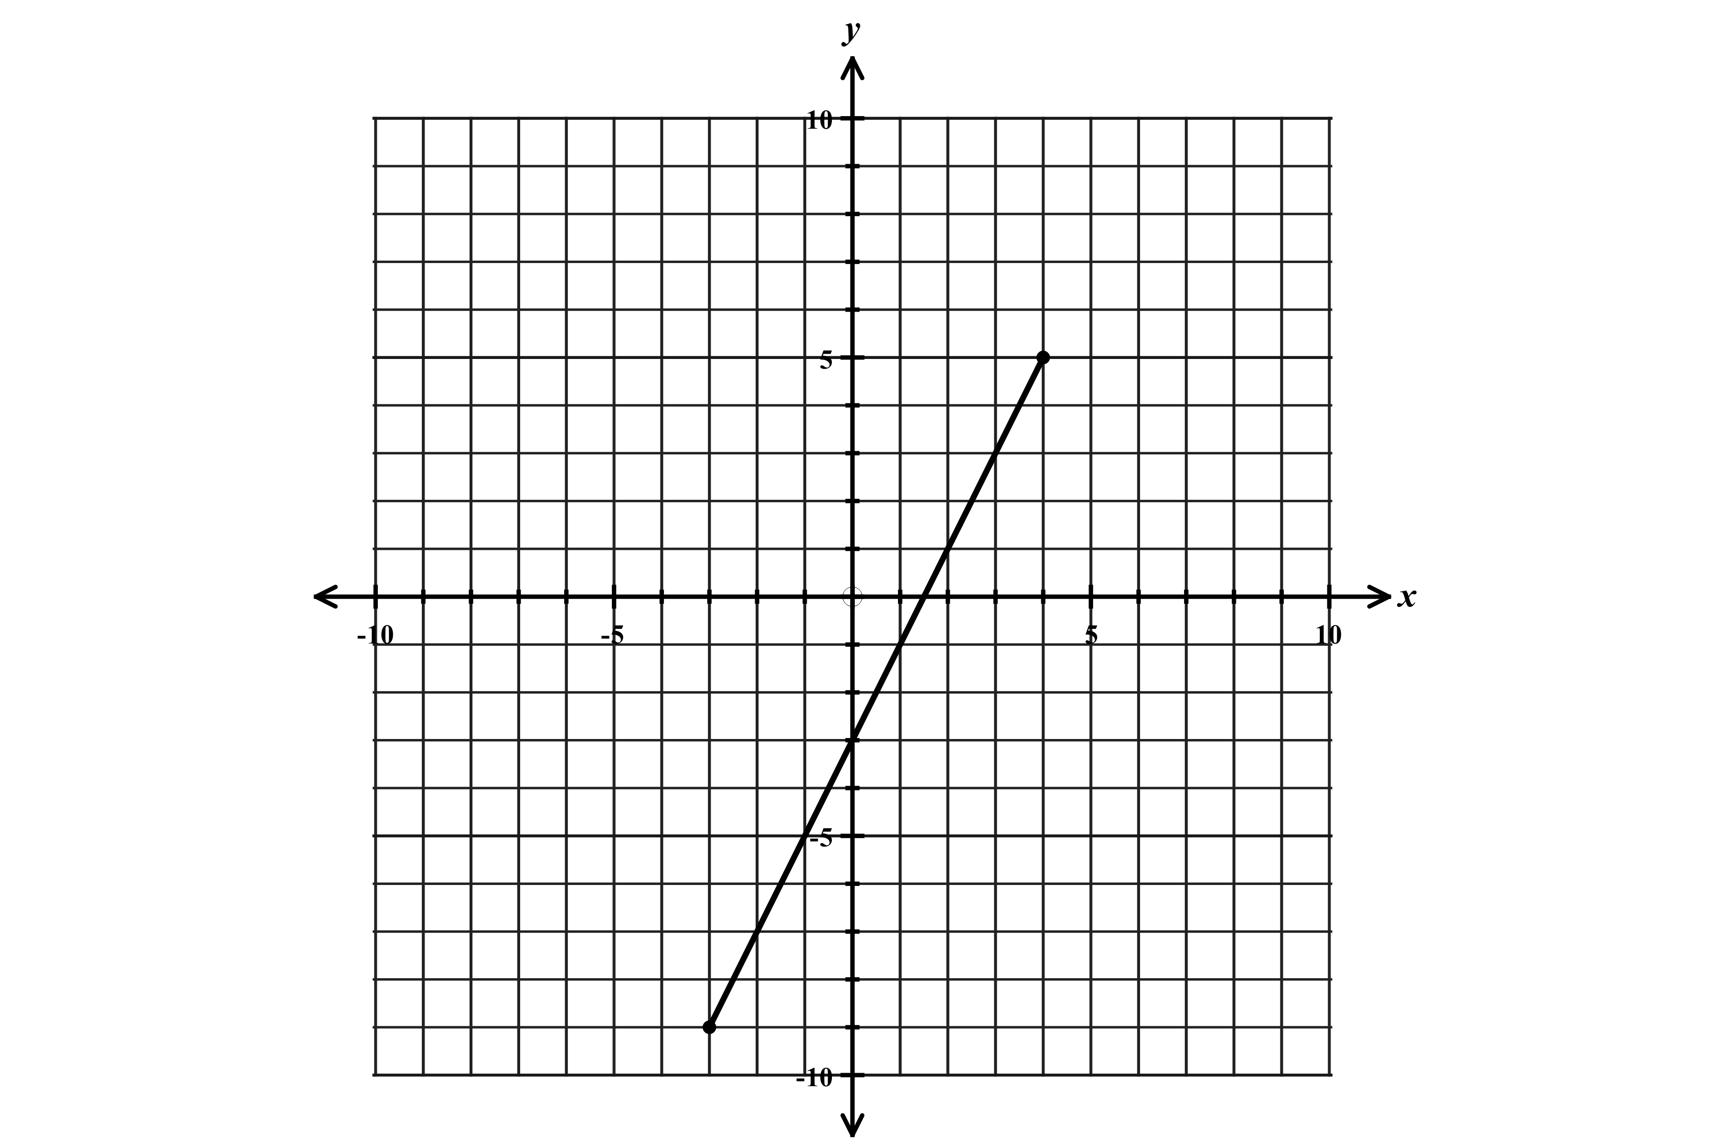

1. Graph the function $f\left(x\right)=2x-3$ over the interval $-3≤x≤4$

Create a table that only includes domain values from -3 to 4
Then graph the function with endpoints.
$$x$$ | -3 | -2 | -1 | 0 | 1 | 2 | 3 | 4
$$f(x)$$ | -9 | -7 | -5 | -3 | -1 | 1 | 3 | 5
Careful of the included and excluded domains!! (closed vs. open endpoints)

The range can be determined from the table or the graph.

Range: $-9≤y≤5$ or $\left[-9,5\right]$

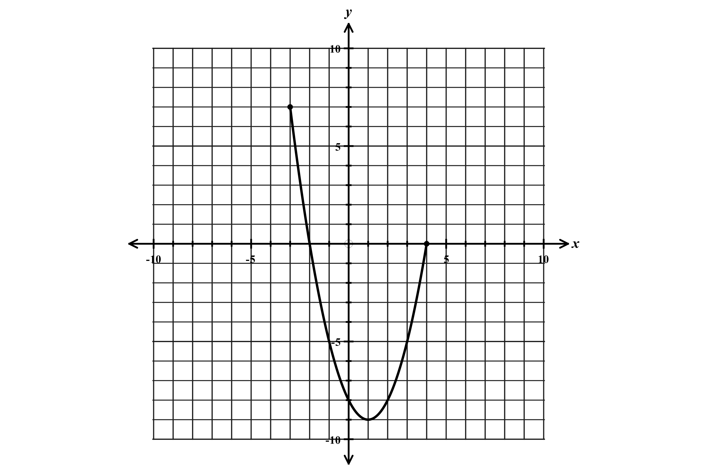
2. Graph the function $f\left(x\right)=x^{2}-2x-8$ over the domain $-3≤x≤4$

$$x$$ | -3 | -2 | -1 | 0 | 1 | 2 | 3 | 4
$$f(x)$$ | 7 | 0 | -5 | -8 | -9 | -8 | -5 | 0

Range: $-9≤y≤7$ or $\left[-9,7\right]$

Find the minimum and maximum range values from the table or the graph

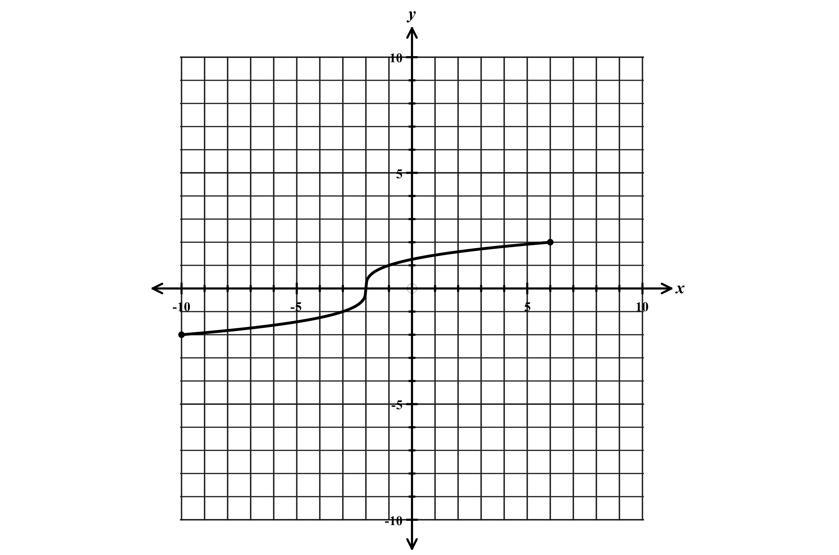

3. Graph the function $y=\sqrt[3]{x+2}$ over the given domain.

$$-10≤x≤6$$

$$x$$ | -10 | -3 | -2 | -1 | 6
$$f(x)$$ | -2 | -1 | 0 | 1 | 2

Range: $-2≤y≤2$ or $\left[-2,2\right]$

