You must show work/explain EVERY question, even the multiple choice questions.
y
x
- Which of the following is the equation to the function to the right?

1) | $$y=2^{x}$$ | 3) | $$y=2x+1$$
2) | $$y={\frac{1}{2}}^{x}$$ | 4) | $$y=x^{2}+1$$

1.) _________
2.) Which graph represents the solution set for and ?
1) | 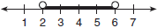 | 3) | 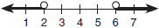
2) |  | 4) | 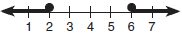

2.) _________

3.) The expression is equivalent to
1) |  | 3)
2) |  | 4)
3.) _________
4.) Which equation represents a quadratic function?
1) |  | 3)
2) |  | 4)

4.) _________
5.) If , then solve for w in terms of x and y.
1) |  | 3)
2) | 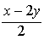 | 4) | 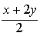  5.) ________
6.) The relation defined by the set of ordered pairs {(0, 2), (-2, 2), (1, 4), (4, 1), (0,-1)} is not a function. Which of the ordered pairs from the relation, when omitted, will make the resulting set a function? Explain your choice. [2 points]

7.) Factor completely: $x^{4}-x^{2}-12$ [3 points]

8.) Graph and label the function $y=\left|x\right|$ and $y=\left|2x\right|$ on the set of axes below. [5 points]
a) Include a table of values for both functions.
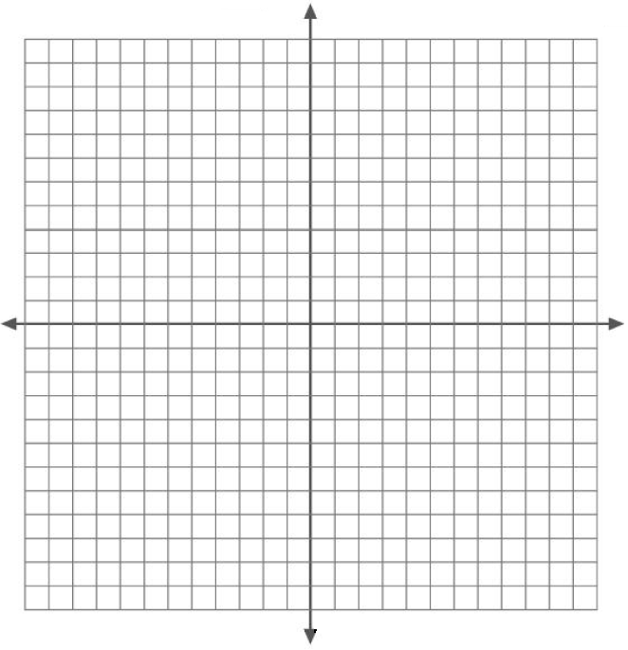

b) Explain how increasing the coefficient of x affects
the graph of $y=\left|x\right|$.

