You must show work/explain EVERY question, even the multiple choice questions.
- If $f\left(x\right)=\left|3x-4\right|+2$ find$f(-10).$

1) | 28 | 3) | 36
2) | 34 | 4) | 38

- _________

2.) A sequence has an initial value of 10 and each term is twice the previous term. Which function models this sequence?
1) | $$a\left(n\right)=10{(2)}^{n}$$ | 3) | $$a\left(n\right)=10+2n$$
2) | $$a\left(n\right)=10{(2)}^{n-1}$$ | 4) | $$a\left(n\right)=10+2(n-1)$$

- _________

3.) Given the length of three sides of a triangle, which is a right triangle?
1) | 10, 26, 24 | 3) | 30, 15, 26
2) | 20, 12, 18 | 4) | 40, 50, 80

- _________

4.) A mouse population starts with 2,000 mice and grows at a rate of 5% each year. The number of mice after t years can be modeled by the equation $P(t)=2000{(1.05)}^{t}$. What is the average rate of change in the number of mice between the second year and the fifth year, rounded to the nearest whole number?

1) | 116 | 3) | 348
2) | 2205 | 4) | 2553

4.) _________
5.) Seven less than the product of twice a number is greater than 5 more than the same number. Which integer satisfies that inequality?
1) | 1 | 3) | 12
2) | 2 | 4) | 13

5.) ________
6.) A bakery ordered 20 bags of flour $f$ and 16 pounds of butter $b$ on a Monday for a total cost of $110. On Tuesday the bakery ordered 30 bags of flour and 12 pounds of butter for a cost of $120.
A. Write a system of equations that could be used to find the cost of one bag of flour and one pound of butter. [2 points]

B. Solve the system of equations to find the cost of each. [3 points]

One bag of flour $ _________________ On pound of butter $ ________________

7.) Let $f\left(x\right)=x^{2}-6x$ and $g\left(x\right)=-2x+5$. On the axes provided draw the graphs of $y=f(x)$ and $y=g(x)$. Include any tables and don’t forget to label! [3 points]
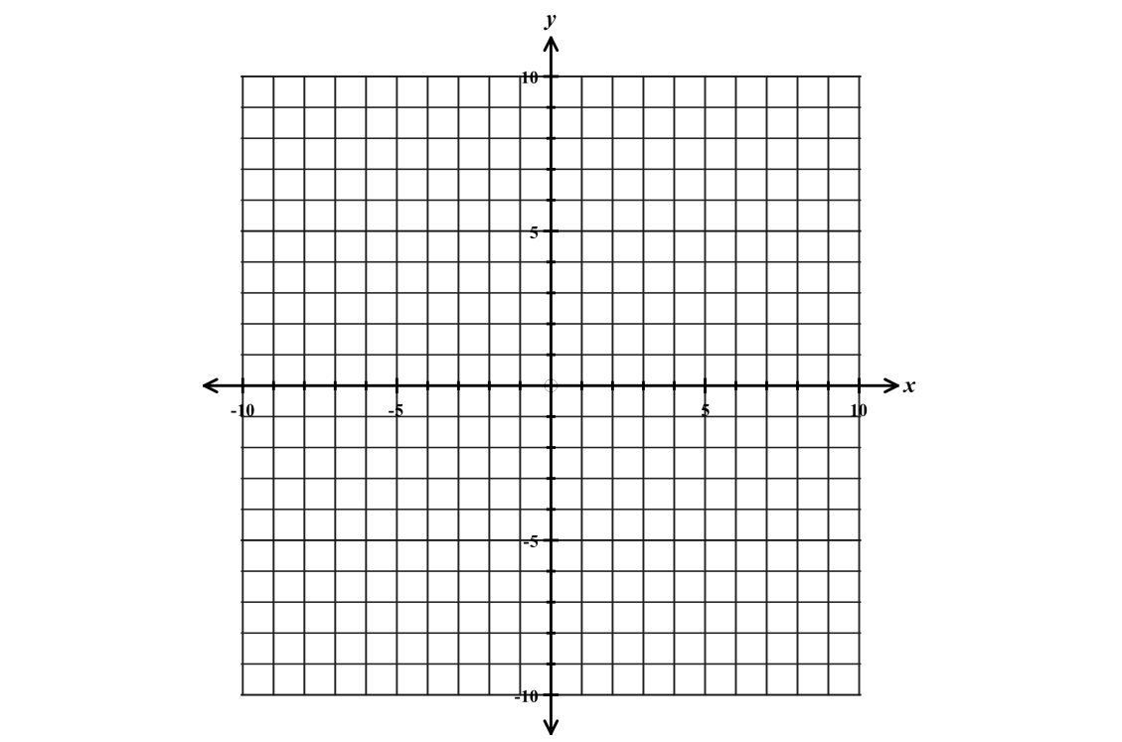

State all values of $x$ for which $f\left(x\right)=g\left(x\right).$ [2 points]

