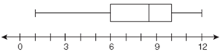**1 Variable Statistics and Box Plots**

**The 5 numbers you need for a box plot are:**

**minx –**

**Q1 –**

**Median –**

|  |  |  |  |  |
| --- | --- | --- | --- | --- |
|  | | | | |
|  |  |  |  |  |
| **Press the Stat key** | **Choose “Edit” by pressing Enter** | **Enter data into** | **Stat Calc**  **Choose 1-Var Stats** | **Scroll down to the bottom** |

**Q3 –**

**maxX –**

**Three other useful numbers that the calculator gives you are:**

