Algebra 1 Unit 8 Name _________________________________________________________

Roots and Cubic Functions Period _______

Recall that a quadratic function can be written for a graph if the roots (zeros) are known.

Example: Write the equation in standard form for the graph shown below.
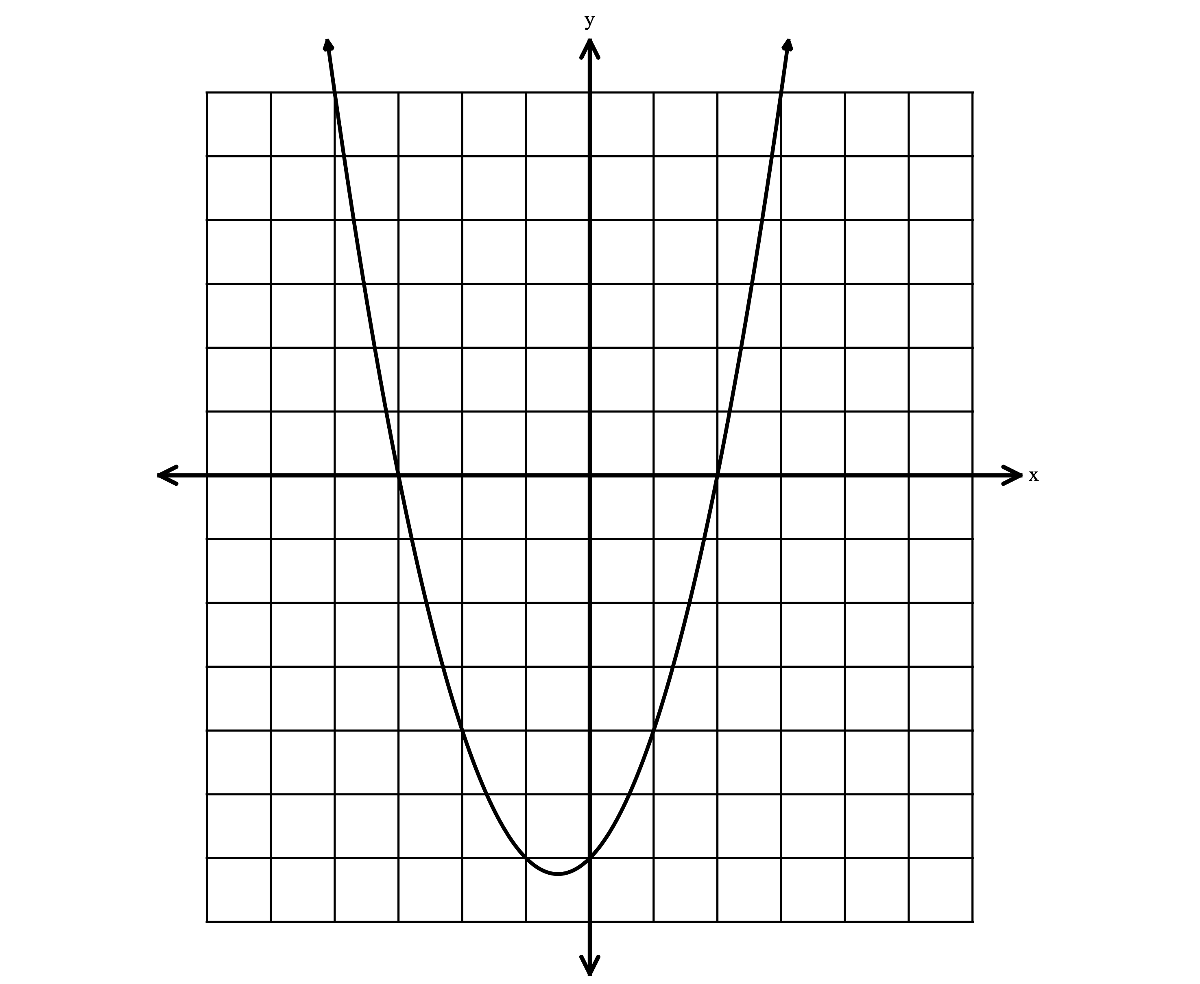
$f(x)$

Writing Cubic Functions from Graphs

Exercise #1: Consider the polynomial function shown below.
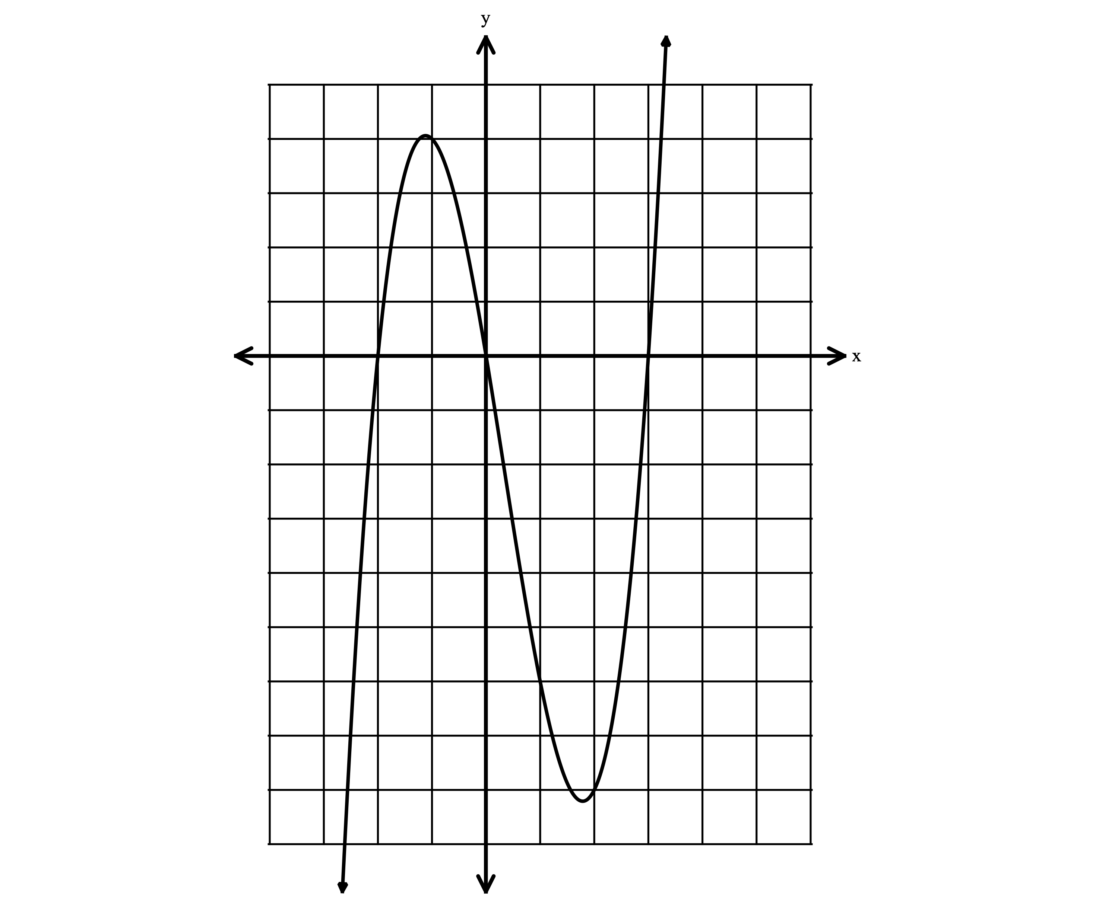
A. What are the roots (zeros) of the function?

B. Write the factors of the function.

C. Write the equation for the graph in factored form.

D. Write the equation in standard form. Check your equation
on the calculator.

Exercise #2: A polynomial function has the factors $x+3, x+1$ and $x-2$. Which graph correctly represents the function? Explain your reasoning.
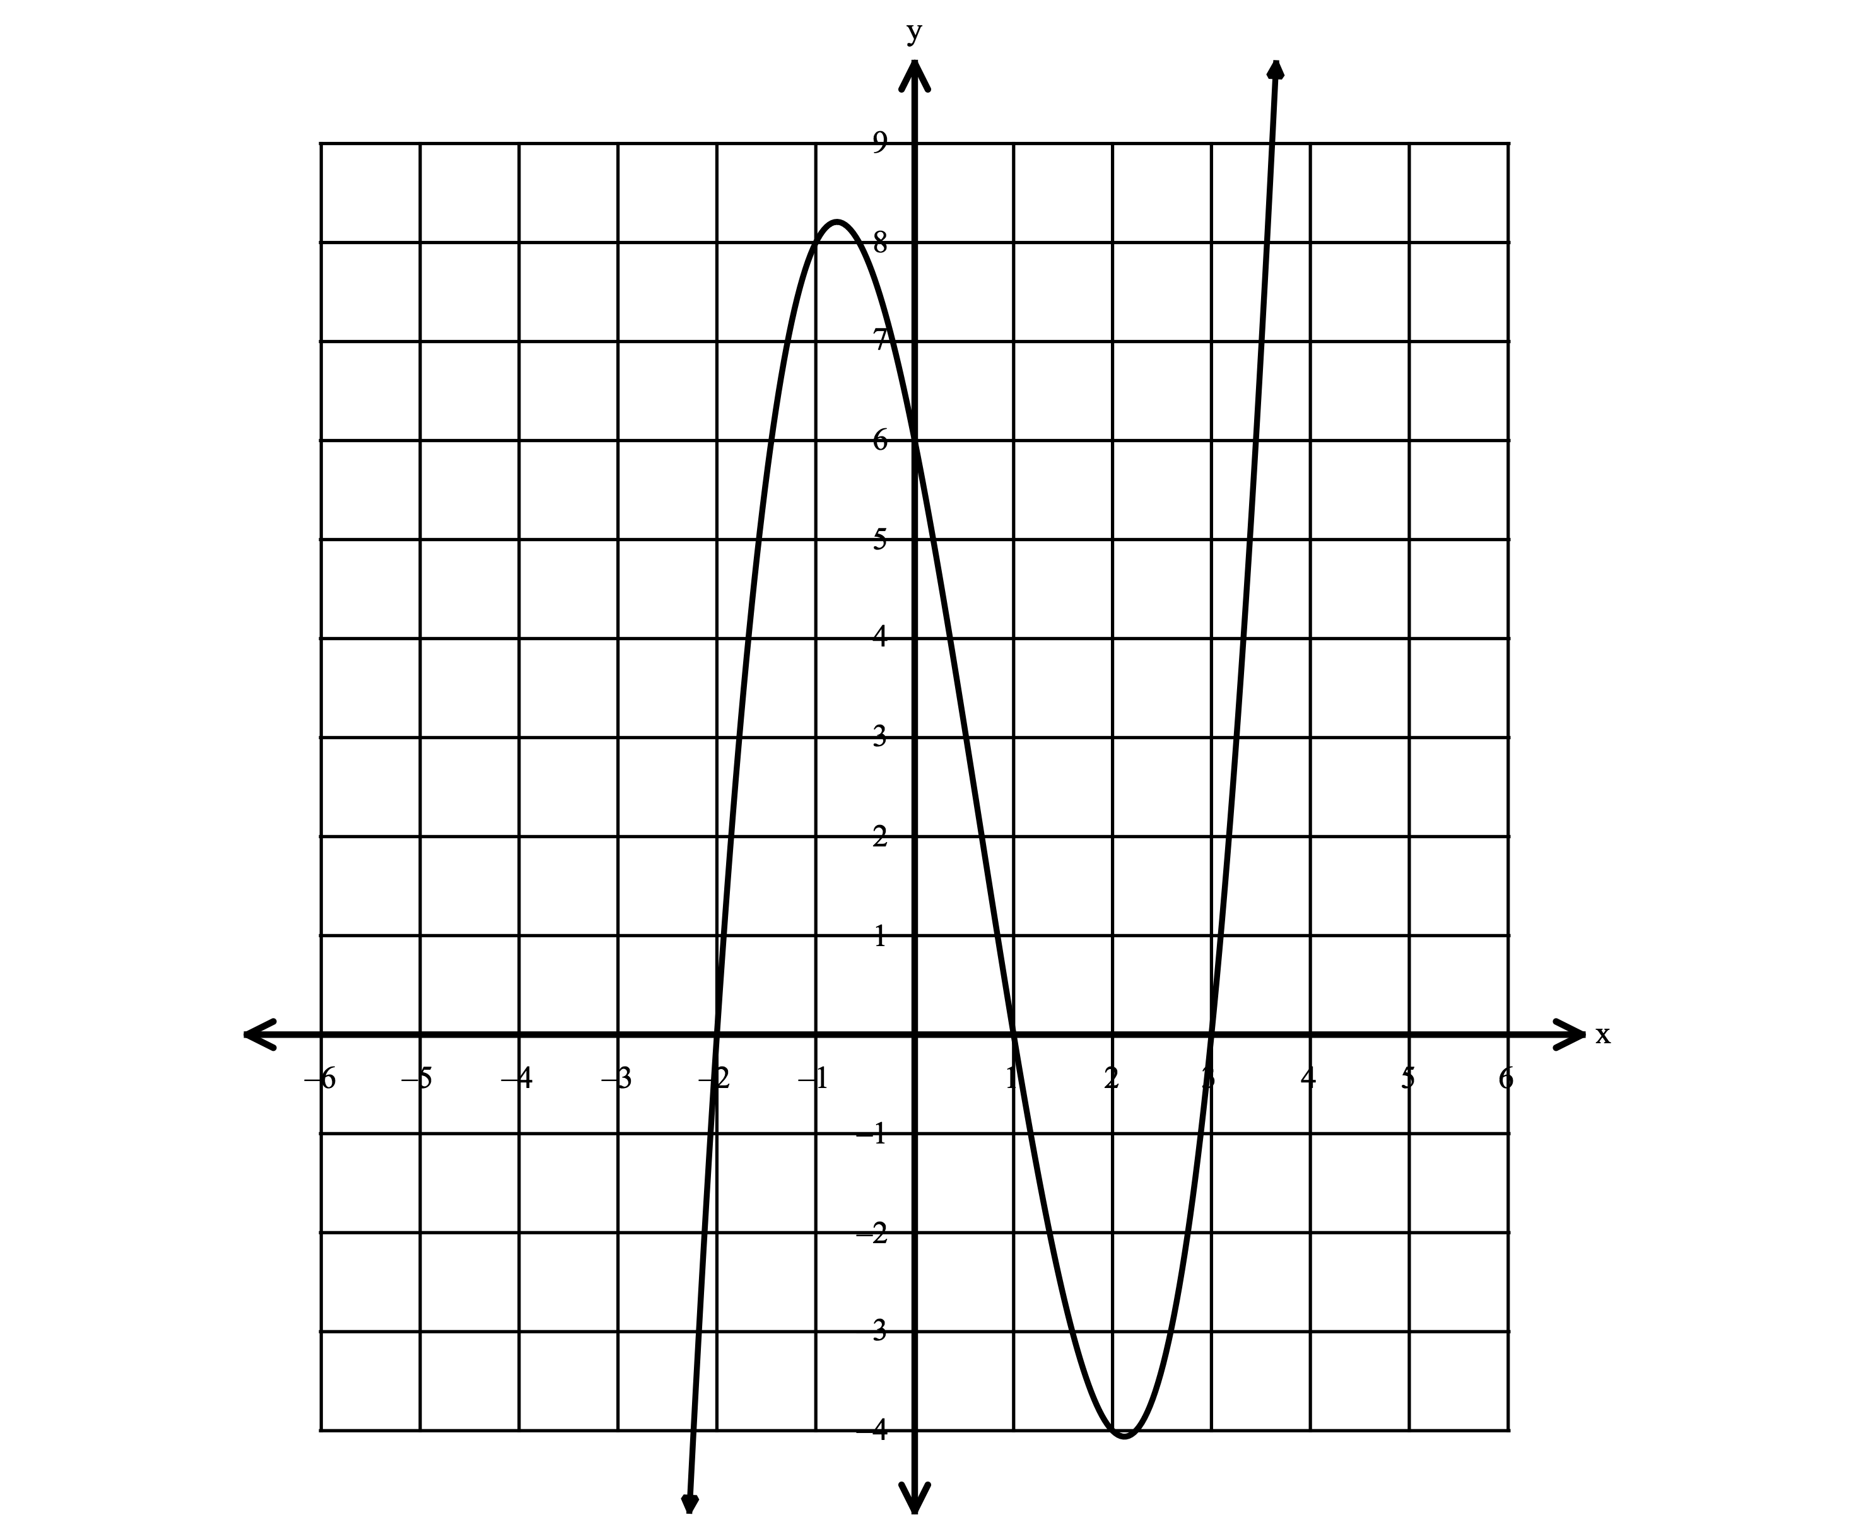
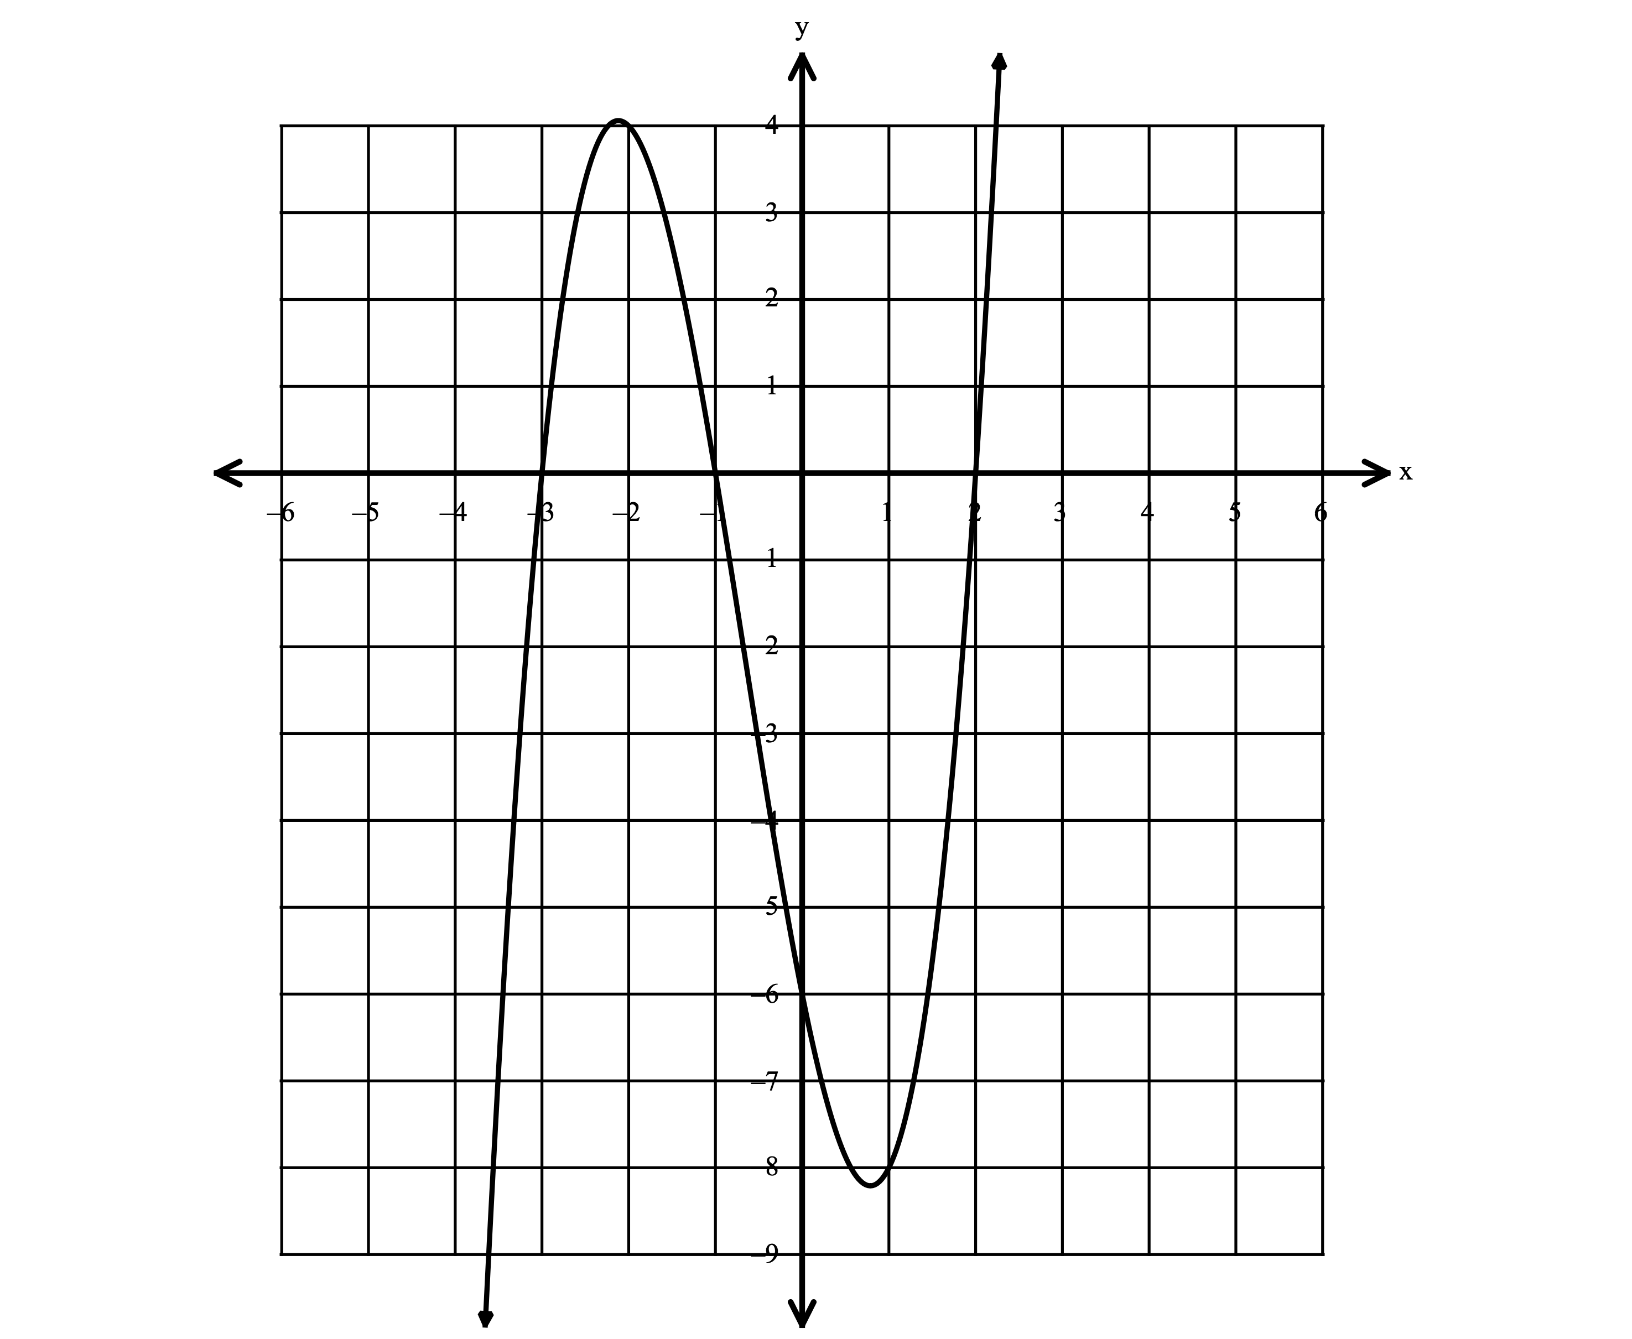
I. II.

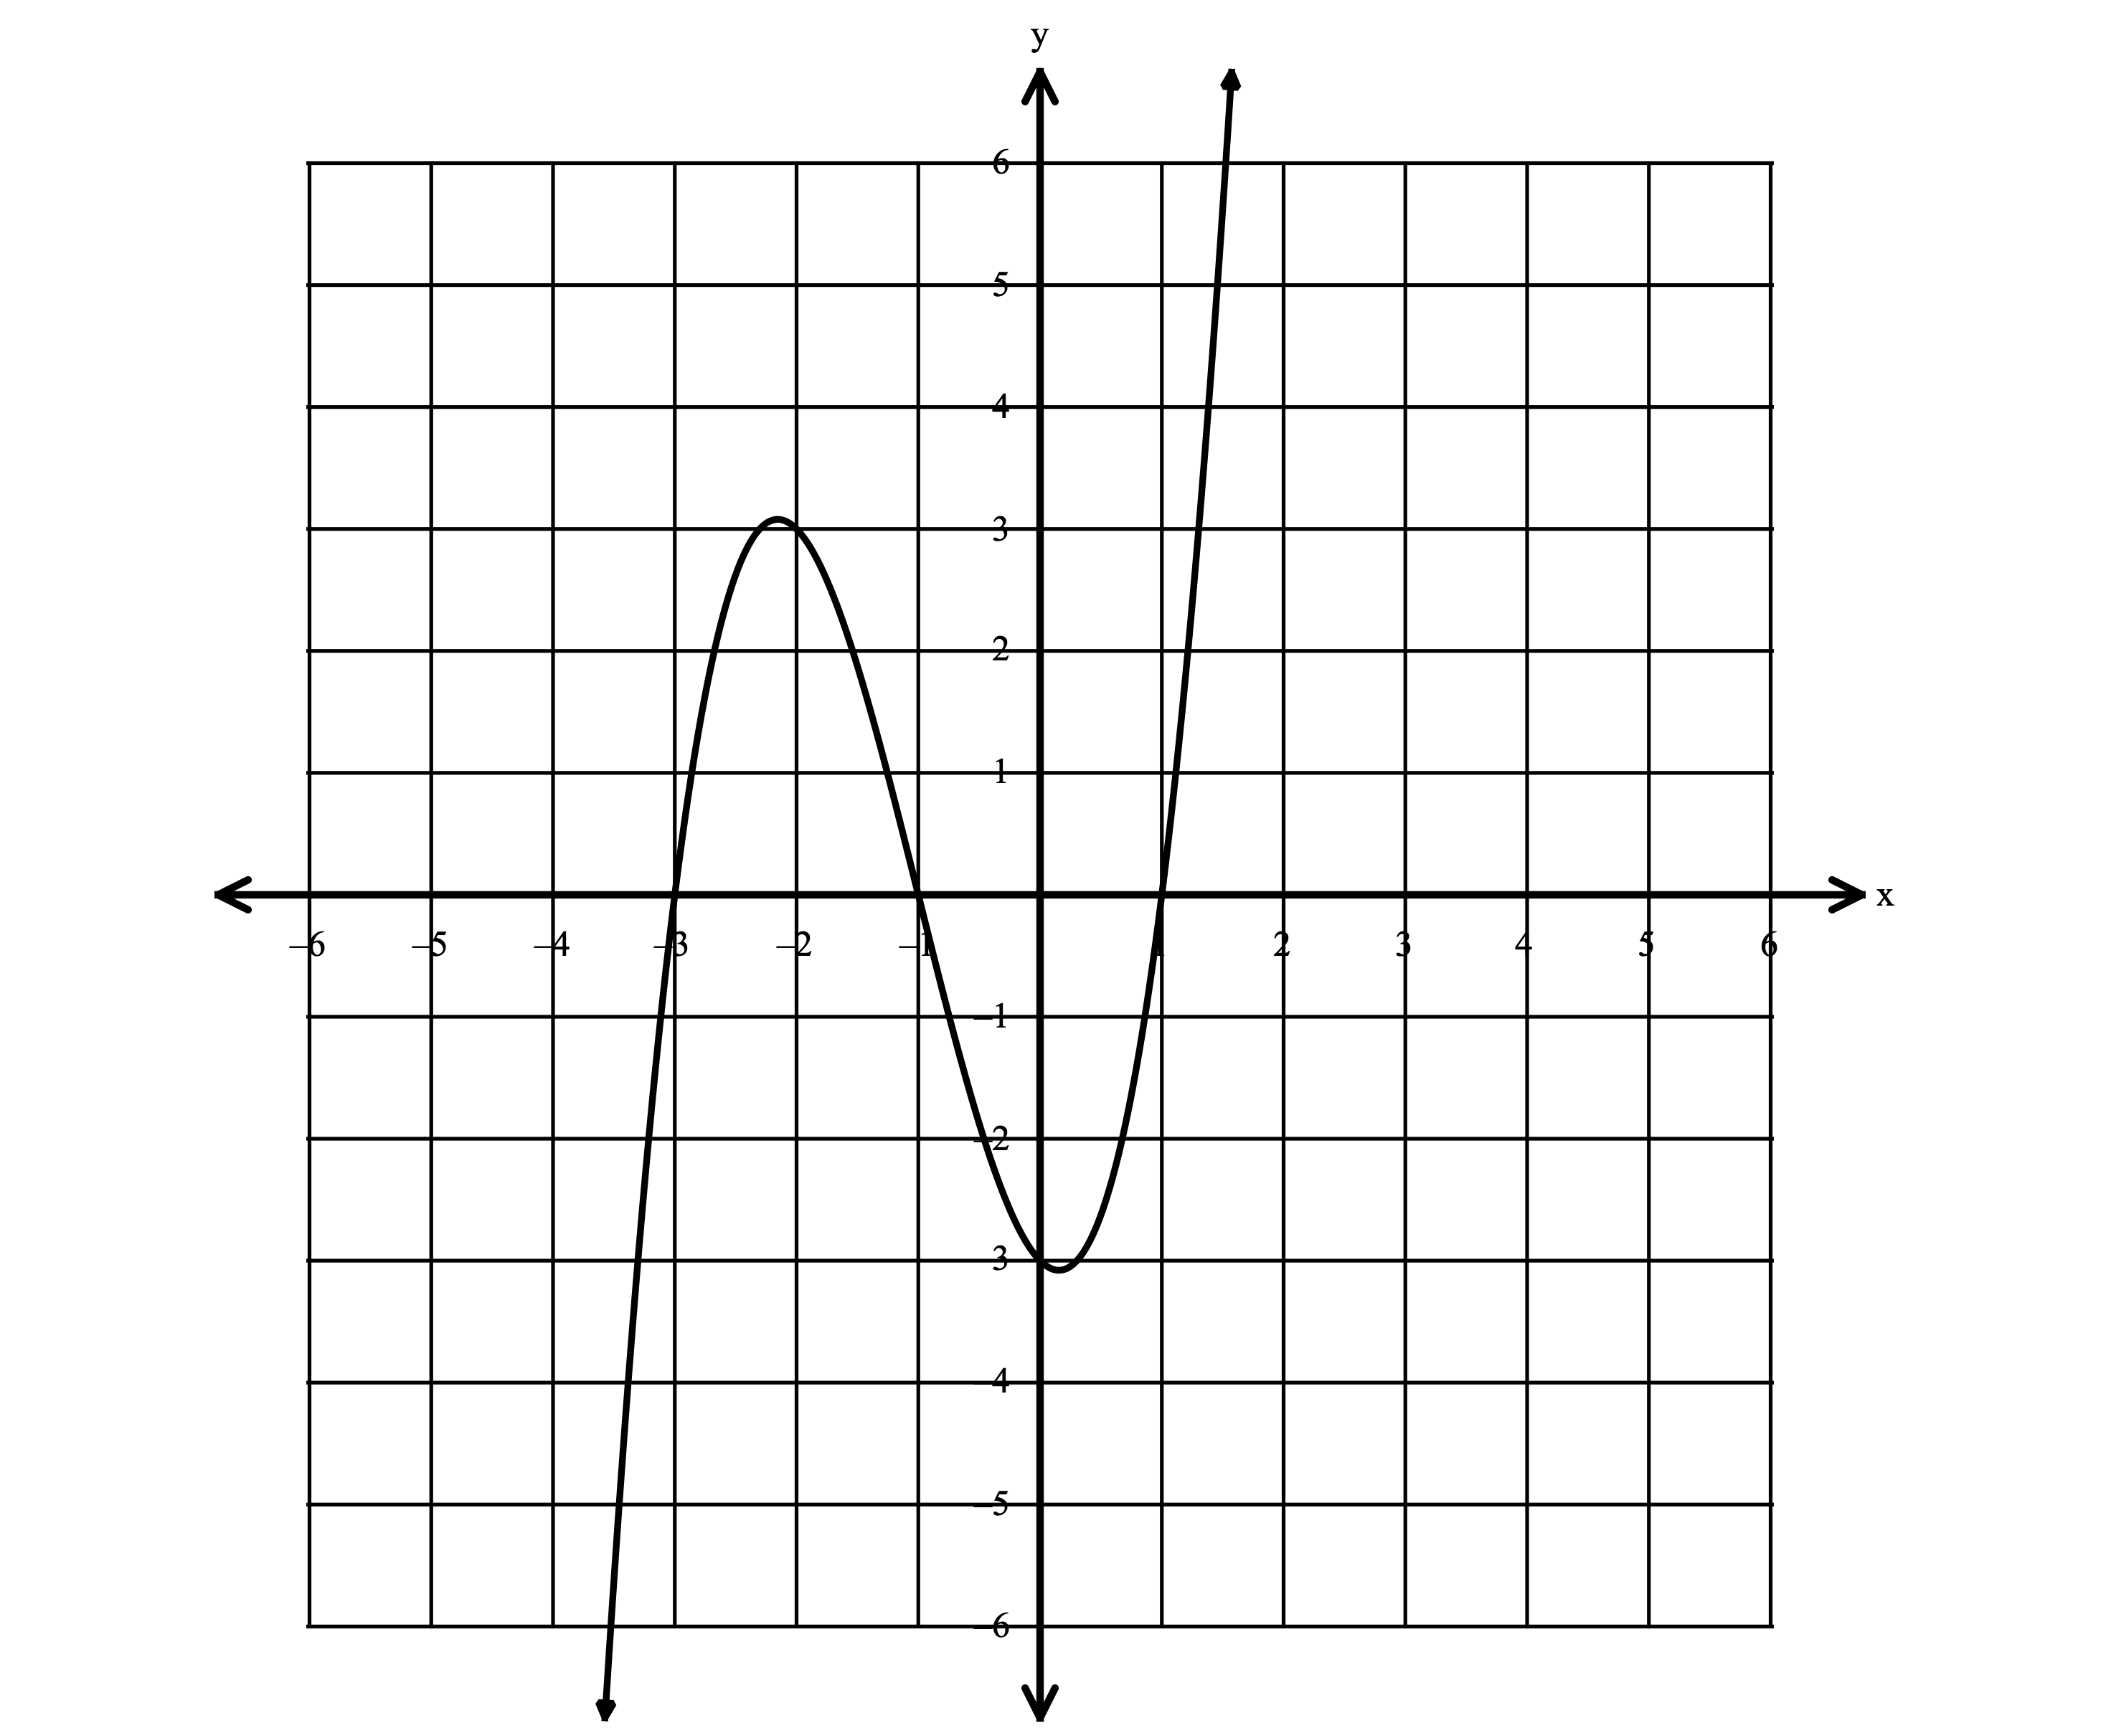
Exercise #3: Which equation(s) correctly represent the graph shown below? Justify your answer.

I. $y=(x+1)(x^{2}-4x+3)$

II. $y=(x+3)(x^{2}-1)$

III. $y=(x-1)(x^{2}+4x+3)$

IV. $y=(x-3)(x^{2}-1)$

Exercise #4: Write the equation for the graph shown below in standard form.
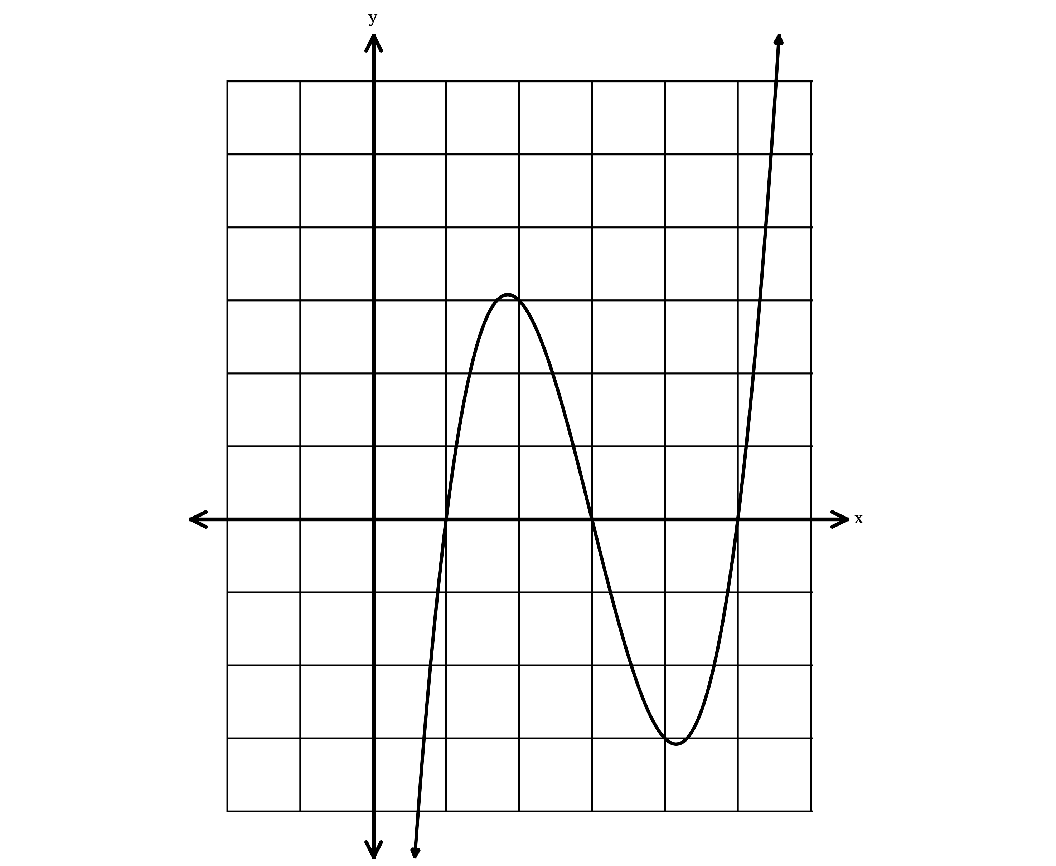

Exercise #5: A polynomial function is represented by the equation $f\left(x\right)=\left(x+2\right)(x^{2}-5x+6)$. Which graph correctly represents the function? Explain your reasoning.
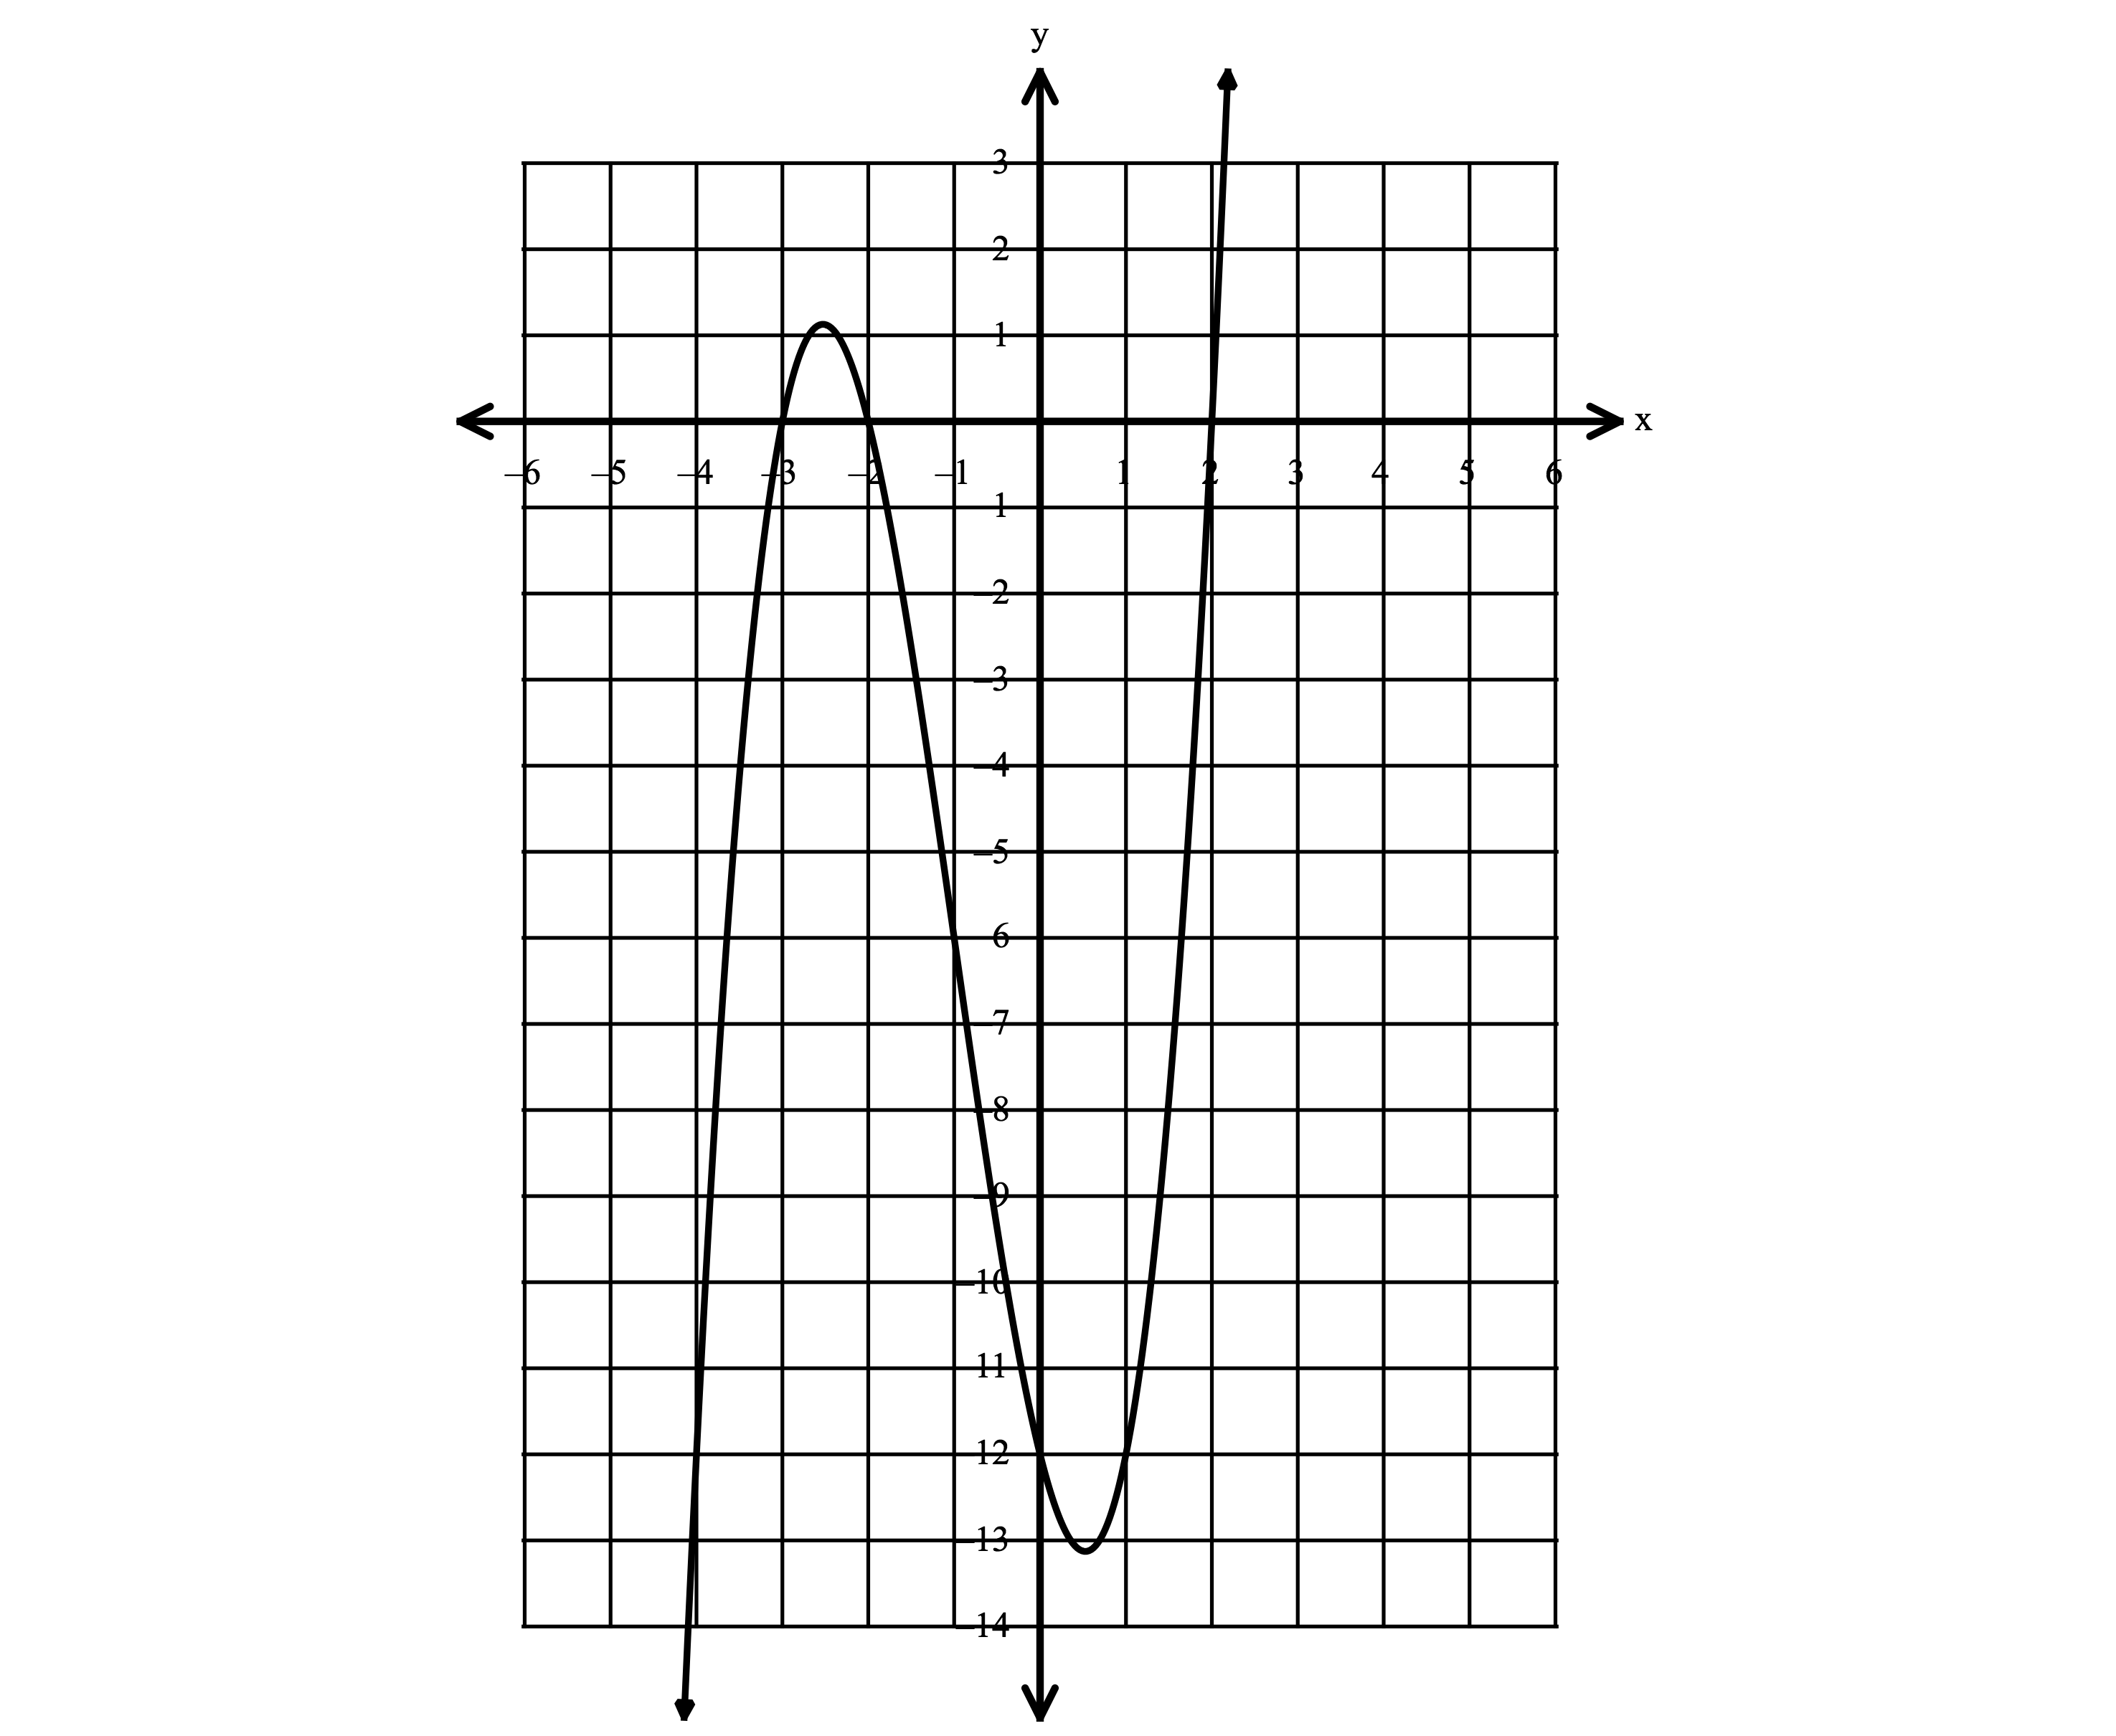
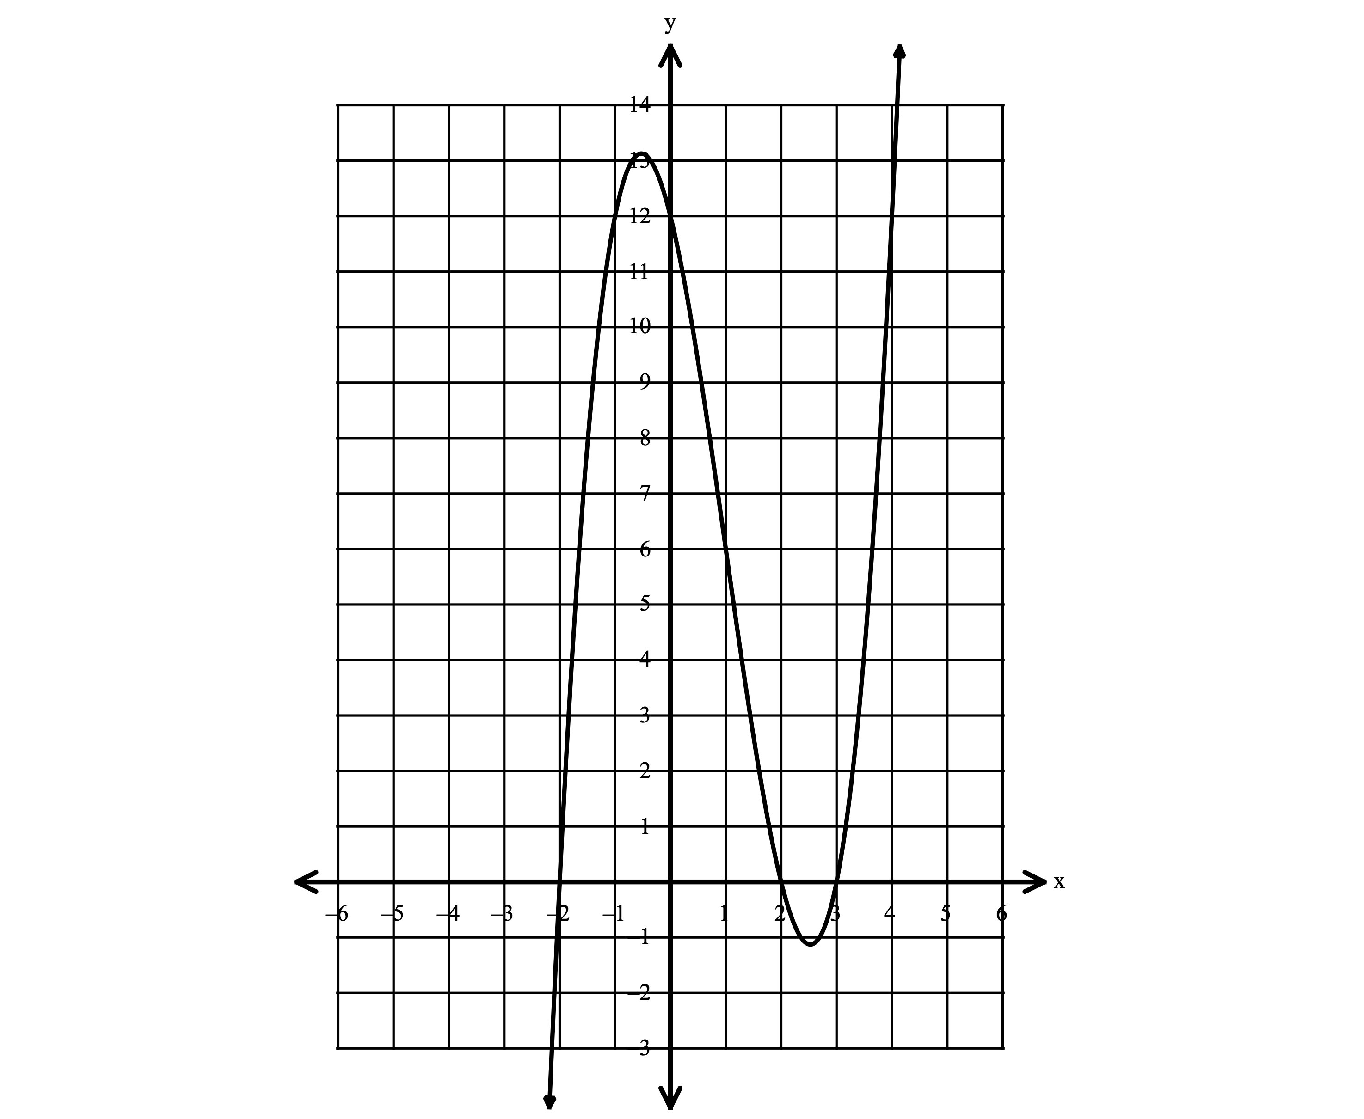
I. II.

Homework

Exercise #1: A polynomial function contains the factors $x-1, x+3,$ and $x+4$. Does the graph shown below correctly describe the function? Explain your reasoning.
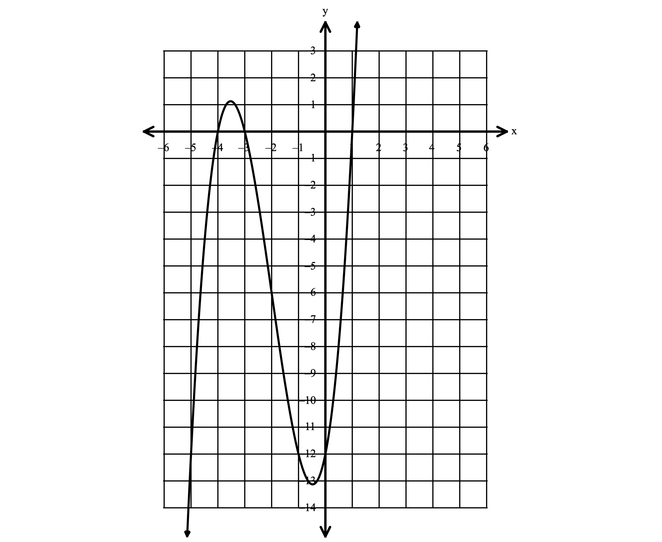

Exercise #2: Write an equation, in standard form, to describe the polynomial function shown below.
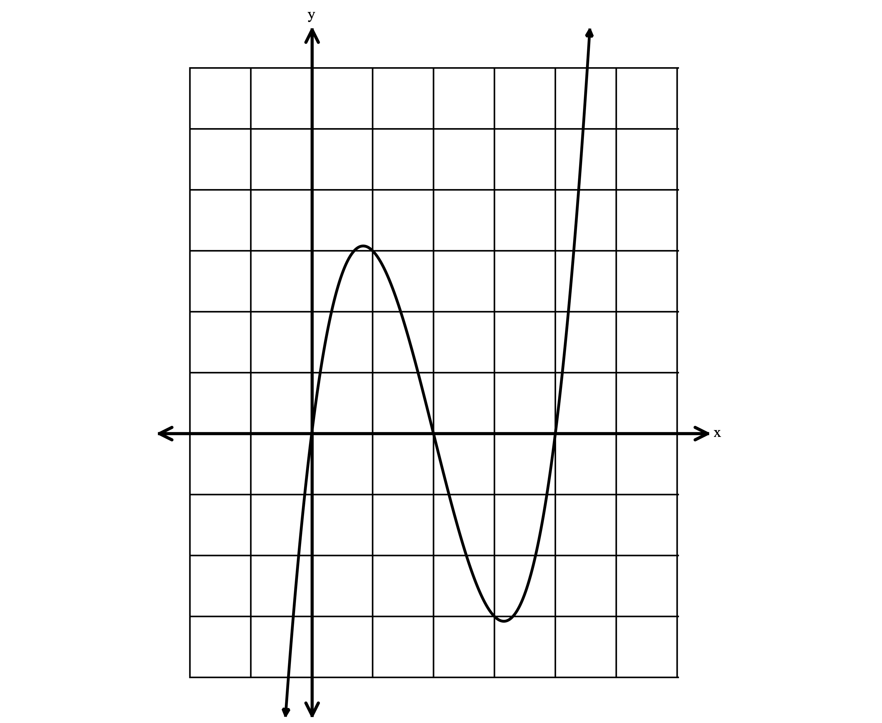

Exercise #3: Martin claims that the equation $y=x(x^{2}-4)$ can be used to describe the graph below. Is Martin correct? Justify your answer.
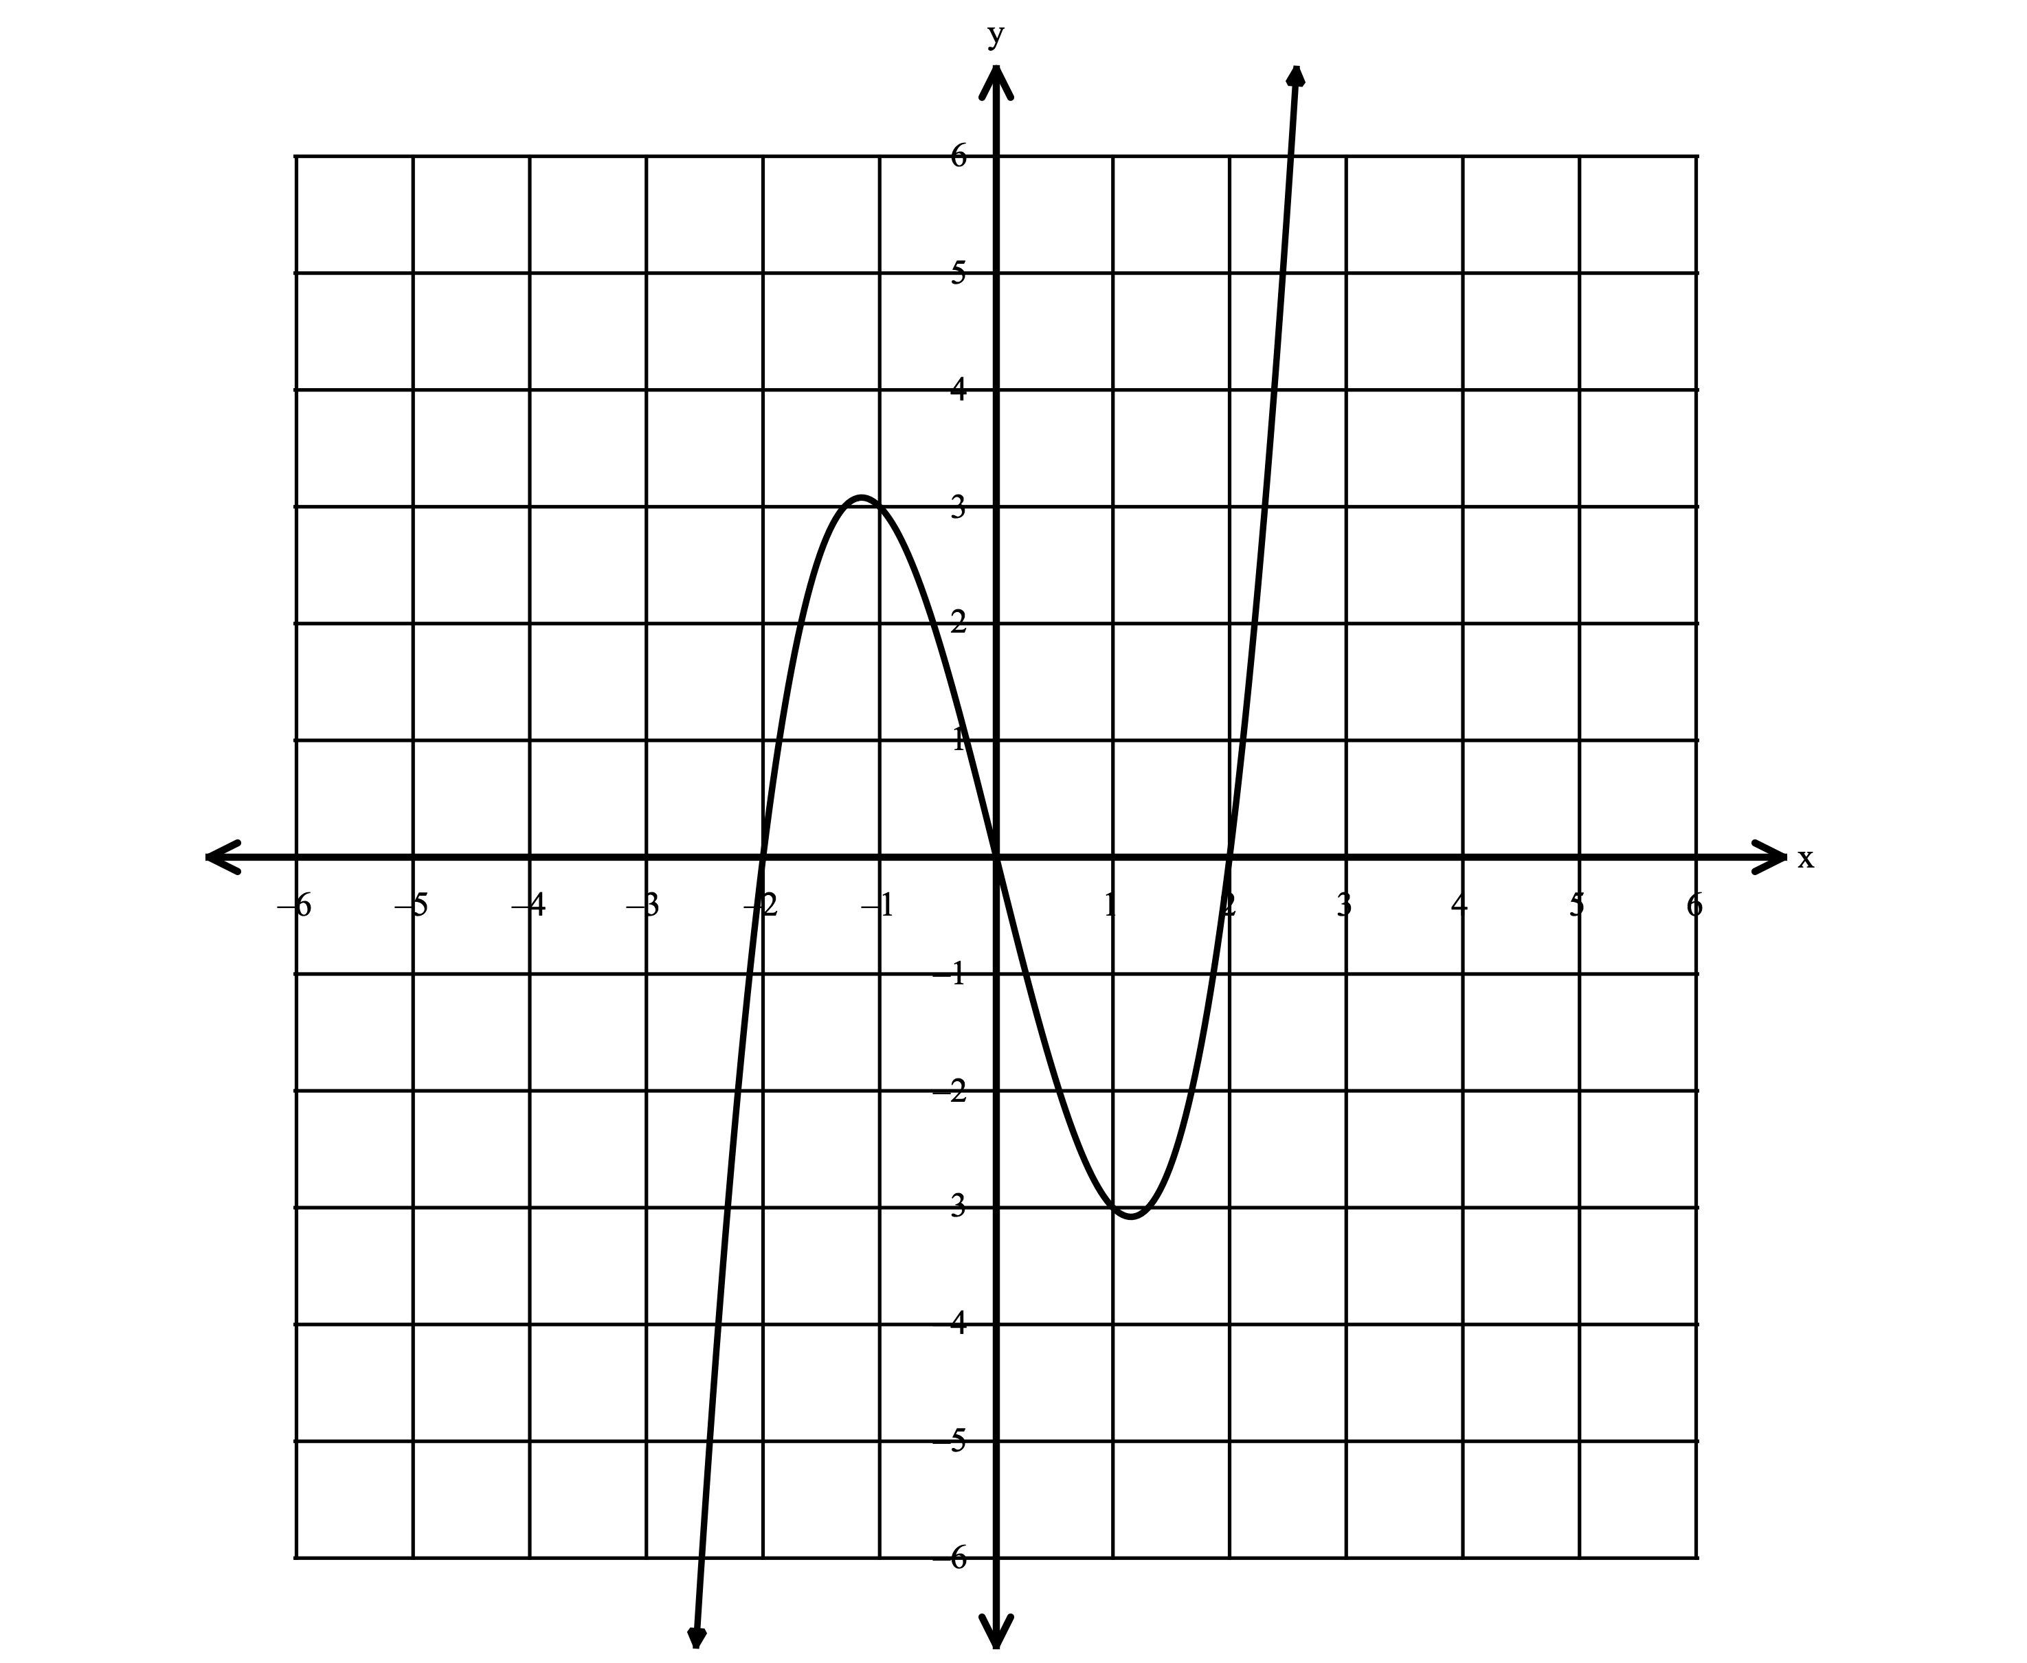

Exercise #4: Which equation(s) correctly describe the graph shown below? Justify your answer.
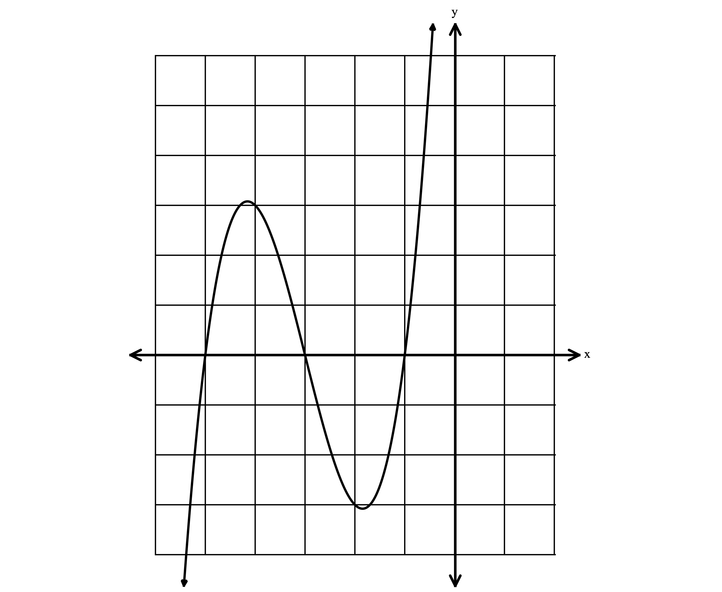
I. $f\left(x\right)=\left(x+1\right)\left(x^{2}+8x+15\right)$

II. $f\left(x\right)=(x-5)(x^{2}-4x+3)$

III. $f\left(x\right)=(x+3)(x^{2}+6x+5)$

IV. $f\left(x\right)=(x+5)(x^{2}-4x+3)$

Exercise #5: Write an equation in standard form to describe the polynomial function shown below. Explain how you determined the equation.
